Test on Part 1 (Peacemaking)
You need to answer all four questions from this section, using the sources specifically for answering Q1 and Q2.
Source D – A cartoon published in Britain in February 1919 entitled ‘Giving Him Rope’.
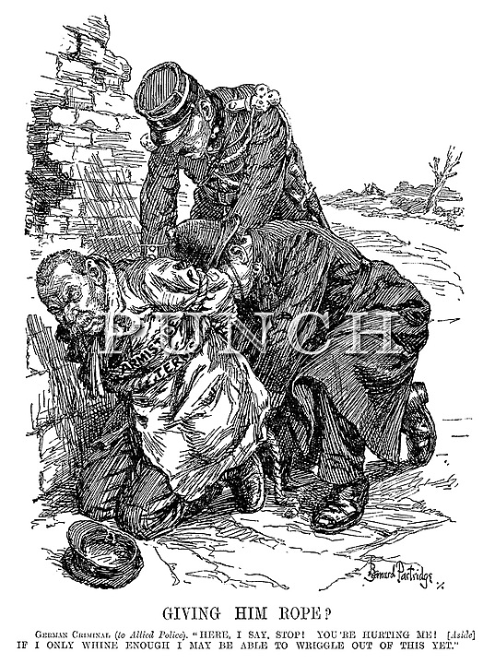

Source E – A German newspaper cartoon published in July 1919, entitled ‘Clemenceau the Vampire’. The figure on the bed represents Germany.
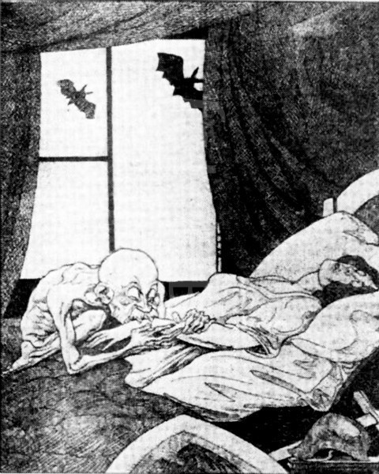

Source F – From J M Keynes’ book ‘The Economic Consequences of the Peace’ published in 1919. Keynes was a leading economist who worked for the British government but resigned in protest three weeks before the Treaty of Versailles was signed.
Nations should not morally visit on the children of their enemies the wrongdoings of parents or of rulers. The Treaty includes no provisions for the economic recovery of Europe – nothing to make the defeated Central Empires into good neighbours. The Big Three were preoccupied with other issues – Clemenceau to crush the economic life of his enemy, Lloyd George to bring home something that would be acceptable for a week, the President to do nothing that was not just and right.

Answer questions 01, 02, 03 and 04.

- Study Source D.
Source D opposes Germany. How do you know?
Explain your answer by using Source D and your contextual knowledge.
[4 marks]

- Study Sources E and F.
How useful are Sources E and F to a historian studying opinions about the Treaty of Versailles?
Explain your answer using Sources E and F and your contextual knowledge.
[12 marks]

- Write an account of how the Treaty of Versailles caused problems for Germany.
[8 marks]

- Clemenceau was the least satisfied of the ‘Big Three’ by the Treaty of Versailles.

How far do you agree with this statement? Explain your answer.
[16 marks]
[SPaG: 4 marks]

