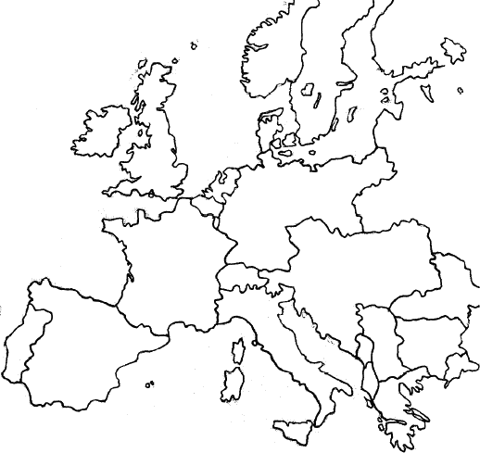What were the Costs of WWI?

Germany

Britain

Central Powers

Triple Entente (Including Russia until 1917)

Austria-Hungary

Belgium

Italy

France

USA