Year 9 – Hope and Despair Assessment 1
Of Mice and Men Character Analysis
Read the following extract from Chapter 4 of Of Mice and Men and then answer the question that follows.
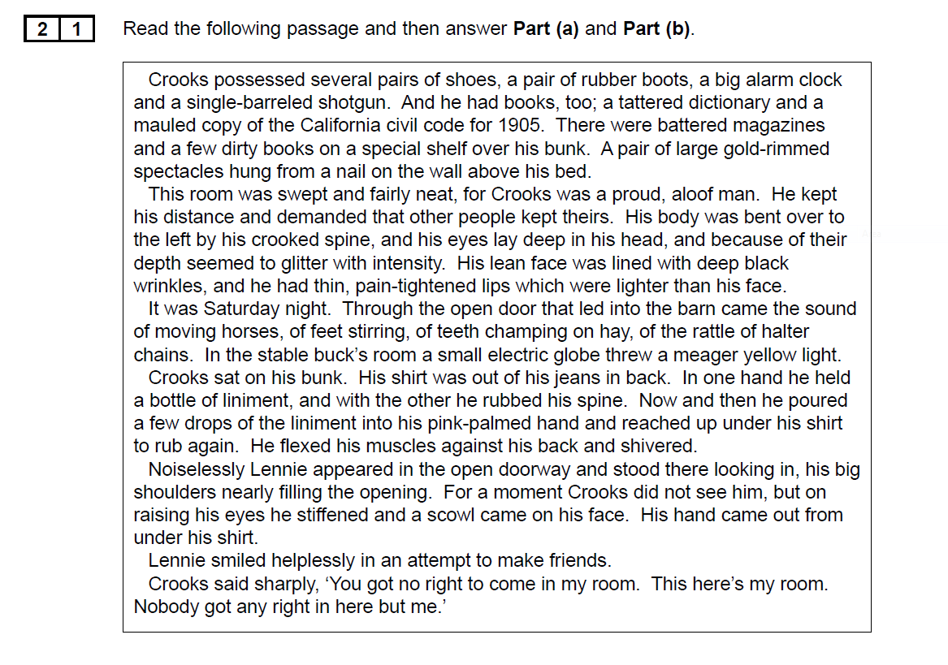
In this extract, Steinbeck describes Crooks’ bedroom before Lennie enters.
Starting with this extract, explore how Steinbeck presents inequality in Of Mice and Men.
Write about:
- How Steinbeck presents Crooks and the inequality he suffers within this extract
- How Steinbeck presents inequality in the novella as a whole

