‘To a Mouse’ by Robert Burns
Can you tell me what you think this poem is going to be about using the words in the box?
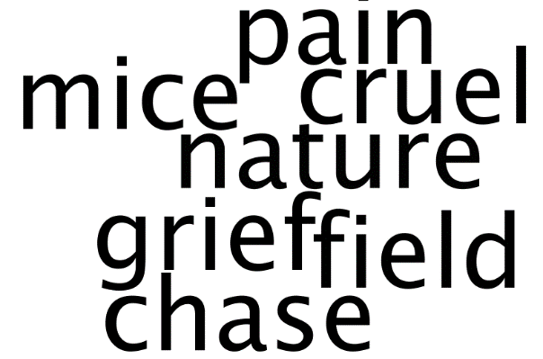
Small, sleek, cowering, timorous beast,
Oh, what panic is in your breast!
You need not start away so hasty
With a hurrying scamper!
I would be loath to run and chase you,
With a murderous spade!
Can you find the dictionary definition?
Timorous
Cowering
Tick the statement that is true:
- The mouse is seen to be weak and powerless
- The mouse is seen to be strong and powerful
“…murderous spade”: What does the man want to do to the mouse?
………………………………………………………………………………………………………………..

*I know that you must steal;
So what? Poor beast, you must live!
Why must the mouse steal food?
Can you highlight the correct word:
The word ‘poor’ is an emotive/violent word because it makes us think that the mouse is struggling/happy with survival.
*survival = living
What is the author implying about the weather?

Your tiny house too is in ruin!
Its feeble walls the winds are strewing!
And nothing now, from which to build a new one
Of foliage green!
And bleak December's winds ensuing
Both bitter and keen!
Write the negative words in the boxes below:
Ruin
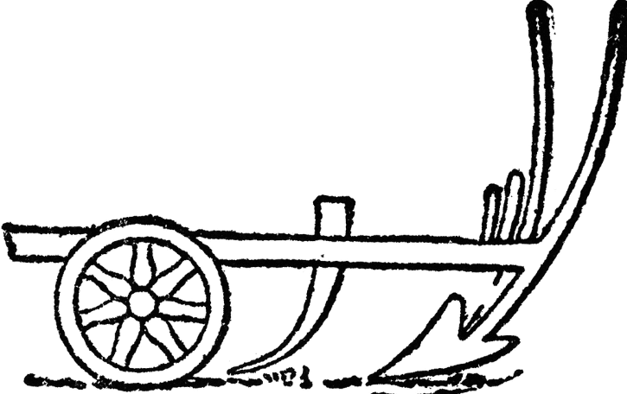
Plough
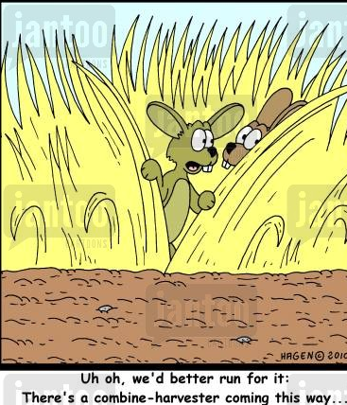
You saw the fields laid bare and wasted
And weary Winter coming fast,
And cosy here, beneath the blast,
You thought to dwell,
Until crash! the cruel plow passed
Right through your cell.
- Annotate the poem for:
personification | onomatopoeia | alliteration | adjectives
Direct Address: When the author talks to the reader
“the cruel plow passed right through your cell”: Who is the poem addressed to and why?
…………………………………………………………………………………………………………………
…………………………………………………………………………………………………………………

The mouse has had to ……………hard to collect food and feels very “……………….” It is hard for the mouse because they have no …………….. and have to live in the “………………” winter weather.
frosty | weary | work | home

That tiny heap of leaves and stubble (grain stalks)
Has cost you many a weary nibble!
Now you are turned out for your trouble
Without house or home (belongings),
To endure the Winter's sleety dribble,
and frosty cold.

How do you think the mouse is feeling? What words make you think this?
*Full sentences

But Mousie, you are not alone
What does Robert Burns mean by ‘the best laid plans of mice and men’?

In proving that foresight may be vain:
The best laid plans of mice and men
Often go astray
And leave us nothing but grief and pain
Instead of promised joy!

What is the poet saying to the mouse about life? *write four sentences that clearly show your understanding
1.
2.
3.
4.
Still, you are blessed, compared with me!
Only this moment touches you:
Why do you think the man thinks the mouse is “blessed” (lucky)?
The poet thinks the mouse is blessed compared to himself because….
But oh! I backward cast my eye
On prospects turned to sadness!
And though forward I cannot see,
I guess and fear!
What does the poet fear?
…………………………………………………………………………………………………
…………………………………………………………………………………………………
Can you fill in the gaps?
In the poem the mouse's hard work is ……………………by one event in its life. It will be forced to suffer through the hard ………………. even though it carefully prepared for the season. Robert Burns wants us to know that people are also ……………………….. to disaster. He knows that the best plans often go …………... He wants the reader to know that men suffer more than a mouse because they have to …………………… all the time whereas a mouse only lives in the moment.
winter | Destroyed | vulnerable | worry | wrong

Q: How does this poem help us understand the difficulties that George and Lennie in ‘Of Mice and Men’ face?
*Write a PEA with clear evidence from the poem and book
Extension: Write a paragraph that explains why John Steinbeck used a line from the poem ‘To a mouse’ for his title ‘Of Mice and Men’? *what does he want us to think
Challenge: Use quotations and show clear analysis of language in your response

