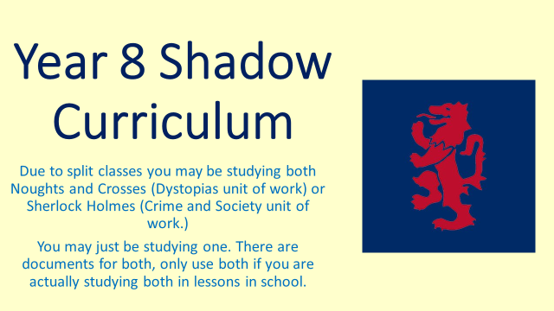
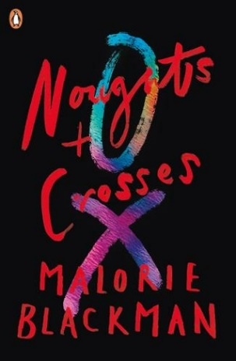
Dystopias Shadow Curriculum

You do not need to complete all the tasks unless you are away from school for a long period of time. You should add up the amount of time you miss from lessons and homework and work through the tasks accordingly.

- Create a research poster or leaflet about racial segregation in America in the 20th Century
****

- ‘Checking Out Me History’ by John Agard.
- In the ‘Accompanying Resource 1’ document you will find the poem and the accompanying worksheet to go through this poem and analyse.
- Create a leaflet with information about the historical figures Agard wants us to know about (Toussaint L’Ouverture, Nanny de Maroon, Shaka Zulu, Caribs and Arawaks and Mary Seacole)

****

- Watch ‘The Help’ on ClickView.
- Create an advert which one of the women in this film could put in a magazine or shop window asking for someone to work in their home. Think about the rules the help would have to follow and the jobs they would do
- Write a series of diary entries from the perspective of a black hired help during this time. Use your research to help you. You could present these in an interesting and unique way if you wish

****

- In the ‘Accompanying Resource 2’ document you will find an article on a real life militia and some accompanying tasks to complete

****

- Watch the first episode of Noughts + Crosses on ClickView or BBC iPlayer
and copy and complete the table below:

Character | How I thought they were based on the book | How they were presented in the episode

