Checking Out Me History Tasks

Checking Out Me History By John Agard
Dem tell me
Dem tell me
Wha dem want to tell me
Bandage up me eye with me own history
Blind me to my own identity
Dem tell me bout 1066 and all dat
dem tell me bout Dick Whittington and he cat
But Touissant L’Ouverture
no dem never tell me bout dat

Toussaint
a slave
with vision
lick back
Napoleon
battalion
and first Black
Republic born
Toussaint de thorn
to de French
Toussaint de beacon
of de Haitian Revolution

Dem tell me bout de man who discover de balloon
and de cow who jump over de moon
Dem tell me bout de dish run away with de spoon
but dem never tell me bout Nanny de maroon

Nanny
see-far woman
of mountain dream
fire-woman struggle
hopeful stream
to freedom river

Dem tell me bout Lord Nelson and Waterloo
but dem never tell me bout Shaka de great Zulu
Dem tell me bout Columbus and 1492
but what happen to de Caribs and de Arawaks too
Dem tell me bout Florence Nightingale and she lamp
and how Robin Hood used to camp
Dem tell me bout ole King Cole was a merry ole soul
but dem never tell me bout Mary Seacole

From Jamaica
she travel far
to the Crimean War
she volunteer to go
and even when de British said no
she still brave the Russian snow
a healing star
among the wounded
a yellow sunrise
to the dying

Dem tell me
Dem tell me wha dem want to tell me
But now I checking out me own history
I carving out me identity
‘Checking Out Me History’ Tasks
- Find five interesting facts about John Agard
- Read through and note down any word or phrase that is repeated more than once in the poem
- Find and copy out the reference to a nursery rhyme
- Find and copy out the bits of the poem which were sung by John Agard
- Read through and list all the historical figures mentioned (you could use a different colour for ones you know and ones you don’t)
Using metaphors:
Below you will find metaphors taken from John Agard’s poem.
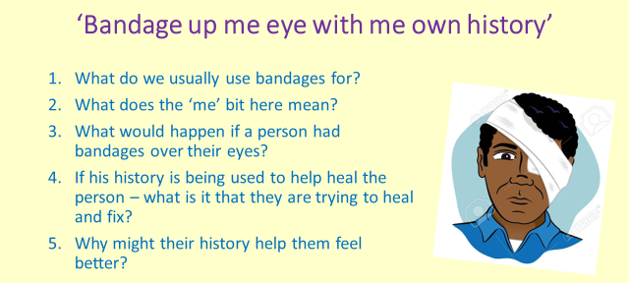
You need to copy the metaphor out and complete the accompanying questions for each one. This should be done on paper or in your book.

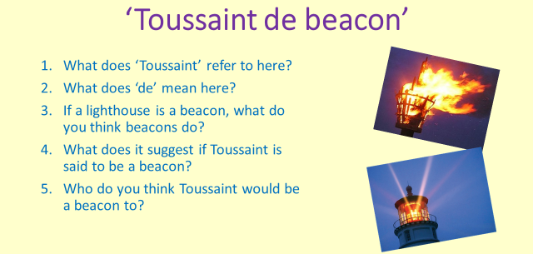
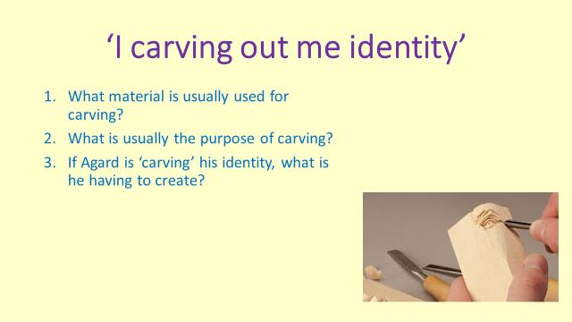
Using Personification:
Bellow are examples of personification taken from John Agard’s poem.
You need to copy the quote out and complete the accompanying questions for each one. This should be done on paper or in your book.
