Year 8 Shadow Curriculum
Dystopias (‘Noughts and Crosses’ by Malorie Blackman)

If you have recently read… | 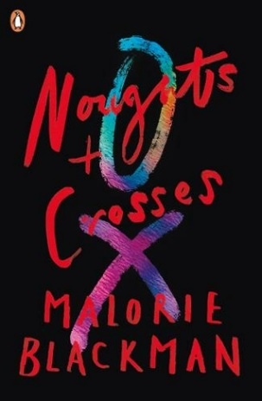  Then complete task…
Callum struggles in Mr Jason’s history lesson, which seems to be all about Crosses | Task 1
The bomb at the Dundale shopping centre | Task 2
Ryan McGregor’s trial | Task 3
The kidnap | Task 4
The end (no spoilers here!) | Task 5

Task 1: History Lessons and ‘Checking Out Me History’ by John Agard.
- In the ‘Accompanying Resource 1’ document you will find the poem and the accompanying worksheet to go through this poem and analyse.
- Create a leaflet with information about the historical figures Agard wants us to know about (Toussaint L’Ouverture, Nanny de Maroon, Shaka Zulu, Caribs and Arawaks and Mary Seacole)

Task 2: Militias
In the ‘Accompanying Resource 2’ document you will find an article on a real life militia and some accompanying tasks to complete

Task 3: Ryan McGregor’s Trial
Complete the task in the ‘Accompanying Resource 3’ document

Task 4: Sephy’s Kidnap – Dramatic Vocab
- Complete the table below. You will need to use a thesaurus or thesaurus.com to find synonyms for each word. From your selection of synonyms choose the best one.
- Learn the spellings and definitions of these synonyms
- Re-write the kidnap scene from another character’s point of view, trying to use as many of these new, adventurous word choices as you can

Good | Better | Best

Task 5: The end – Final Tasks
- Watch the first episode of Noughts + Crosses on ClickView or BBC iPlayer and copy and complete the table below:

Character | How I thought they were based on the book | How they were presented in the episode

OR
- Watch ‘The Help’ on ClickView.
- Create an advert which one of the women in this film could put in a magazine or shop window asking for someone to work in their home. Think about the rules the help would have to follow and the jobs they would do
- Write a series of diary entries from the perspective of a black hired help during this time. Use your research to help you. You could present these in an interesting and unique way if you wish
OR
- Imagine you are creating a new film version of ‘Noughts and Crosses’. Create a movie poster, cast the actors you would want to play the roles and explain any changes you would make to the story to help it suit a film.
OR
- Design a new front and back cover for the story, including blurb

