A Slightly different starting of Component 1

**Component 1**

**Resource Pack**

**Performance / Design Candidates**

**40%**

**EDUQAS GCSE Drama**

**2021_22**

**Contents**

* Overview of Component 1 (40% examined in December 2020)
* 2020 Stimuli
* Our Practitioners/ Styles
* Rehearsal Techniques
* Portfolio of supporting evidence
* Marking Criteria for supporting evidence and performance
* Evaluation
* Marking Criteria for Evaluation
* Examination Paperwork
* Support Material for Portfolio

Week 1

**Overview**

**Practical Component 1**

**To my dearest 20201 Year 11s**

I am hopeful that when we come to perform/ design your Component 1 exam performances (November/ December 2021) all will be back to normal – but you are going to do this first “initial response/ chose a Practitioner part on your own.

Do not worry – we are just going to spend this week coming up with ideas, researching and letting your creative thoughts go!!

Usually you would be put into groups of between **2** and **5** performing candidates and a design student who will be responsible for Lighting design or Sound design.

The timings of the piece are based on the number of students in the group:

* **Group of two actors: 5-10 minutes**
* **Group of three actors: 7-12 minutes**
* **Group of four actors: 9-14 minutes**
* **Group of five actors: 11-16 minutes**

Any hoo you will select **ONE** stimulus and **ONE** Style/practitioner to base your piece on.

**So Task 1 –**

**look / listen to both these stimuli. As you look / listen jot down everything that comes into your head. There are NO WRONG answers. Mind Map/ draw/ doodle/ brain storm etc etc**

**1.**

Because…it all decays! All your precious memories…everything you are…everything you think you are…you cannot hang onto it …it fades …until there is just a vague smudge of what you were’.

(100 – Imaginary Body)

**2. Stars in their eyes**

They'll be making sure you stay amused  
They'll fill you up with drugs and booze  
Maybe you'll make the evening news

And when you're tripping over your dreams  
They'll keep you down by any means  
And by the end of the night you'll be stifling your screams  
Since you became a VIPerson  
It's like your problems have all worsened

Your paranoia casts aspersions  
On the truths you know  
And they'll just put you in the spotlight  
And hope that you'll do alright

Or maybe not  
Now why do you wanna go and put starz in their eyes?  
Why do you wanna go and put starz in their eyes?

So why do you wanna go and put starz in their eyes?  
Now why do you wanna go and put starz in their eyes?  
Starz in their eyes?  
Remember they said you'd show them all  
Emphasise the rise but not the fall  
And now you're playing a shopping mall  
Your mum and dad they can't believe  
What you appear to have achieved  
While the rest of these users

Are just laughing in their sleeves  
Since you became a VIPerson  
It's like your problems have all worsened

Your paranoia casts aspersions  
On the truths you know  
And now the tabloids use your face  
To document your fall from grace

And then they'll tell you that  
That's just the way it goes  
That's just the way it goes  
Now why do you wanna go

And put starz in their eyes?  
It's the same old story well  
But they just didn't realise  
And it's a long way to come from the dog  
And duck karaoke machine

And Saturday night's drunken dreams  
Now why do you wanna go and put starz in their eyes?  
It's the same old story well they just didn't realise  
And it's a long way to come  
From your private bedroom dance routines  
And Saturday night's drunken dreams  
Now why do you wanna go and put starz in their eyes?

Why do you wanna go and put starz in their eyes?  
So why do you wanna go and put starz in their eyes?  
Now why do you wanna go and put starz in their eyes?  
Starz in their eyes?  
Now why do you wanna go and put starz in their eyes?  
It's the same old story well they just didn't realise  
And it's a long way to come

From the dog and duck karaoke machine  
And Saturday night's drunken dreams  
(When I grow up im going to be famous)  
Behind the steel barrier sequins and glitter  
Five inch heels still knee deep in the litter  
Each of them a bitter bullshitter  
Wrapped up in the cloak of fake glamour  
Getting lost in the camera  
Well footprints are fools gold

Diamonds crusts on their one off plimsolls  
So little time for these one off arseholes  
Rigour mortis Ken and Barbie dolls  
A pair of big shades and a push up bra  
It's such a short gap  
Between the gutter and stars  
But you've come a long way

From the place that you started

So why'd you wanna go and get so down hearted  
Welcome to the kingdom of the blagger  
Uncutting you nose clean coat in you bladder  
A whole lot happier a whole lot sadder  
Used to be satisfied but now you feel like Mick Jagger  
(Jagger, Jagger, Jagger, Jagger, Jagger, )

Now why do you wanna go and put starz in their eyes?  
It's the same old story but they just didn't realise  
And it's a long way to come  
From the dog and duck karaoke machine  
And Saturday night's drunken dreams  
Now why do you wanna go and put starz in their eyes?  
It's the same old story well they just didn't realise  
And it's a long way to come  
From your private bedroom dance routines  
And Saturday night's drunken dreams

Source: Musixmat

Supporting Evidence

You must create a portfolio of supporting evidence. This portfolio must show details of how the piece has been **created** and **developed to communicate meaning to an audience**.

**1. how ideas have been researched, created and developed in response to the chosen Stimulus**

**2. how ideas from the chosen practitioner/genre have been incorporated in the piece to communicate meaning**

**3. how the ideas have been developed, amended and refined during the development of the devised piece.**

**Evaluation**

You must evaluate the final performance. Your evaluation will be written under

supervised conditions. You will have **1 hour 30 minutes** to complete it.

You must complete the following **three** main sections:

**1. An analysis and evaluation of your interpretation of character/role in your**

**final performance**

**2. An analysis and evaluation of how either your own performance skills (i.e. voice, movement, interaction) contributed to the effectiveness of the final performance**

**3. An analysis and evaluation of your individual contribution to the final performance.**

Week 2

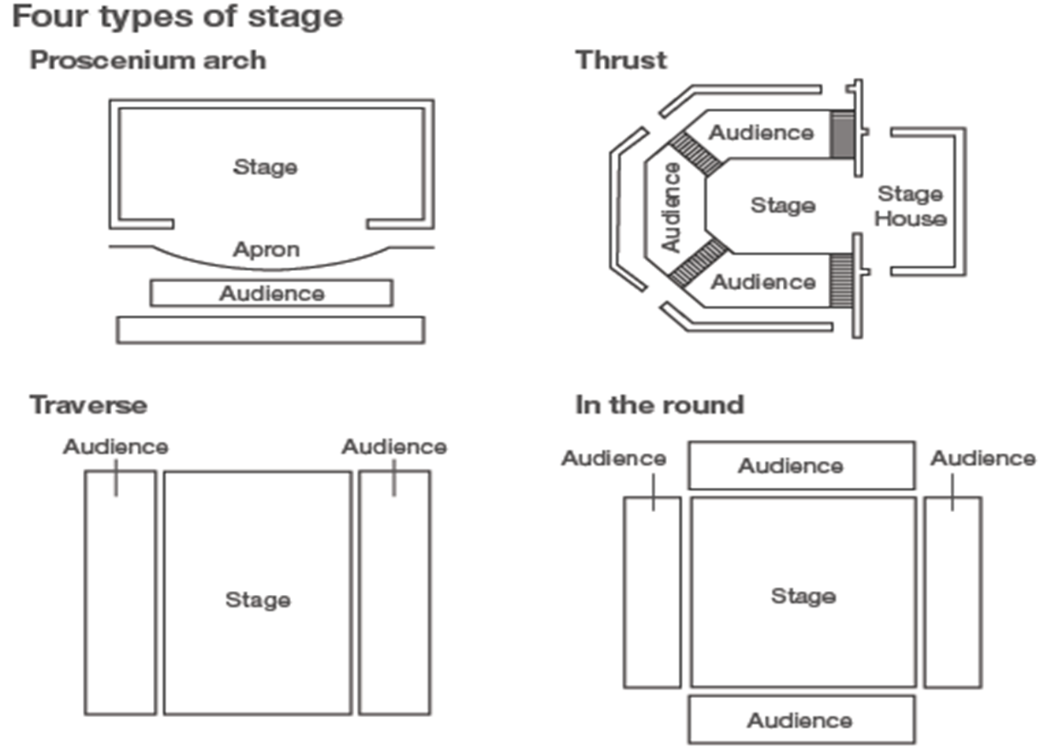**Stages?**

**Brecht/ Epic Theatre**

* Select **One** clear **political message** to your audience (Don’t try and put more than one in for your audience to think about, it dilutes the message)
* The message must be something the audience can relate to in today’s society
* Minimal costume/set/props (never want the audience to be to immersed in the action)
* Characters multi-rolling. The audience must always be aware they are watching actors
* Direct address to the audience
* Humour (SPASS to break any tension)
* Placards

|  |
| --- |
| **Episodic Nature -** which means they stand alone and are constructed in small chunks |
| **Multi role –** an actor takes on a few roles in the play |
| **Split role –** two actors play the same role in the play |
| **Direct address to audience –** either in or out of role |
| **Narrator -** audience are constantly reminded that they’re watching a piece of theatre. |
| **Symbolism to suggest location** |
| **Symbolic Props -** A suitcase might become a desk, or a car door or a bomb. |
| **Shock tactics –** make the audience think and not allow them to wallow in emotion |
| **Protest: Placards / Songs / Newspapers** |
| **Screen and Power points** |
| **Political message –** relevant to audience (helping the decision process) |
| **Actors that step out of role comment on the character in the third person** |
| **Actors speaking the stage directions** |
| **Alienation effect –** audience not able to have emotional involvement, need to feel informed |
| **Song and Dance –** reminds audience they are watching a performance |
| **Freeze Frames** |



**Stanislavski**

Stanislavski viewed theatre as a means of artistically expressing things, and that the audience’s role was to ‘look in’ on action on the stage. He favoured the idea of the ‘fourth wall’, which separated the audience and the actors, to re-create total **realism** on the stage. The aim is to be a real as possible.

**Stanislavski's techniques (Internal)**

• Concentration of attention

• Relaxation of muscles

• Units and objectives

• Emotional memory

• The magic ‘if’

• Feeling of truth

**Stanislavski's techniques (External)**

• Tempo-rhythm and movement

• Diction and singing

• Intonation and pauses

• Restraint and control

• Accentuation

• Making the body expressive

• Naturalistic set, costume, lighting and sound



**Physical theatre**

For dramatic effects, Physical Theatre uses bodies and faces rather than using props, scenery or even sound effects at times. It does not have to have an educational or political message.

* Physicality of objects
* Use of sound/instruments
* Use of objects in a symbolic manner, e.g. sticks
* Animals, e.g. Two teenagers who are discussing another girl, in a rather nasty
* Manner, take on the characteristics of two cats.
* Use of ritual
* Masks
* Fast forward / slow motion
* Using a piece of dialogue from a play and presenting it as a piece of movement in order to convey meaning
* Use of puppets and dolls
* Dream sequences
* Disjointed structure
* Minimalistic set
* 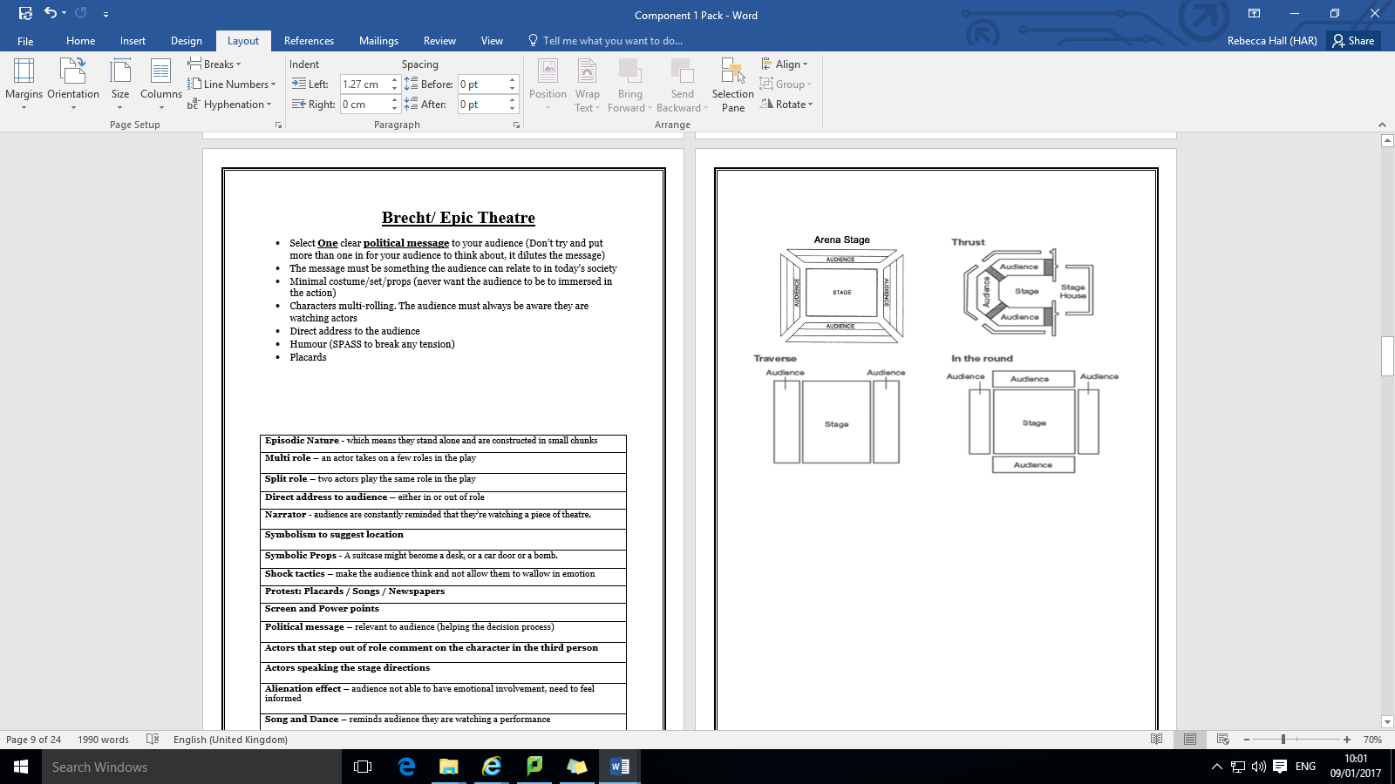****Use of lighting

**Portfolio and supportive evidence**

1. **Ideas have been researched, created and developed in response to the chosen stimulus**

*What was your stimulus?*

*What were your initial thoughts surrounding it?*

*How did you create an idea from it?*

*What did you have to research to develop this idea further?*

1. **Ideas from the chosen practitioner/genre have been incorporated in the piece to communicate meaning**

*What style/practitioner did you chose after gathering ideas from your stimulus?*

*Why did it complement the stimulus/idea?*

*What techniques from this style/practitioner did you include?*

*How did this help communicate meaning to your audience?*

1. **Ideas have been developed, amended and refined during the development of the devised piece.**

*How did your piece develop?*

*What was your specific contributions to the overall creation of the piece?*

*What changed and why?*

*What rehearsal techniques did you use? (See page 13)*

*How did they help develop/improve the piece?*

**Help for Portfolio**

You can answer these things in three ways:

For each stage, you must provide ***illustrative material*** (as listed below) and a **commentary**, which may include annotations on the illustrative material.

The commentary for each stage should be approximately 250 words and total **750 to 900** words for the complete portfolio.

Candidates may also produce their portfolio as a suitably edited blog

**(between 750 and 900 words)**, as an audio-visual recording, including the illustrative material, or an audio commentary on the illustrative material.

Audio and audio-visual portfolios should be between **six** and **nine** minutes.

***Illustrative material***

**• sketches**

**• photographs**

**• ground plans**

**• diagrams**

**• storyboards**

**• mood boards**

**• sections of script**

**• digital media, including brief recordings of sections of a rehearsal or material appropriate to the skill area, e.g., sound clips. These should be no longer than one minute.**

The portfolio is intended to **highlight** the creative process

of devising the piece of theatre.

It is not intended to be a full record of the

rehearsal period.

You should choose carefully the evidence which

**best** supports the **three** significant stages of development of their piece of theatre.

**Rehearsal Techniques**

**Hot-seating –** a technique to gain a deeper understanding of a character or role. An

individual sits in a chair designated as the 'hot-seat'. The rest of the group asks the person

in the 'hot-seat' relevant questions about their feelings, thoughts, actions or circumstances.

The person in the 'hot-seat' answers the questions in role or as they think the character

they are playing would answer.

**Improvisation –** to perform quickly in response to something, or to act without previous planning. A distinction is made between spontaneous and prepared improvisation. The former relating to making up a role as you go along and the latter relating to working within a previously agreed structure of ideas and roles.

**Role reversal –** during an improvisation or rehearsal for a scene, the actors reverse the roles/characters they are portraying in order to gain a different view or understanding of

their own role.

**Role transfer –** one person begins acting out a character or role which they pass on to another person to develop, imitate or alter.

**Sculpting –** a technique used in conjunction with still-image work developed by Augusto Boal into Image Theatre. A group is divided into 'sculptors' and 'sculptees'. There are normally only one or two sculptors who create a sculpture by moving the 'sculptees' into

different positions and stances in response to a stimulus or idea.

**Ranking –** an exercise used to explore the status of roles of character. Each performer

'ranks' their role within defined terms, such as social standing or economic prosperity, by

assigning a number between one and ten. One is the lowest status and ten the highest.

The exercise can be repeated at any time to determine whether the status of the roles may

have altered during the course of the drama.

**Forum theatre –** a way of working developed by Augusto Boal. Participants sit or stand in a large circle to observe an improvisation usually started by two of their number. The improvisation will be based on a given situation or set of circumstances agreed by the group at the outset. At any point in the proceedings, the performers can stop the action and ask the rest of the group who are sitting around in a circle (The Forum) for help or advice about what to do or say next. The improvisation may continue or The Forum can stop the action if they think that what is happening is inappropriate or believe that the drama should be taken in a different direction. They can either offer advice, decide to take over from one of

the performers or join in by taking on another role.

**Collage –** putting together a 'patchwork' of dialogue, sounds and visual images from

different contexts to provide an impressionistic presentation.

**Transporting a character –** a technique to explore how a character or role might react or

behave in a different situation, location or time. For example, an intimate bedroom scene

between two lovers is 'transported' to a crowded supermarket.

**Day in the Life –** Mime a typical day in the life of the character you are playing.

**Speed Run –** Run the scene extremely quickly and then extremely slowly. How does it change the meaning of the piece? Which we best suited to your scene?

**Monologues –** Write a monologues based on one of the stimuli how does this give you an idea for your piece.

**Run through –** Running through the performance from beginning to end and gaining feedback

**Washing line –** Getting Post its and writing all of the scenes on them. Using a wall, play around with the structure of your piece. How could it effect the overall impact? How will it suit your style/practitioner?

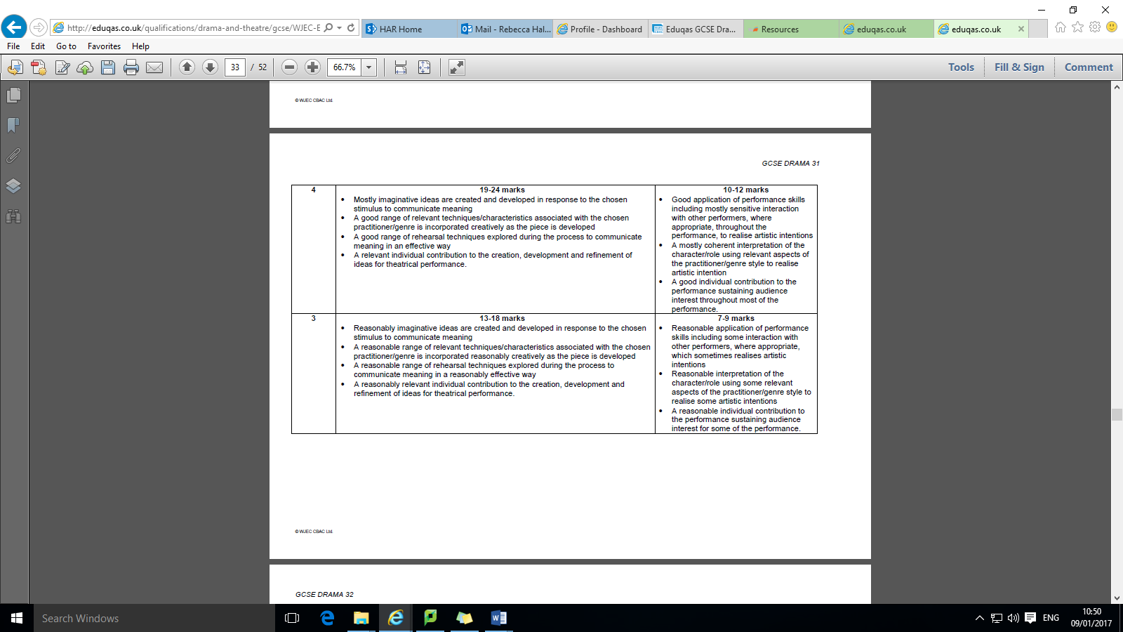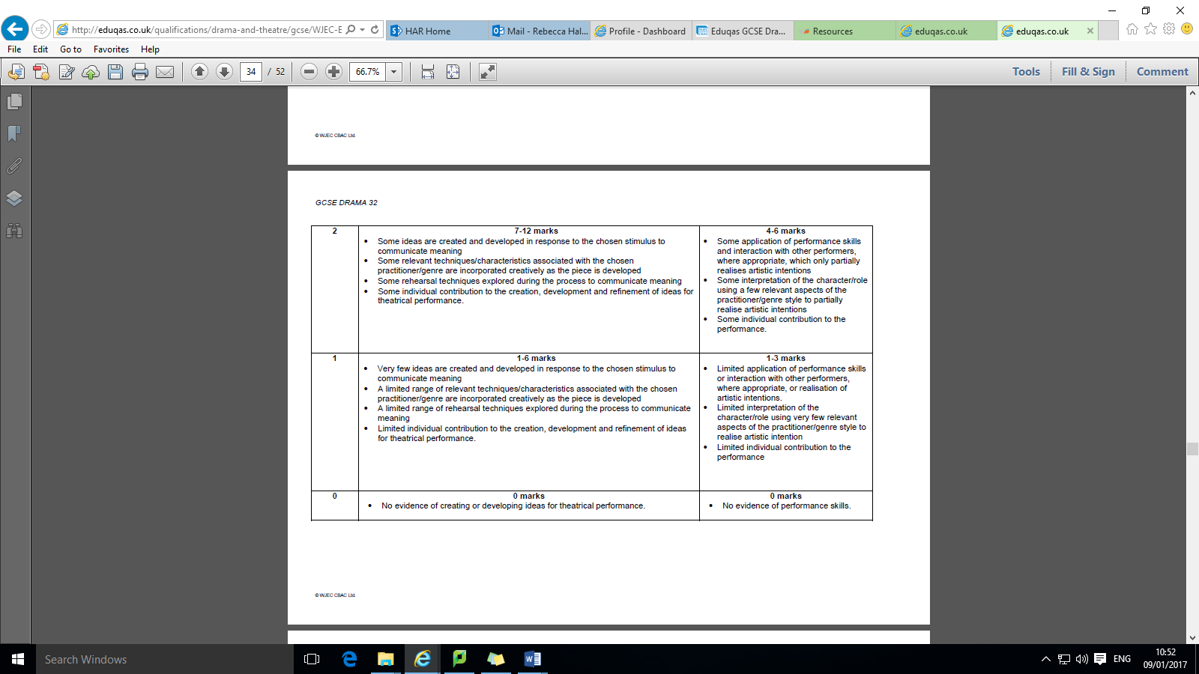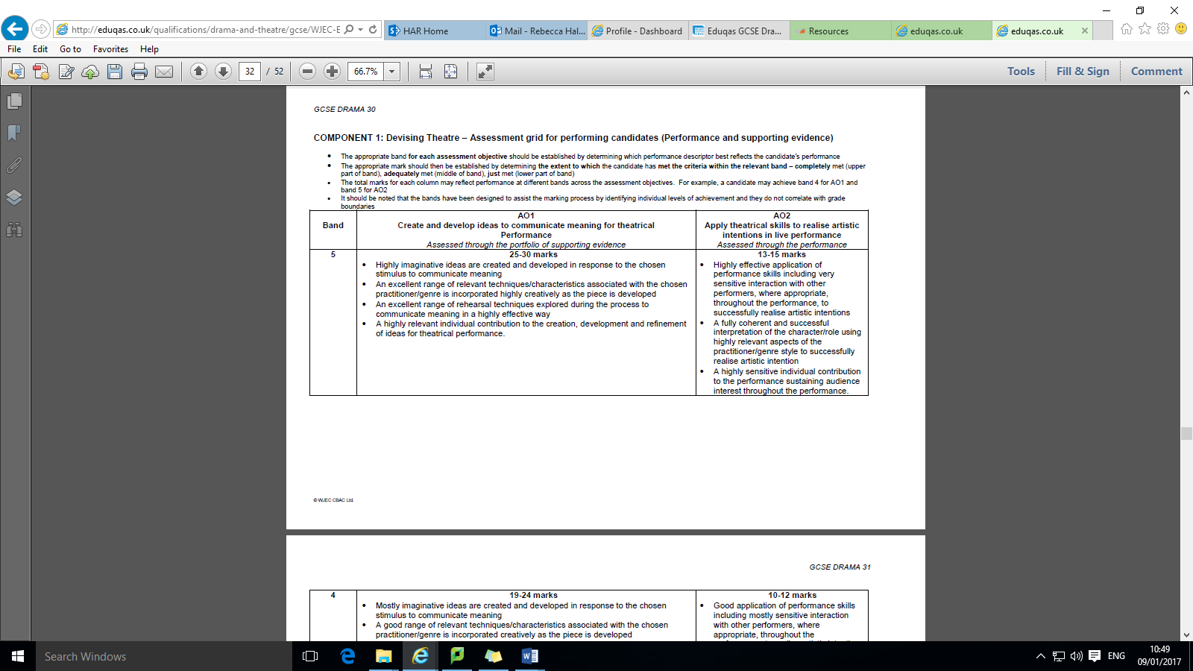

**Evaluation**

The Evaluation takes place after your performance. It is asking you to reflect on three key areas. You have 90 minutes to complete it and it is conducted in class under the supervision of your teacher.

You may take in **two** pages of notes. They must be in **bullet points**.

* **Tips direct from the Exam Board**

• ***Link*** to your chosen style: practitioner or genre

• Always give reasons

• Always give good examples

• Refer to individual contribution

• Include a few quotes from the devised scene.

**The three areas of evaluation are:**

1. Analyse and evaluate your **interpretation** of character/role in the final performance.
2. Analyse and evaluate **how** your own **performance skills** contributed to the effectiveness of the final performance
3. Analyse and evaluate your **individual** contribution to the final performance, including how effectively you fulfilled your initial aims and objectives (referring back to stimulus and practitioner/genre).

**Helpful Key words for Evaluation**

**General words, which help evaluation in all subjects**

• realised

• decided

• could

• should

• would

• Frequently

• usually

• because

• In order to

• However

**Frames for evaluation**

• It would be better if…

• I could improve by…

• If you…you would…

• When you…you should…

• It is better because…

• This means that…

• In order to…

• Changing the…would…

• What worked quite well was...

• We chose to...

**Highly subject-specific (often nouns)**

• character

• performance

• expression

• physical

• movement

• gesture

• script

• interaction

**Subject-specific but not uniquely**

**(often adjectives and adverbs)**

• motivation

• consistent

• controlled

• balanced

• coordinated

• considered

• relevant

• contrasting

• dramatic

• effective

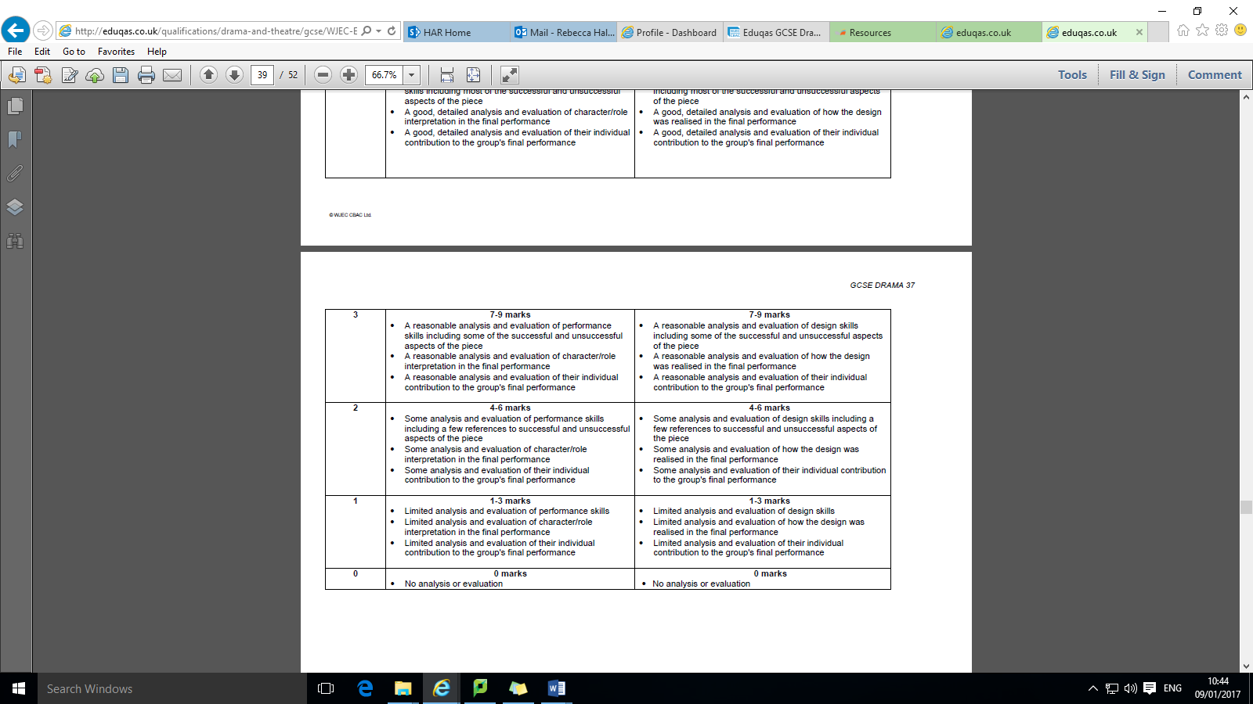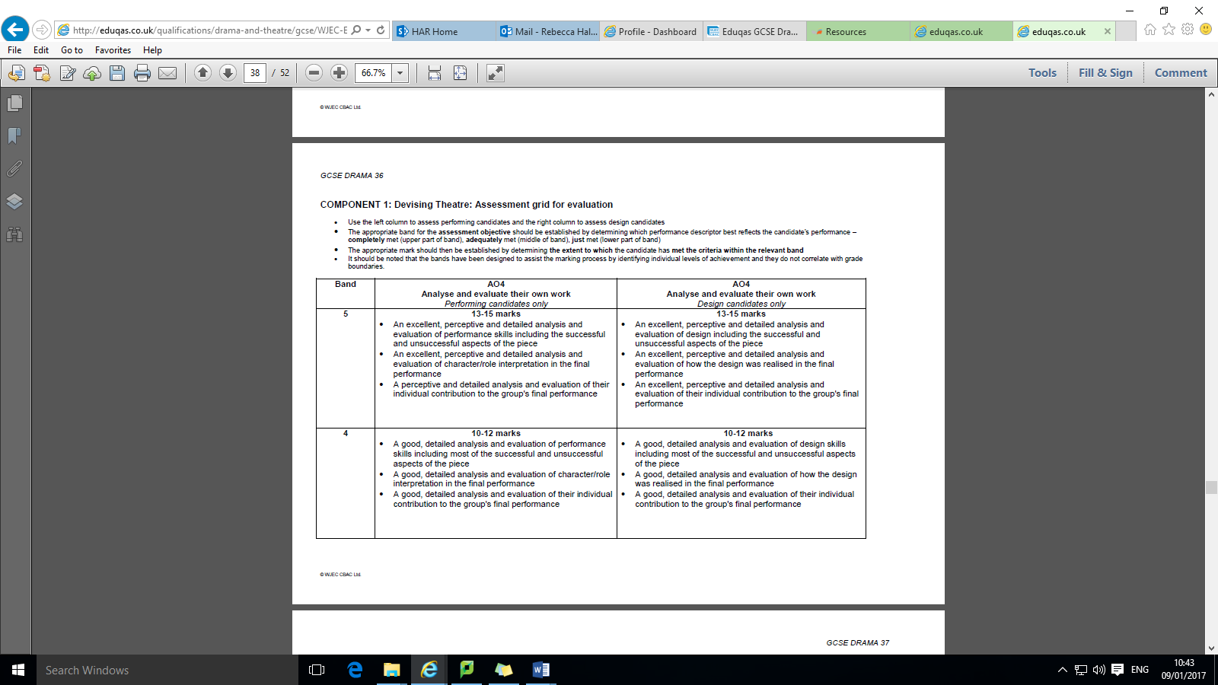



**Component 1 Devising Theatre**

GCSE Drama

**Centre Name………………………………….............Centre Number……………………………………….**

**Candidate Name……………………………………. Candidate Number……………………………………**

**Skill (acting or design)……………………………. Title of Piece…………………………………………..**

**Practitioner/genre………………………………….. Stimulus……………………………………………….**

***NOTICE TO CANDIDATE***

The work you submit for assessment must be your own. If you copy from someone else, allow another candidate to copy from you, or if you cheat in any other way, you may be disqualified from at least the subject concerned.

***DECLARATION BY CANDIDATE***

I have read and understood the ***Notice to Candidate*** (above). I have produced the attached work without assistance other than that which my teacher has explained is acceptable within the specification.

Candidate signature: …………………………………..……........ Date:…………………………

***DECLARATION BY TEACHER***

I certify that the work of the above candidate has been carried out under the conditions required by WJEC and that, to the best of my knowledge and belief; it has been produced by his/her own efforts. I have monitored the work in development at least three times.

Teacher signature: …………………………………..……........ ...Date:……………………….

|  |  |  |  |  |  |  |  |  |
| --- | --- | --- | --- | --- | --- | --- | --- | --- |
| **AO1** | | | **AO2** | | | | **AO4** | |
| **Create and develop ideas to communicate meaning for theatrical performance** | | | **Apply theatrical skills to realise artistic intentions in live performance** | | | | **Analyse and evaluate their own work** | |
| *Supporting evidence* | | | *Performance/design* | | | | *Evaluation* | |
| Teacher | Moderator | | Teacher | | | Moderator | Teacher | Moderator |
| /30 | /30 | | /15 | | | /15 | /15 | /15 |
| **Length of piece** | |  | | | **Penalties** (if applicable – see page 21 of specification) | |  | |
| **Total mark** (Teacher) | | | | | | | /60 | |
| **Teacher comment** (optional) | | | | | | | | |
| **Total mark** (moderator) | | | | | | | /60 | |
| **Moderator Comment** | | | | | | | | |
| Moderator Signature | | | |  | | | | |
| Date | | | |  | | | | |