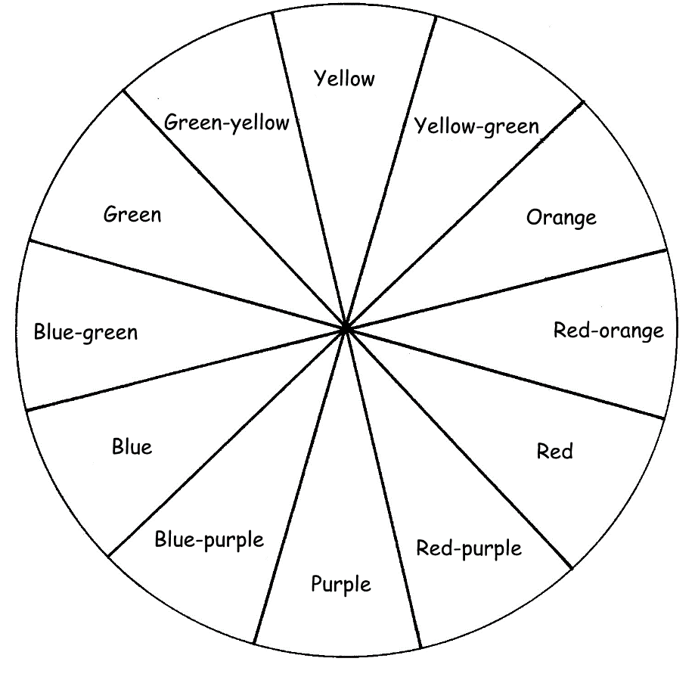

**Cool**

**Colours**

**Warm**

**Colours**

**Analogous Colours** **are:**

……………………………………………………………………………………………………………………………………………………………….

……………………………………………………………………………………………………………………………………………………………...

**Complementary Colours are**: ……………………………………………………………………………………………………………………………………………………………….

……………………………………………………………………………………………………………………………………………………………..

**Tertiary Colours are**: (Give and example)

……………………………………………………………………………………………………………………………………………………………….

=

=

**+**

**+**

**+**

**=**

**Green**

**Orange**

**Violet**

Secondary colours are ………………………………..

…………………………………………………………………………………………………………………………………………

**Secondary Colours**

**Colour Theory**

Colour in the colour wheel. You may have to blend 2 colours together to get the colour you need eg: yellow– green blend green and yellow together