|  |
| --- |
|  |
|  |
|  |
|  |
|  |
|  |
|  |
|  |
|  |
|  |
|  |
|  |
|  |
|  |
|  |
|  |
|  |
|  |
|  |
|  |
|  |
|  |
|  |
|  |
|  |
|  |
|  |
|  |
|  |
|  |
|  |
|  |
|  |
|  |

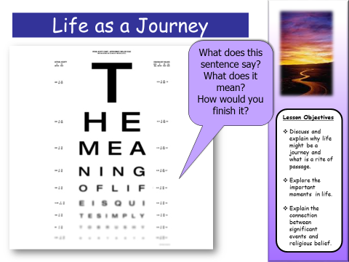

|  |
| --- |
|  |

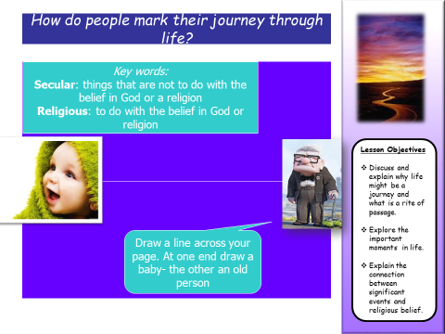 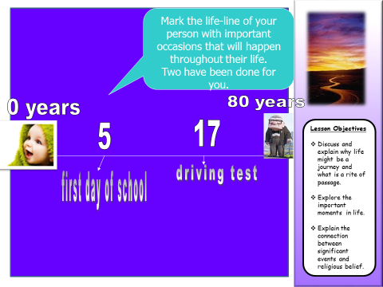

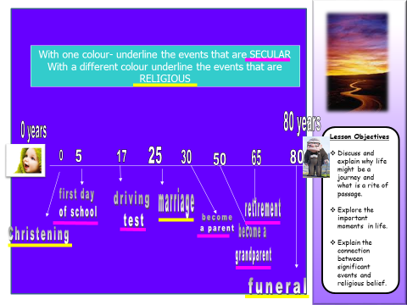

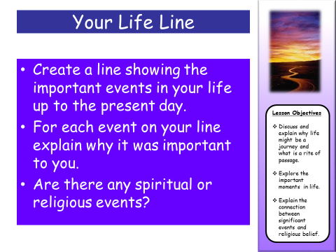

|  |  |  |
| --- | --- | --- |
| An important event in my life. | What impact did it have on me?  How did it change me? | Why is it so important? |
|  |  |  |

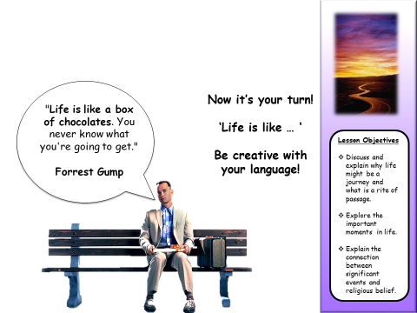

|  |
| --- |
|  |
|  |
|  |
|  |
|  |
|  |
|  |
|  |
|  |
|  |
|  |
|  |
|  |
|  |
|  |
|  |
|  |
|  |

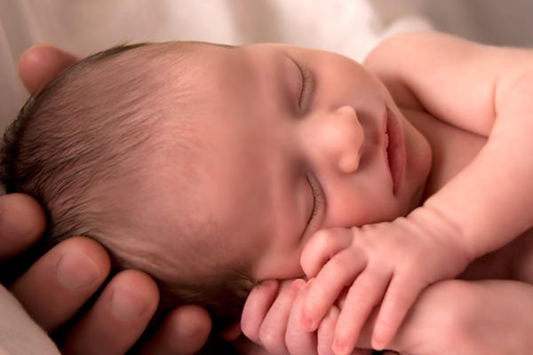

|  |
| --- |
|  |
|  |
|  |
|  |
|  |
|  |
|  |
|  |
|  |
|  |
|  |
|  |
|  |
|  |
|  |
|  |
|  |
|  |

|  |
| --- |
|  |
|  |
|  |
|  |
|  |
|  |
|  |
|  |
|  |
|  |
|  |
|  |
|  |
|  |
|  |
|  |
|  |
|  |
|  |
|  |
|  |
|  |
|  |
|  |
|  |
|  |
|  |
|  |
|  |
|  |
|  |
|  |
|  |
|  |

**Muslim Birth Celebration**

|  |  |  |
| --- | --- | --- |
| 1 | 2 | 3 |
|  |  |  |
| 4 | 5 | 6 |
|  |  |  |



  
  
  
  
  
  
  
  
  
  
  
  
  
  
  
  
  
  
  
  
  
  
  
  
  
  
  
  
  
  
  
  
  
  
  
  

