NAME
TUTOR GROUP
LESSON DAY AND TIME
TEACHER

ISLAM
Beliefs and Practices

Intro to islam
LEARNING TARGETS
1 | I will know what Muslims believe.
2 | I will understand the Five Pillars of Islam.
3 | I will know the difference between Sunni and Shia.
At the start of the topic, draw a line on the confidenceometer to show how confident you are about the subject matter. At the end of the topic draw another line to show how confident you are after the lessons on the topic. Don’t forget to label your lines “1” and “2”.
VERY CONFIDENT
NO CONFIDENCE
YOUR QUESTIONS
Think of three questions about this topic that you would like answered by the end. Write them down.
1

2

3

Notes, ideas, scribbles, thoughts and doodles
Things That I Already Know About Islam

Some key concepts…

ISLAM FACTS

1
2
3
4

In Britain today there are nearly ______________ Muslims, making up __________ % of the population.
Up until the __________ twentieth century there were very ____________ Muslims in the __________. From the ___________ onwards significant numbers of __________ came from the former __________, taking up the offer of __________ in post Second _______________ Britain.
The 2011 ___________ shows that Britain is home to one of the most __________ Muslim communities in the ___________. The majority of British Muslims are __________ (95%) with remaining 5% coming from the __________ tradition.
ISLAM IN BRITAIN

Key Words

STICK TEST SHEET HERE

My score
Corrections
Re-test score

THE LIFE OF MUHAMMAD
Key points from the video.

Notes, ideas, scribbles, thoughts and doodles

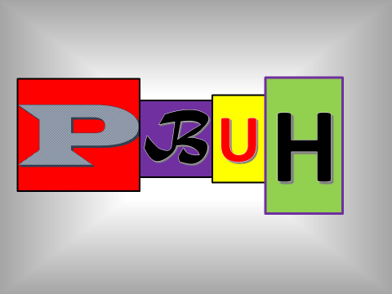

Challenge TWO
THE VAGUELY IMPOSSIBLE INFORMATION GRID
You must have at least five facts about the life of Muhammad in the grid. But beware – the number of facts required may well increase!
(Copy the end result into your grid).
YOUR FINAL PARAGRAPH
Notes, ideas, scribbles, thoughts and doodles
Notes, ideas, scribbles, thoughts and doodles
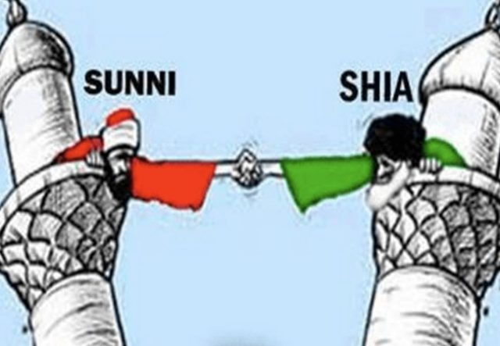
What does the video clip tell you?
Notes, ideas, scribbles, thoughts and doodles
Notes, ideas, scribbles, thoughts and doodles

CHALLENGE THREE
Word Search
A | L | L | M | E | R | C | I | F | U | L | O | C
L | B | A | E | R | L | I | G | H | T | W | N | R
L | T | S | F | U | W | I | F | I | R | S | T | E
C | R | U | O | P | A | G | P | T | S | A | L | A
O | U | O | H | L | G | R | E | A | T | E | S | T
M | T | I | I | O | U | N | R | M | O | G | O | O
P | H | R | D | K | A | T | F | M | H | N | O | R
A | E | O | D | N | R | R | E | H | A | I | R | D
S | M | T | E | I | D | D | C | R | S | V | E | R
S | E | C | N | T | I | S | T | E | U | O | R | S
I | R | I | Y | U | A | L | Y | N | W | L | I | H
O | P | V | G | E | N | E | T | S | I | B | E | B
N | U | G | O | O | D | U | G | D | S | A | B | R
A | S | E | F | I | L | F | O | R | E | V | I | G
T | N | E | M | E | L | C | T | P | E | A | C | E
E | F | O | R | G | I | V | E | R | M | E | O | D
Muslims have attributed 99 names to Allah. Can you find any of them in the grid?
What do they tell you about Allah?

Notes, ideas, scribbles, thoughts and doodles

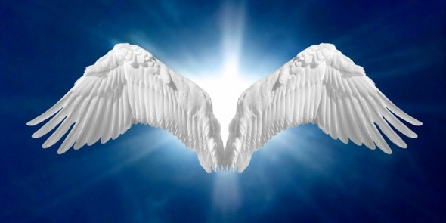
ANGELS
Jibril

Izra’il

Mika’il

Israfil

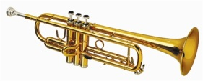 | 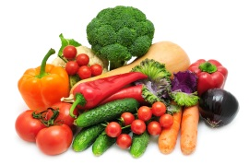 |  | 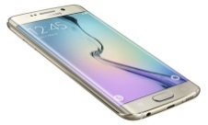 |  | 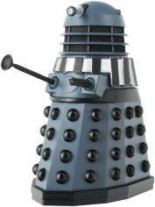
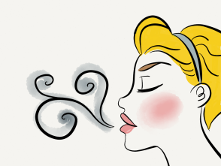 | 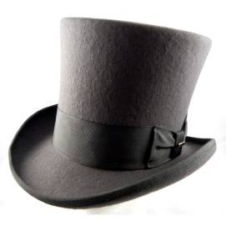 |  |  | 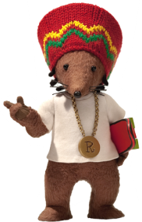

Your Guide To The Afterlife…

5 Things That Are Important To Me
 | Belief | Associated Action
1
2
3
4
5
The five pillars of faith
How to do…
WUDU
1
2
3
4
5
6
7

Rak’ahs Dance!

Notes, ideas, scribbles, thoughts and doodles
Hajj

CHALLENGE FOUR
THE FIVE PILLARS VAGUELY IMPOSSIBLE INFORMATION GRID

