|  |
| --- |
|  |
|  |
|  |
|  |

**RE TERM 6**

**YEAR 7**

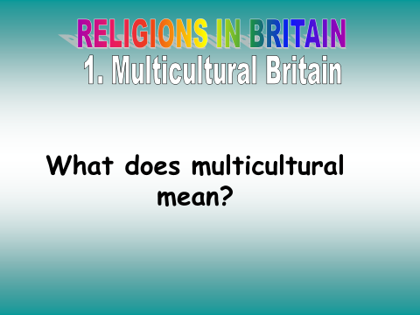

|  |  |
| --- | --- |
| MULTICULTURALISM | |
| ADVANTAGES | DISADVANTAGES |
|  |  |

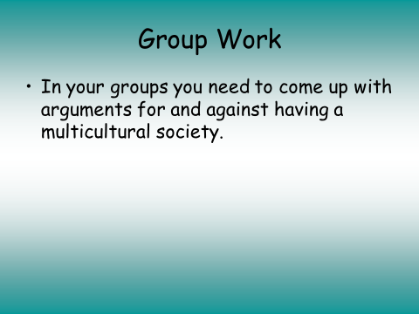

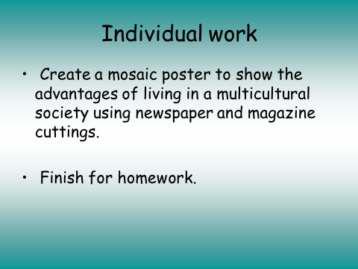

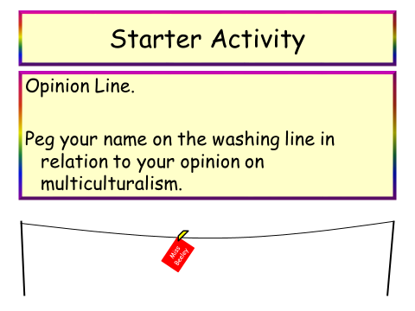

|  |  |
| --- | --- |
| Myths | Facts |
|  |  |

* Design a flag to represent multicultural Britain.

Find a newspaper article about anything linked with multicultural Britain.

Stick it into your book and write a paragraph about whether you agree wit the article.

It could be an example of multiculturalism or about racism or immigration.

|  |
| --- |
|  |
|  |
|  |
|  |
|  |
|  |
|  |
|  |
|  |
|  |
|  |
|  |
|  |
|  |
|  |
|  |
|  |
|  |
|  |
|  |
|  |
|  |
|  |
|  |
|  |
|  |
|  |
|  |
|  |
|  |
|  |
|  |
|  |
|  |
|  |
|  |
|  |

