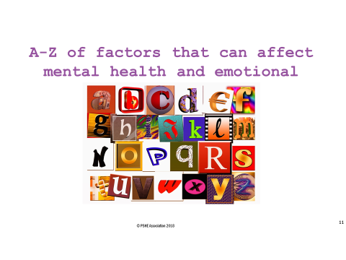

Kaz is 13 years old and goes to a school similar to ours. This chart shows how Kaz’s emotional wellbeing changes throughout a typical day. What might affect the ‘ups and downs’ of Kaz’s wellbeing.

8am

9am

10am

11am

12pm

1pm

2pm

3pm

4pm

5pm

6pm

7pm

8pm

9pm

10pm

What might have improved Kaz’s wellbeing?

What might have caused Kaz’s wellbeing to change?

What strategies might Kaz have used to feel better?

What might Kaz be doing or thinking now?

What might cause this gradual decline in Kaz’s wellbeing?

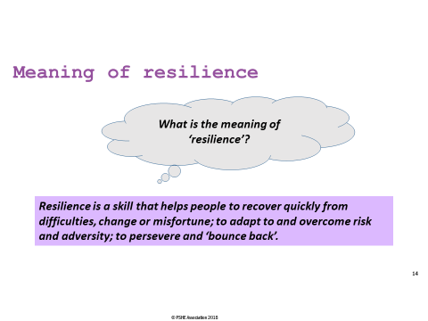

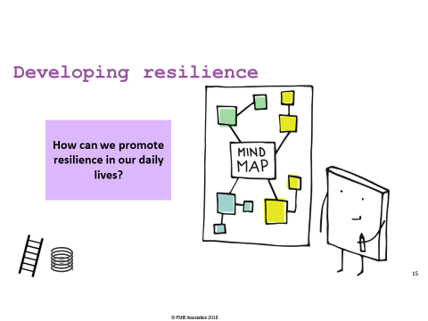

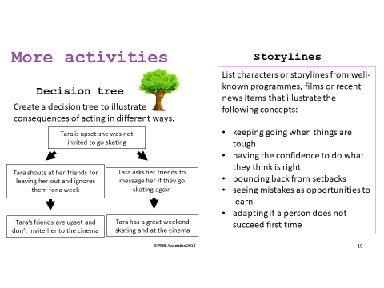

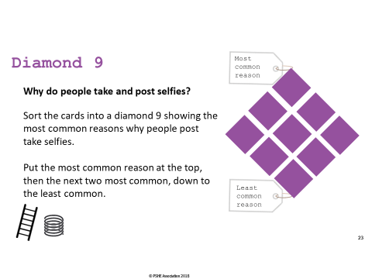
A digital day in the life of Taylor
To get attention, likes and
comments
Because it is fun and
creative
Because everybody else
does it
So everyone thinks they
look good
To show fun things they are
doing
To express their personality
and identity
To help them make new
friends
Because they are bored
To make other people
jealous

[
Cut up and organise into sets
]
7:30am

Taylor wakes up and starts to get ready for school. While eating breakfast, Taylor opens a picture sharing app and scrolls through mostly looking at pictures of celebrities, friends and cats. Taylor notices a favourite celebrity has posted a picture at a new film opening, and thinks “Wow! I could never look that good!”.
8:00am

On the way into school Taylor meets a friend on the bus and they take selfies and videos that they send to everyone in their friendship group. They are mostly just pulling silly faces and telling jokes. Some people send snaps back and they have a real laugh.
8:30am

Taylor goes to registration and some people snigger about the selfies they sent earlier. Two girls seem to be whispering behind Taylor’s back. Taylor starts to wonder if something they said or did was really embarrassing.
9:00am

In first lesson, Taylor is bored, so posts a new status under the desk with the hashtag #uglyboringteachers. The post gets 100 likes and 30 shares within five minutes.
10:30am

1:00pm

Its break time and Taylor is looking at a photo-sharing app again. Everyone else seems to be having such an amazing time. And everyone else looks so stunning and has so many more interesting things to post. Taylor takes a range of selfies, chooses the best one, adds a filter, crops it, then posts it.
Taylor briefly checks to see if there are any notifications on new posts. The selfie Taylor posted at break has had a few negative comments and hardly any likes. After a while Taylor deletes the photo and decides to skip lunch.
3:30pm

Taylor leaves school with a group of friends and they show each other their favourite videos online, including a new one by Taylor’s favourite band.
4:00pm

7:00pm

11:00pm

Taylor goes to an intensive exercise class for 45 minutes. The class is part of a ‘programme’ that’s recently been in the media a lot with loads of videos of celebrities doing the workouts because it gave them a ‘10/10 body’ in less than a month. Hopefully it will work the same for Taylor?
After a quick dinner with the family, Taylor spends a couple of hours playing an online game with players around the world. Taylor beats the others and gets the highest score. In the chatroom, the others all start accusing Taylor of using a cheat site. Someone starts referring to Taylor as “The_Chubby_Cheater” so Taylor logs off.
Taylor spends an hour checking all the social media sites, scrolling through news feeds, leaving comments and liking / sharing friends’ posts. Taylor eventually falls asleep, with phone in hand, just after midnight.

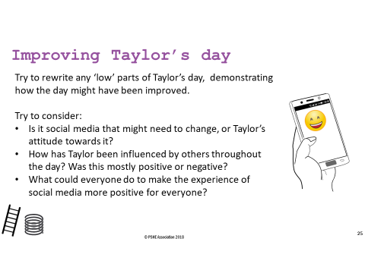
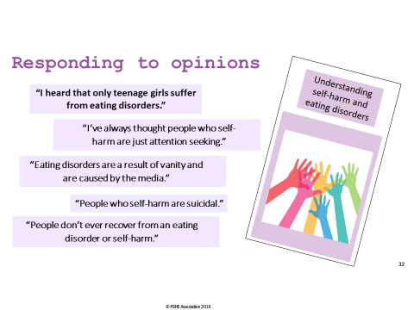

Part 1
Pete was feeling stressed about his exams but was coping well until there were problems at home. He didn’t feel able to manage everything that was going on for him at the time. Pete found himself becoming more disconnected from his friends and it felt easier to just keep quiet and out of everybody’s way.
Pete’s friend, Yasmin, had started to notice some changes in Pete’s behaviour. He wasn’t coming out with the rest of the group, and the types of clothes he wore had changed; even though it was the summer he was always in baggy, long sleeved jumpers. In school, he seemed to be really tired and easily distracted. She tried to ask him what was wrong, but he told her it was nothing, and got really angry and stormed off when she tried to ask more questions. Every time their teacher started talking about exams and revision, Pete’s mood seemed to get worse.

Part 2
As time went on, Yasmin became more worried about Pete. She spoke to their mutual friend, Dimitri, about her concerns:
Yasmin: “Have you noticed anything… different… about Pete recently?
Dimitri: “It’s Pete. He’s always been different!”
Yasmin: “No, really, I’m kind of worried about him. Don’t you think he’s been acting ‘off’ lately?”
Dimitri: “He’s probably a bit stressed about exams - we all are, aren’t we?”
Yasmin: “I think it’s more than that. He was really defensive when I asked him if he was OK.”
Dimitri: “Well that means he doesn’t want to talk about it Yasmin, so stop interfering.”
Yasmin: “I think maybe we should tell someone.”
Dimitri: “It’s really none of our business.”
Yasmin: “He’s our friend. Of course it’s our business. I think he might need some help.”
Dimitri: “Well there’s not much we can do, really, is there?”
Part 3
Yasmin wanted to talk to Pete about what was happening and let him know that she’d be there for him. First, she decided to get some advice from her Dad. She wanted to tell him her concerns and get support for herself before talking to Pete. After speaking to her Dad, Yasmin arranged to meet Pete after school.
At first, Pete was defensive and kept trying to change the topic, but when he realised Yasmin wasn’t going to let it go, he opened up about what had been happening, and told her about how difficult he was finding it to cope. He had started to use some really dangerous behaviours which he was finding it difficult to manage.
Yasmin was now even more worried about Pete, as his health seemed to be seriously declining, but at the end of the conversation he had begged Yasmin not to tell anyone else.

Now that Yasmin and
Dimitri have had their
discussion, what are the
consequences of each
person’s view?
Yasmin thinks they
should tell someone their
worries about Pete.
Dimitri thinks it is none
of their business and
they can’t do anything.
?
?

Speak to Pete to persuade him to get help, and/or speak to a trusted adult such as a parent or form tutor to get advice and support. | Pete is likely to continue using unhealthy coping strategies, and may increase using them as his current state of mind means he’s unlikely to be able to think clearly enough to get help for himself.
Pete would be referred to the school’s safeguarding lead, who is likely to speak to Pete and then contact his parents. | It may take a long time for anyone else to notice or raise concerns about Pete.
Pete is likely to be referred to his doctor or a counselling service. Child and Adolescent Mental Health  Services (CAMHS) are a part of the NHS who support young people with mental health concerns. | Pete may feel that nobody cares about him as no-one has noticed he is struggling. This may make things worse.
Pete could be supported through specialised care and learn techniques to manage his unhealthy coping strategies. | Pete risks developing further, potentially serious, physical health consequences related to the unhealthy coping strategies he is using.

