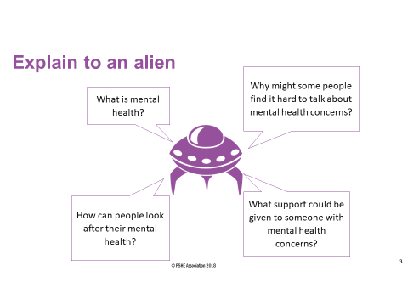

|  |
| --- |
|  |
|  |
|  |
|  |
|  |
|  |
|  |
|  |
|  |
|  |
|  |
|  |
|  |
|  |
|  |
|  |
|  |
|  |
|  |
|  |
|  |
|  |
|  |
|  |

|  |
| --- |
| Your definition of mental health |
|  |

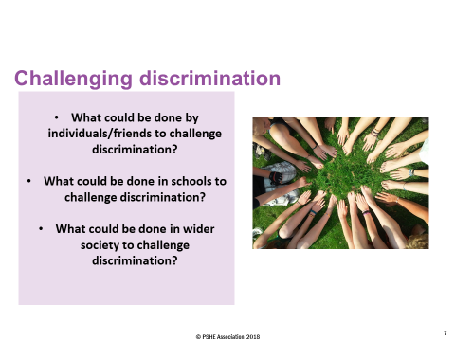

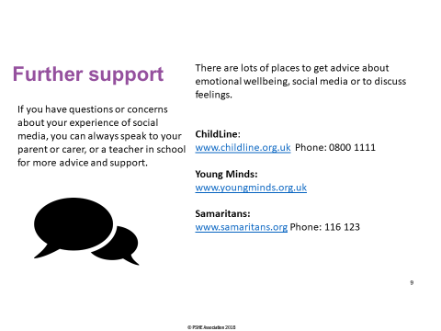

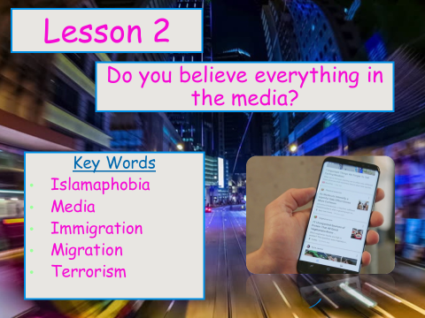

|  |
| --- |
|  |
|  |
|  |
|  |
|  |
|  |
|  |
|  |
|  |
|  |
|  |
|  |
|  |
|  |
|  |
|  |
|  |
|  |
|  |
|  |
|  |
|  |
|  |
|  |
|  |
|  |
|  |
|  |
|  |
|  |
|  |
|  |
|  |
|  |
|  |
|  |
|  |
|  |
|  |
|  |



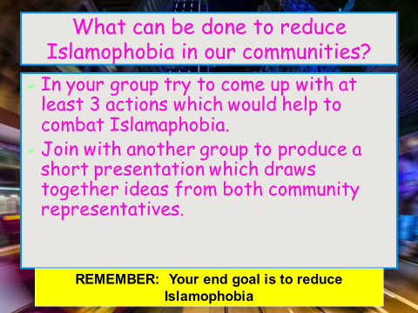

|  |
| --- |
|  |
|  |
|  |
|  |
|  |
|  |
|  |
|  |
|  |
|  |
|  |
|  |
|  |
|  |
|  |
|  |
|  |
|  |
|  |
|  |
|  |
|  |
|  |
|  |

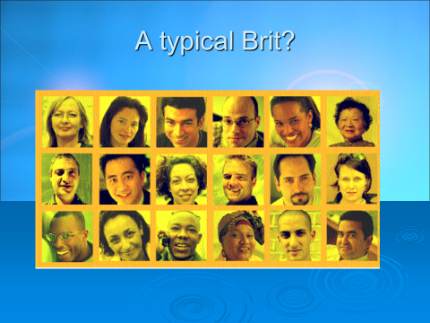

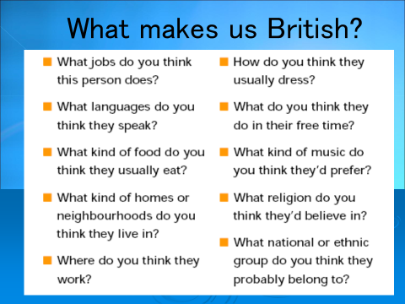

|  |
| --- |
| New Verse For The National Anthem |
|  |



|  |  |
| --- | --- |
| Quiz | |
| 1 |  |
| 2 |  |
| 3 |  |
| 4 |  |
| 5 |  |
| 6 |  |

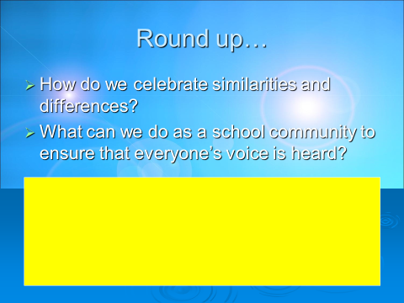

**Balloon Debate**

“The best thing about Britain is…”