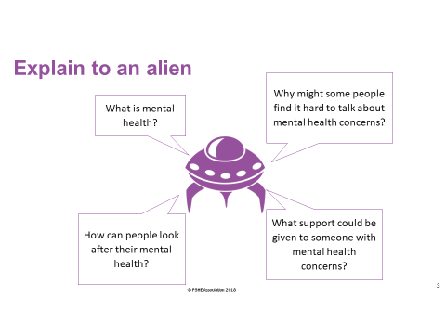

|  |
| --- |
|  |
|  |
|  |
|  |
|  |
|  |
|  |
|  |
|  |
|  |
|  |
|  |
|  |
|  |
|  |
|  |
|  |
|  |
|  |
|  |
|  |
|  |
|  |
|  |

|  |
| --- |
| Your definition of mental health |
|  |



  
  
  
  
  
  
  
  
  
  
  
  
  
  
  
  
  
  
  
  
  
  
  
  
  
  
  
  
  
  
  
  