Great Fire of London 1666: The Aftermath
After the Great Fire of London, 5/6ths of the walled area of the city of London was destroyed. Charles II wanted to get new designs of how London would look after this fire. He promised London would be “a much more beautiful city than is at this time consumed [by the Great fire of London]”. He promised main thoroughfares (roads) would be “of such width as may with God’s blessing prevent the mischief that one side may suffer if the other be on fire”. This would hopefully prevent any other fires being as disastrous as the Great Fire of London.
Read and study the proposed designs for London. Which fits Charles II’s promise best and why? Stick your winning design into your book.
Challenge: Look at North London (to the east of the Tower of London) today on Google Maps. Do you think any of the designs were successful? Are there any elements that still exist today?
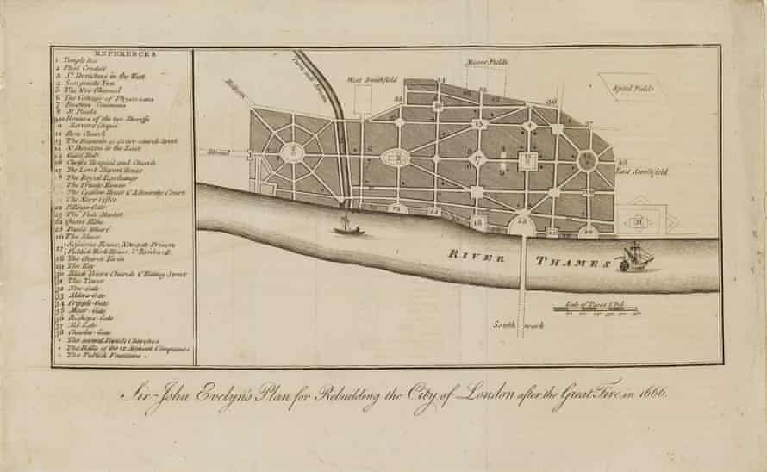
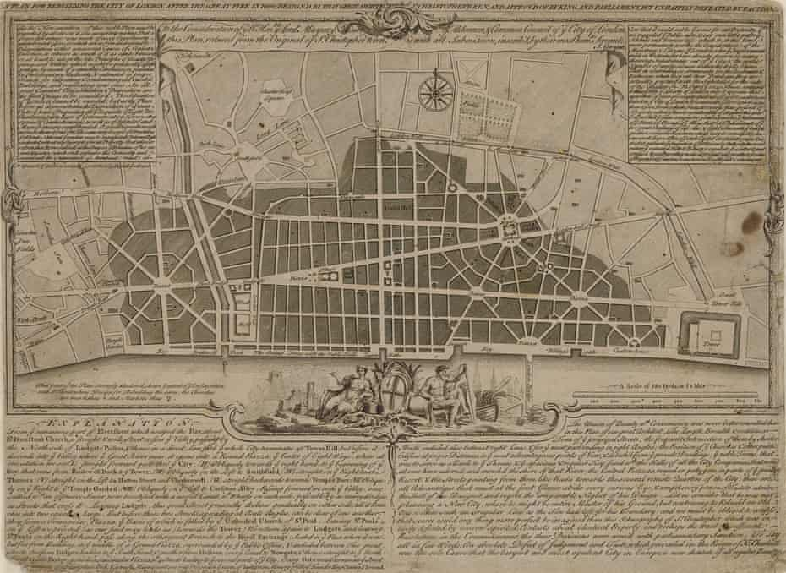
This is the design for North London from scientist Robert Hooke. This design was a variation on a grid system that later became popular in the development of cities in the United States. The large squares would be built around churches, showing how important religion was in England still.

Writer John Evelyn’s design was very similar to Wren’s. Evelyn submitted his work for royal inspection two days after Wren’s followed large parts of his design. In both cases, a complete change of the areas around Fleet Street and the Royal Exchange would have been required to accommodate huge, round-point piazzas, and the area along the river Thames would have become one long, public dock for ships.
This design is from the great architect Sir Christopher Wren. He imagined a reconstructed capital full of wide boulevards and grand civic spaces [for people to meet in], a city that would rival Paris for magnificence. He wanted to create a city of “pomp and regularity”.

