GCSE
HISTORY (8145)
Paper 2 Shaping the Nation
Resource pack for the 2022 historic environment specified site
Lord Burghley’s Almshouses at Stamford.
Elizabethan England, 1568–1603
The purpose of this pack is to provide you with guidance and resources to support your teaching about the Lord Burghley’s Almshouses at Stamford, the 2022 specified site for the historic environment part of Elizabethan England, 1568–1603. It is intended as a guide only and you may wish to use other sources of information about the Lord Burghley’s Almshouses at Stamford. The resources are provided to help you develop your students’ knowledge and understanding of the specified site. They will not be tested in the examination, as the question targets AO1 (knowledge and understanding) and AO2 (explaining second order concepts).

Note: for paper code, add /PM after for preliminary material documents and /TN after for Teachers Notes. Do this for inside footers as well.
General guidance

The study of the historic environment will focus on a particular site in its historical context and should examine the relationship between a specific site and the key events, features or developments of the period. As a result, when teaching a specified site for the historic environment element, it is useful to think about ways of linking the site to the specified content in Parts 1, 2 and/or 3 of the specification.

There is no requirement to visit the specified site as this element of the course is designed to be classroom based.

Students will be expected to answer a question that draws on second order concepts of change, continuity, causation and/or consequence, and to explore them in the context of the specified site and wider events and developments of the period studied. Students should be able to identify key features of the specified site and understand their connection to the wider historical context of the specific historical period. Sites will also illuminate how people lived at the time, how they were governed and their beliefs and values.

The following aspects of the site should be considered:
• location, function and the structure
• people connected with the site e.g. the designer, originator and occupants
• the design and how the design reflects the culture, values, fashions of the people at the time
• how important events/developments from the depth study are connected to the site.

Students will be expected to understand the ways in which key features and other aspects of the site are representative of the period studied. In order to do this, students will also need to be aware of how the key features and other aspects of the site have changed from earlier periods. Students will also be expected to understand how key features and other aspects may have changed or stayed the same during the period.

Background information for Lord Burghley’s Almshouses at Stamford

What were alms and almshouses?
Alms were gifts such as money or food given as charity to help the poor. When this money was given to build and maintain houses which poor people in an area could live in rent free, they were known as almshouses. Almshouses have a long history in England with the oldest being established before the Norman Conquest. Even today over sixteen hundred remain, housing approximately 35,000 people.

Why was poverty increasing in the sixteenth century?
There were several reasons why poverty increased during the sixteenth century.

One reason was population growth. The population of England and Wales doubled to 4.2 million. This increase was the result of a rising birth rate, caused by people marrying at an earlier age and then having children. This combined with a lower death rate, as farming productivity improved, meaning that farms were able to produce more food. This rising population was vulnerable to epidemics and poor harvests, such as in 1586-8 and 1596-9, which made many people poorer.

Unemployment was another reason for the increase in poverty in this period. Agriculture was the country’s main industry and source of wealth but there was a long-term trend for landlords to use land for sheep farming – which was more profitable - rather than for growing crops. This was called enclosure, and it reduced the need for farm workers, leaving many unemployed. There was also underemployment and seasonal unemployment in England’s most important industry which was the production and export of woollen cloth. Interruptions to this trade could increase poverty for those involved.

Another important reason was the high price of food. There was a trend in the sixteenth century for prices to increase, which is known as price inflation. Most important was the price of basic foods, especially bread, which rose as the population grew and even more when harvests were bad. This inflation affected people on fixed incomes particularly badly. For example, farm labourers without their own land suffered badly because their wages did not keep pace with rising prices.

Resource H recognises the importance of these long-term economic trends of the sixteenth century but also suggests that the short-term crises of famine, particularly in the last twenty years of Queen Elizabeth’s reign, helped bring the problem of poverty to the attention of the government and made dealing with it more urgent.

Why were the Elizabethans worried about the problem of poverty?
Elizabethans were alarmed by both the size and nature of the problem posed by the poor. Books at the time made Elizabethans aware of the problem, and in particular that of vagrancy and idleness. In William Harrison’s ‘Description of England’, published in 1577, he estimated that there were 10,000 vagrants wandering the country, which did not include those poor who lived in towns and villages. He divided the poor into three categories (Resource F). Firstly, there were those who Harrison called ‘the true poor’ such as orphans, the old, or blind who were unable to provide for themselves. Secondly, he identified those who were poor because of some misfortune such as wounded soldiers or the sick. These groups made up the ‘impotent poor’. Finally, he identified ‘the thriftless poor’. Although he accepted that this group included some who were travelling the country genuinely looking for work, it was mainly made up of those who chose to be vagrants and criminals. In 1566 Thomas Harman, a Justice of the Peace from Kent, also wrote a bestselling book in which he described the different sorts of vagabonds (Resource G).

In practice, many Elizabethans had little time for such differences and saw all the poor as wasters and thieves, which justified treating them harshly and whipping them out of town. Other writers also increased the Elizabethans’ anxiety about the poor by drawing attention to the danger that they posed to the social order. For example, Elizabeth’s government in London received reports from a network of Justices of Peace, like Edward Hext in Somerset who wrote to Lord Burghley in 1596 warning about large gangs of vagabonds who were travelling through his county. These reports focused on the scale of poverty and the potential for disorder, which alarmed the upper classes and the Elizabethan Privy Council.

The government were particularly concerned about able-bodied unemployed men or women, variously called rogues, vagabonds, vagrants, or sturdy beggars (Resource F) who tended to make their way to the nearest town or London. They were seen as a threat to public order and were initially treated as criminals. A 1572 Act of Parliament permitted the punishment of vagabonds, with those over the age of 14 being ‘severely whipped and burned through the gristle of the right ear with a hot iron an inch in diameter unless some responsible person will take him into service for a year.’ A further Act in 1576 required each county to set up of houses of correction where those who were "unwilling to work", including vagrants and beggars, were set to work. As a result, persistent vagabonds could be whipped, imprisoned, and in extreme circumstances executed.

What did Queen Elizabeth’s government do about poverty?
Queen Elizabeth’s government learned a great deal from various local initiatives in Norwich, Ipswich, York, and London so that during her reign the treatment of the poor underwent a fundamental change. The government realised that not all the able-bodied poor were idle wasters and that some genuinely wanted to work but were unable to find it. The laws passed by the government show that they accepted that they did have a responsibility to look after the poor. For example, the 1601 Poor Law consolidated earlier laws and included a compulsory poor rate and the punishment of vagrants and beggars, but also tried to provide work for the poor so that they would neither wander from place to place nor needlessly claim relief.

Why did attitudes to the poor change?
Although the Elizabethans remained anxious about the increased scale of poverty and its effects on society, beliefs about poverty were changing. Resource I shows that wealthy and powerful people accepted that many of the poor were poor through no fault of their own, and that poor relief was not solely the government’s responsibility. Richer members of society like William Cecil, Lord Burghley, were still expected to, and wanted to provide charity for the poor.

Many people were also influenced by Puritanism and Resource H explains how Puritans believed good Christians should behave towards the poor. Puritans valued work as a way of glorifying God, and thought the same about providing poor relief. However, they believed strongly that helping the poor had to done for the right reasons, so were critical of the good works encouraged by the Catholic Church which they thought were done with little thought behind them.

What mattered to the Puritans was the intention behind the action. Therefore, they believed that the rich had to use their wealth to glorify God, rather than themselves. The Puritan belief that God preferred industry to idleness meant that giving alms to provide employment for the poor was extremely worthwhile in its own right. Giving alms also supported social stability by reducing vagrancy and the resulting threat to good order. Finally, Puritans also believed that poor relief could bring about an improvement in the morals and behaviour of the poor partly because it could require them to go to church on Sunday.

What did wealthy and powerful Elizabethans do to help the poor?
Although Queen Elizabeth’s government passed laws to help the poor, many other people also carried out their own charitable works which added to the help provided by the government. In some cases, this involved building almshouses for poor people to live in.

After the Reformation, and particularly in the 1570s, many people used their new wealth to revive the ancient tradition of founding almshouses to help the poor, and Resource I discusses some of the reasons behind this trend. This Historic Environment study concentrates, in particular, on the almshouses founded in 1597 by William Cecil, Lord Burghley, at Stamford in Lincolnshire near Burghley House. Resource J2 describes how it was set up while Resources A, B, C and D show it as it is more recently. There are many other examples of almshouses founded by the Elizabethan nobility to carry out their duty to help the poor such by the Margaret Clifford, Countess of Cumberland, at Beamsley, or Elizabeth’s Archbishop of Canterbury, John Whitgift, in Croydon.

As described earlier, the laws passed in 1572 and 1576 by the government were designed to punish vagrants, but both laws also made it easier for wealthy people to help the poor by setting up and endowing institutions such as almshouses. This was further encouraged in 1598 by an Act which simplified the ways in which almshouses, workhouses, and houses of correction could be set up. This resulted in a remarkable surge in the founding of almshouses in the early seventeenth century.

Who was William Cecil, Lord Burghley?

William Cecil, who also known as Lord Burghley, founded the almshouses at Stamford and was the leading statesman of Queen Elizabeth’s reign. He held three major offices of government, being Secretary of State from Elizabeth’s accession until 1572; Master of the Court of Wards¹ from 1561 until his death in 1598; and, most important of all, Lord Treasurer from 1572 also until the end of his life. As a result, he was very powerful, combining the roles of a modern prime minister and leading civil servant.

Burghley was a loyal servant of the Queen and aimed to make England strong, self-sufficient and stable. In politics he was driven by a duty to serve and protect Queen Elizabeth. In religious matters he was a moderate Protestant with perhaps a tendency towards Puritanism. However, what Burghley felt was most important was that everyone, regardless of personal belief, was above all else loyal to the Crown and their country. This can be seen when he warned the leading clergyman in the English church, the Archbishop of Canterbury, John Whitgift, against using the brutal methods of the Spanish Inquisition² when dealing with the Puritans. Burghley’s warning was probably not due to any strong preference for the Puritans, but rather as the result of a clever understanding of the political situation and an anxiety to avoid a head-on collision with powerful Puritans, either in the Puritan-inclined House of Commons or the Privy Council. However, as Resources H & I show, Puritanism also gave Elizabethans a new way of looking at poverty and the poor.

Tudor officials did not receive very large salaries from the Queen but instead relied on royal patronage in the form of grants of land or more offices. Over the years Burghley acquired an enormous amount of property throughout England and, as a landed noble, this provided him with a substantial income. He also made a huge amount of money from the fees and payments he received as Master of the Court of Wards. None of this was seen as corruption but simply as a way of making the system of government and patronage run more smoothly. As a devout Christian, Burghley wanted to carry out his religious and social duty to help the poor which was why he founded the almshouses at Stamford (Resource E & J2). Indeed, Resource J2 also shows that he applied the same care and precision to setting up the almshouses as he did in managing Elizabeth’s government.

Burghley was also concerned about the future of his family and the legacy that he would leave behind (Resource J2). As a result, he carefully guarded the reputation of his family by making sure that his sons and daughters, grandchildren and great-grandchildren behaved properly. This came naturally to a nobleman like Burghley who saw it as his responsibility as Master of the Wards and as Elizabeth’s counsellor to preserve and maintain a landed society based on rank and status.

(1) A government office which collected feudal taxes for the Crown and supervised the heirs to noble titles and their estates.
(2) The Spanish Inquisition was a powerful organisation set up within the Catholic Church in Spain. It’s job was to find and punish non-believers – known as heretics – in lands controlled by Catholic Spain. It was well known for its brutal methods, including torture and execution.

Resources

Resource A  page 7 | A modern photograph of Lord Burghley’s Almshouses at Stamford.

Resource B  page 7 | A modern photograph of the back of Lord Burghley’s Almshouses at Stamford.

Resource C  page 8 | A photograph of Lord Burghley’s Almshouses at Stamford.

Resource D  page 9 | A plan showing the location of Lord Burghley’s Almshouses at Stamford.

Resource E  page 10 | A plan of Lord Burghley’s Almshouses at Stamford as they were in 1597  Note: (1) the plan is drawn facing South, and (2) refers to Lord Burghley’s ‘Hospital’ as he took over the buildings and grounds of a former medieval charitable Hospital in Stamford to make into his almshouses.

Resource F  page 11 | A sixteenth century picture of three types of beggar.

Resource G  page 11 | A drawing of Nicholas Blunt from Thomas Harman’s book, first published in 1566.  He also posed as Nicholas Jennings known as a ‘Counterfeit Crank’. In one disguise he was a respectable man who had fallen on hard times, and in the other disguise, a mad man dressed in rags and covered in blood and mud.

Resource H  page 12 | An extract from ‘Poverty in Elizabethan England’ by Paul Slack, published in ‘History Today’, 1984.

Resource I  page 14 | An extract from ‘Almshouses in Early Modern England’ by Angela Nicholls, 2017.

Resource J1  page 16 | A map showing the location of Lord Burghley's alms house, Burghley house and estate in Stamford Lincolnshire.

Resource J2  page 16 | An extract from ‘Burghley’ by Stephen Alford, 2008.

The Lord Burghley’s Almshouses at Stamford resources

Resource A | A modern photograph of Lord Burghley’s Almshouses at Stamford.
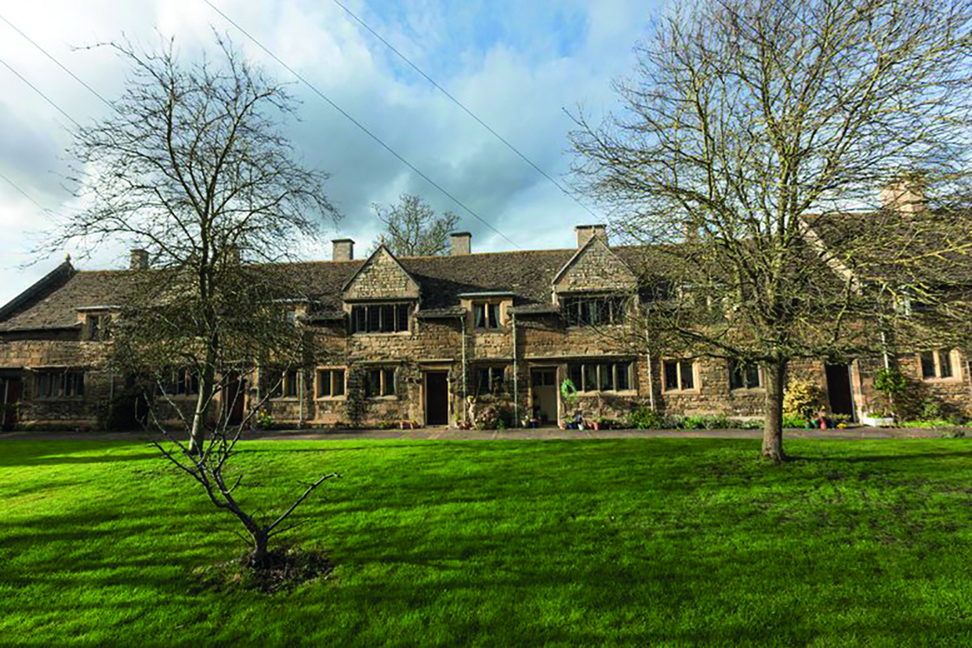

Resource B | A modern photograph of the back of Lord Burghley’s Almshouses at Stamford.
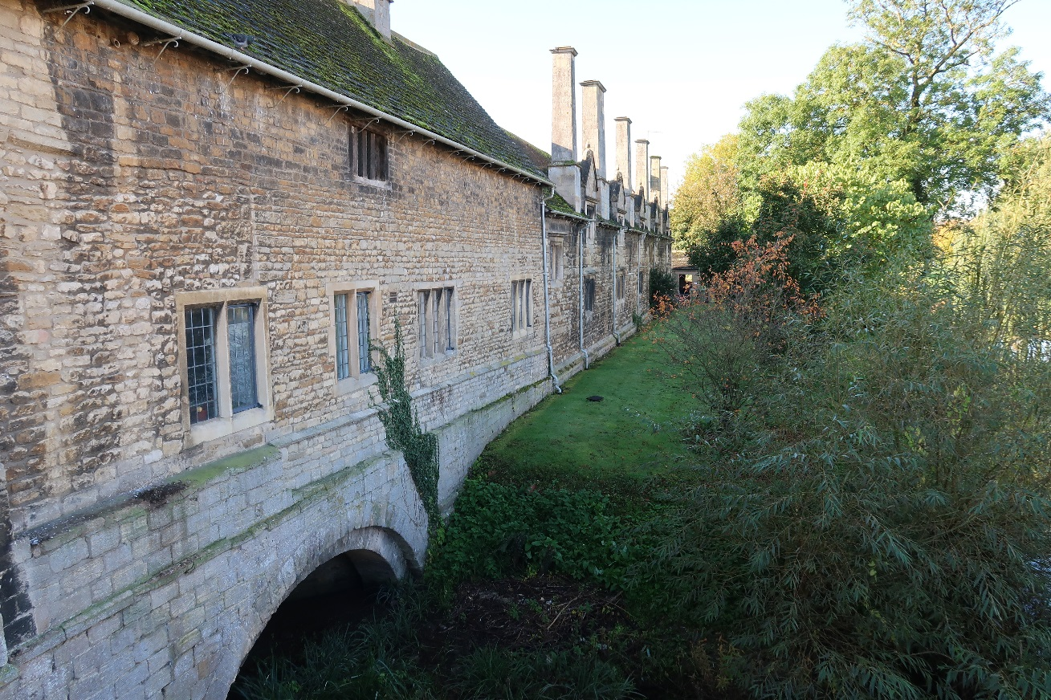

Resource C | A photograph of Lord Burghley’s Almshouses at Stamford.
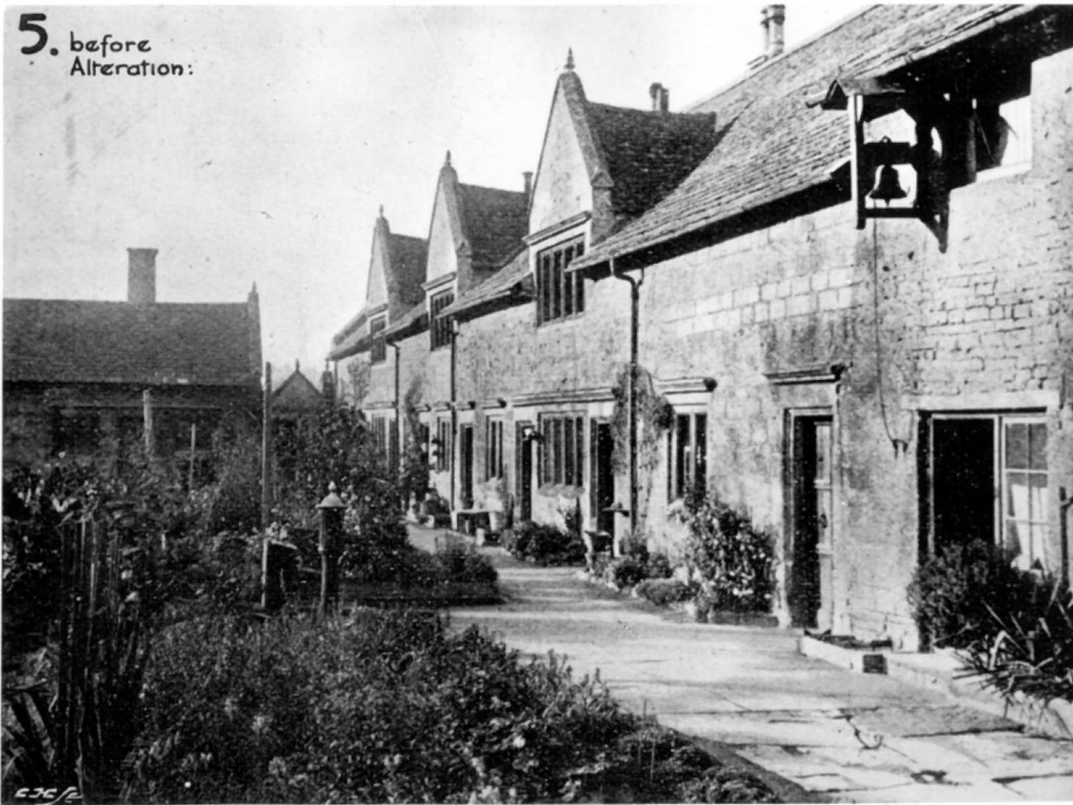

Resource D | A plan showing the location of Lord Burghley’s Almshouses at Stamford.
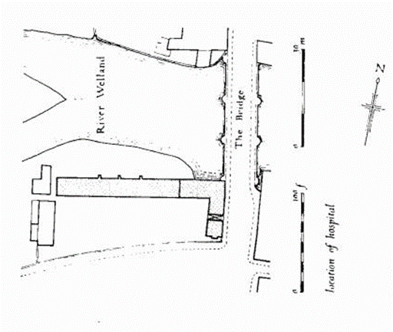

Resource E | A plan of Lord Burghley’s Almshouses at Stamford as they were in 1597.  Note: (1) the plan is drawn facing South, and (2) refers to Lord Burghley’s ‘Hospital’ as he took over the buildings and grounds of a former medieval charitable Hospital in Stamford to make into his almshouses.
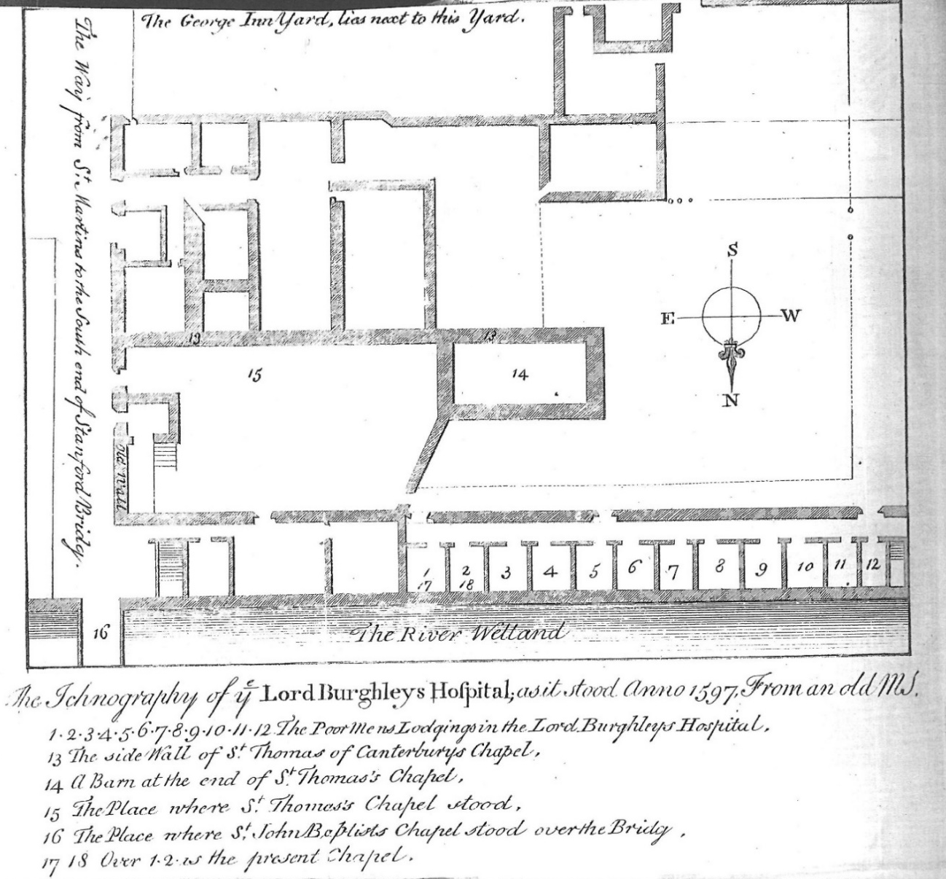

Resource F | A sixteenth century picture of three types of beggar.
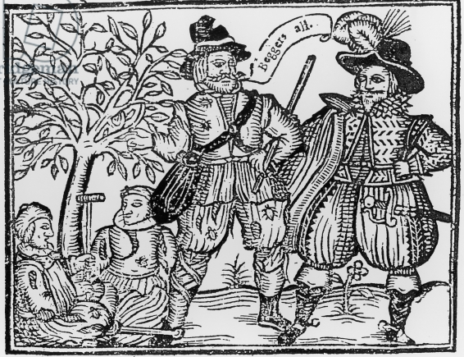

Resource G | A drawing of Nicholas Blunt from Thomas Harman’s book, first published in 1566. He also posed as Nicholas Jennings known as a ‘Counterfeit Crank’. In one disguise he was a respectable man who had fallen on hard times, and in the other disguise, a mad man dressed in rags and covered in blood and mud.
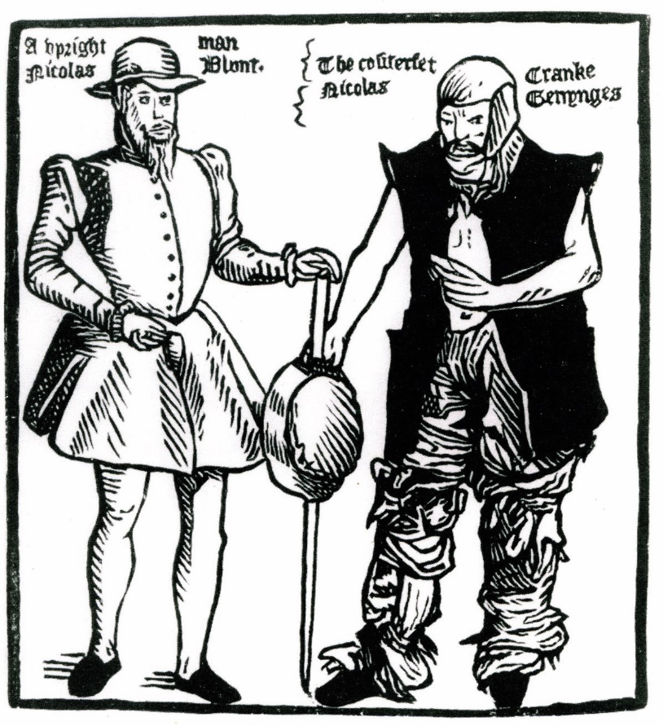

Resource H | An extract from ‘Poverty in Elizabethan England’ by Paul Slack, published in ‘History Today’, 1984.
The new Elizabethan poor laws were influenced by measures taken by various towns such as London, Norwich, Ipswich and York. They had all introduced compulsory taxes for poor relief in the later 1540s and 1550s. The Act of 1572 seems to have been particularly influenced by experiments begun in Norwich in 1570, which included a survey of the poor, an increase in the rates, and new ways to provide employment. However, despite this, it was central government which played the greatest part in framing national social policy. At first sight this seemed entirely negative with the Privy Council's most frequent proclamations aimed at one simple target - rogues and vagabonds. But there was a more positive side to government policy which was shown by the printed Books of Orders sent to all JPs. These Books, first published in 1586, were a major Elizabethan innovation as they brought together all previous advice and required local authorities to adopt common policies. One set of Orders told local officials how to respond to famine and harvest failure by requiring JPs to survey local stocks of grain, arrange for extra supplies and make sure that they were sold in small quantities to the poor.

There was also parliamentary interest in social regulation and control with an increasing concern, particularly in the last twenty years of the reign, about the condition and conduct of the poor. Parliament showed their belief that the manners and behaviour of the lowest in society needed urgent improvement by discussing at least seventeen bills about poverty in the 1597-8 session. Between 1576 and 1601 there were also thirteen bills relating to drunkenness, inns and alehouses. While not treating Sunday as a holy day, illegitimacy, and the use of foul language were all the subject of various parliamentary bills between 1584 and 1601. There can be no doubt that in the second half of Elizabeth's reign those in authority, whether it was the Privy Council, Parliament, or local authorities felt threatened by the large numbers of vagrants and poor, and the disorder that they caused.

Elizabethans certainly believed that economic conditions were getting worse in the long term. They noticed migration to the towns and the serious threat that they believed it could cause. A supply of cheap labour meant that many towns and villages now had a large and vulnerable class of underemployed ‘labouring poor’. The later 1590s were particularly bad, as famine and high prices always pushed the poor towards towns in search of charity. The records of Bridewell prison in London show these trends clearly with the number of vagrants being punished rising from 69 a year in 1560-1, to 209 in 1578-9, and then to 555 in 1600-1. This was an eightfold increase at a time when the city’s population only rose threefold, meaning that from the 1570s until the end of the reign, the streets of London and many other towns were full of vagrants and beggars. Women and children from broken families were particularly numerous amongst the poor which showed how old age, widowhood or the death of a parent could have a devastating effect on a family. The census taken in Norwich in 1570 showed that old age, illness or the death of a bread-winner caused poverty in 35% of the families, but irregular employment, unemployment or low wages was responsible in 50% of cases. The evidence suggests, therefore, that many of the poor were victims of an economy which was failing to employ a rapidly rising population and that conditions were getting worse.

Temporary crises during Elizabeth’s reign were what brought urgency to the concerns and anxiety caused by long term economic trends. Although there was no truth in the widespread belief that vagabonds had caused the Northern Rebellion, it undoubtedly increased fears about the poor immediately after 1569. Crises caused by disease and famine were also much more serious in the last two decades of the reign with plague spreading to many towns after devastating outbreaks in London in 1593 and 1603. This disrupted economic activity and threw hundreds onto poor relief. Harvest failures in 1586 and from 1595 to 1597, brought malnutrition, disease and dramatic increases in the death rate to the poorer suburbs of towns and to more isolated rural areas where people starved to death. Food prices rose everywhere, causing distress and increased social tension over much of the country in the later 1590s. This was accompanied by a peak in crimes against property, by a high illegitimacy rate, and by food and enclosure riots, all of which helped bring about the comprehensive poor relief legislation of 1598. Overall, there were more vagrants and paupers with a valid claim to public assistance, due, not just to frequent and temporary crises caused by famine and plague, but to long-term economic trends which produced unemployment, underemployment and large numbers wandering the country.

There was, of course, opposition to the poor-laws as people did not like paying taxes. Many doubted whether poor relief should be the government’s responsibility at all rather than the old practice of neighbourly, and largely informal, charity. The situation was confused with informal and indiscriminate almsgiving continuing on a large scale, yet the trend throughout the reign was towards more government intervention and direction of welfare activity. The Books of Orders for famine assumed that if the government controlled scarce food resources when the harvest failed, it would be a more efficient and effective way of helping the poor than relying on neighbourly charity. This was partly the result of a common belief at the time that the old methods had failed due to a decline in charitable giving. In fact, this was wrong as, by the 1580s, private donations for poor-relief had made up for the loss of monastic almsgiving, and that these roughly kept pace with inflation throughout the reign. People at the time, however, did not realise this and, seeing only the disappearance of the old religious charitable institutions and empty or absent poor-boxes in churches, some thought that the state must step in to help.

From the beginning of the reign Lord Burghley encouraged government intervention that would benefit all society and as a result he became the driving force behind the Books of Orders. In addition, Puritanism added a new element to the debate about poverty and made a significant contribution to the development of the poor laws. The Puritans favoured discrimination in poor-relief, although they shared contemporary doubts about aspects of it. Many Puritans wanted more generosity towards the poor and supported new hospitals, almshouses and charitable giving but they also wanted to improve the morality of the poor, many of whom they saw as a threat to good order. Although Puritan preachers and writers might acknowledge the existence of the respectable poor, Puritan magistrates spoke differently by stressing the infectious vices and social threat which poverty posed. In the 1570s, for example, Walsingham reported to Cecil how in a Norfolk jail JPs met, after prayers, to punish, ‘rogues, drunkards and other unruly people’ which was, ‘both necessary and godly work’.

Resource I | An extract from ‘Almshouses in Early Modern England’ by Angela Nicholls, 2017.
The founders of almshouses were a varied group, which included trades people, country gentry, local clergymen, city merchants, great lords, and bishops. Charitable giving for many was intended as a public display. Catholics and Protestants provided for the poor, in some cases by the founding of almshouses, as an outward sign of their Christian faith. Courtiers also set an example of how to deal with the problem of the poor by founding almshouses. Landowners showed their status, virtue and moral leadership by providing for elderly tenants and the local poor while the almshouses that they founded left behind a lasting memorial to their name and family. The wealthy in towns provided almshouses to gain prestige and respect. Therefore, it was not only the poor who benefited from almshouses but also those who founded them.

Two important mid-sixteenth century changes might have been expected to reduce both the need for, and attraction of almshouses to potential founders. Firstly, the English Reformation had removed the need for prayers for the dead which had been the function of many medieval almshouses, and secondly, the Elizabethan poor law gave responsibility for housing the poor to the parish. Neither of these changes, however, seems to have made much difference as almshouses continued to be founded in great numbers during the second half of the sixteenth century.

Before the Reformation the main motive for charitable giving was religious with many almshouses having to follow a programme of daily prayer for the souls of their founders in return for shelter, money, and sometimes food and clothing. These prayers, it was believed, would help guarantee the smooth passage to heaven of the souls of the founder and his family. However, there were different attitudes to poor relief which emerged in cities during the early sixteenth century which saw charity as having an improving role in society by encouraging the poor to lead ordered lives of Christian virtue, and by helping to clear the streets of beggars. The founders of almshouses, however, continued to be motivated by the same considerations as their late medieval predecessors. Many of the founders of almshouses were deeply religious which drove their charitable giving and resulted in their almshouses following traditional patterns. There was little difference between the charitable giving of Protestants and Catholics, and although Protestants no longer officially believed in doing good works as a route to salvation, they were eager to support charitable giving and show concern for the poor as a sign of their faith and godliness, which suggested that God had chosen them to be saved. Many Protestants, however, remained sensitive about the suggestion that they gave less to charity than their Catholic predecessors.

Founding an almshouse was a way of leaving a permanent memorial to yourself and family. This was achieved through the building itself, along with its name, the uniform worn by the alms people, and through communal events such as the annual dinner for those administering the almshouse. Many medieval almshouses had been founded to provide accommodation for poor travellers, including pilgrims but with the abolition of pilgrimages this was no longer thought to be an appropriate function for an almshouse. At a time when there was increasing concern about vagrancy, the great majority of almshouses were instead usually provided for the obviously deserving elderly and those unable to work. The effects of old age could be catastrophic on the working poor if they were unable to save enough to support themselves in later life. Once a person became too old to earn a living, whether by labouring, following a trade or as a servant or farm tenant they were at risk of destitution and of losing their homes. It was generally accepted that it was not their fault that the elderly and disabled could not support themselves and so they were appropriate recipients of compassion and charity.

Many almshouses were located in places that were important to the founder and their family. Robert Dudley, for example, had the Queen’s permission to found an almshouse either at Kenilworth, the site of his castle, or at Warwick, where his brother had his ancestral home. For the nobility and gentry, founding almshouses was a way of emphasising their local connections, status and having a physical presence in the area. At a time of social mobility and political uncertainty founding an almshouse was a way to establish or shore up your reputation. Providing for the poor in the neighbourhood was part of the accepted responsibility of a landowner towards his tenants, servants and neighbours. If the landowner had acquired former monastic land then almshouses represented continuity with medieval ideas of looking after the poor.

The founding of almshouses was often influenced by and followed the form of charity favoured by a person’s social circle or family tradition. Some high-ranking Elizabethans modelled their almshouses on the example of the politician and lawyer, William Lambarde. Lambarde, Lord Cobham and Archbishop Whitgift each founded his own almshouse and also worked together in 1592 as the first governors of Sir John Hawkins almshouse in Chatham for disabled sailors. Cobham’s daughter, Elizabeth, married Robert Cecil, whose father, Lord Burghley was another almshouse founder.

Almshouses could provide a secure base for radical preachers and gave them a captive audience for their beliefs. Robert Dudley, the leader of the Puritan group at court, used his almshouses to provide such a base for the controversial Puritan Thomas Cartwright whom he appointed master of his almshouse in Warwick on Cartwright’s return from exile in 1586. Like their predecessors, many Protestant almshouses remained places of prayer with their rules requiring these to be held daily along with regular church attendance. The almshouse of William Lambarde, a committed Protestant and friend of Archbishop Parker, became a model which was copied by many others. He devised rules for his own almshouse which included the requirement that applicants be honest and godly persons who could recite the Lord’s Prayer, the articles of the Christian faith, and the Ten Commandments in English. They would have to meet each morning and evening for prayers and would be fined 4d if they were absent. Lambarde was also particularly concerned that acts of charity should be performed during a person’s lifetime rather than through money left in a will after their death. As a result, others such as Robert Dudley and Sir John Hawkins founded their almshouses in their own lifetimes, rather than with money left in their wills as they did not want their charity to be connected with the Catholic practice of saying prayers for the dead. Yet despite this, many late sixteenth century founders emphasised tradition by incorporating the ruins or remains of medieval almshouses in their new buildings. Lord Burghley’s almshouses at Stamford, for example, were built on the site of a twelfth century almshouse in a deliberate attempt to emphasise continuity with an honourable institution which had been corrupted by popery. Almshouses were an ideal way to make this claim.

Resource J1 | A map showing the location of Lord Burghley's alms house, Burghley house and estate in Stamford Lincolnshire.
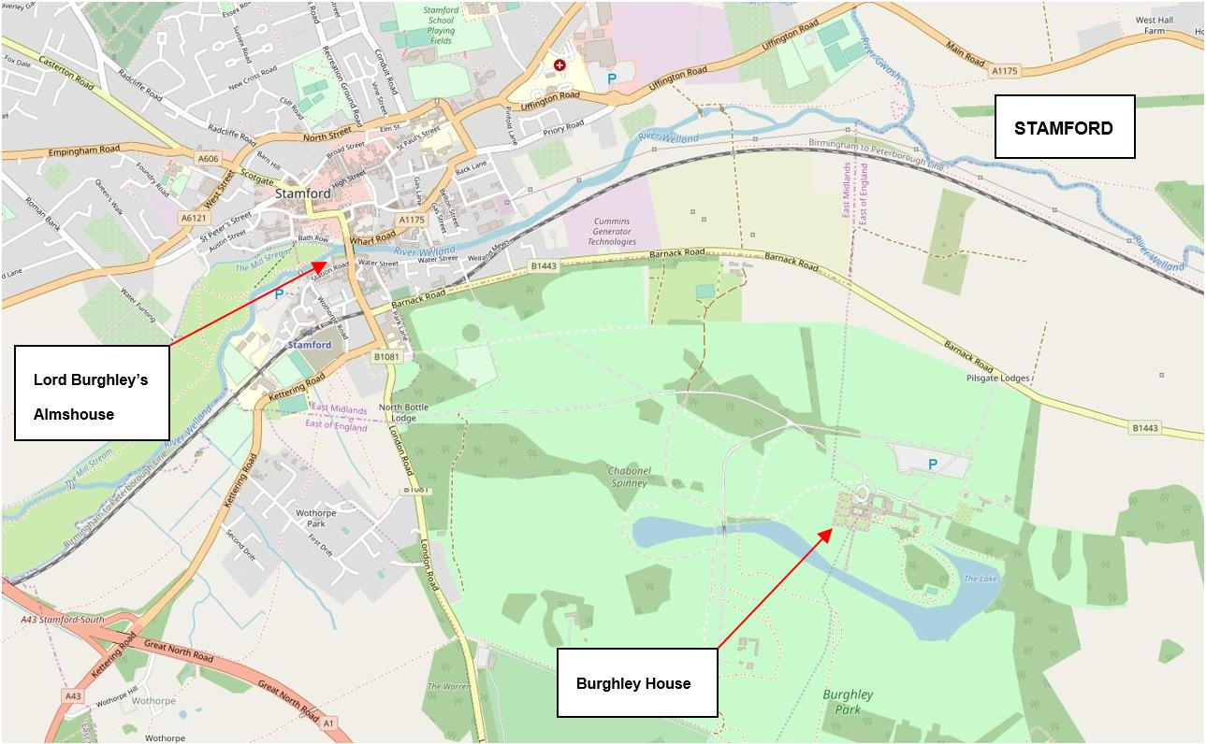

Resource J2 | An extract from ‘Burghley’ by Stephen Alford, 2008.
Lord Burghley had always considered the legacy he would leave behind to be important, whether it was at Burghley House, at Theobalds, his stately home in Hertfordshire, or in politics. Therefore, to found an alms house for thirteen poor men on the south bank of the River Welland in Stamford facing up the hill to St Marys Church where Burghley had been taught as a boy, was a very natural thing for him to do. He had also lived for 30 years opposite the Savoy alms house in London which had been founded by Henry VII for the poor and needy.

These almshouses were to be a very public show of Burghley’s charitable works. He was rich, powerful with strong connections to nearby Northamptonshire. His almshouses would show the world his allegiance to his native county and it would help him carry out his responsibilities to the poor. Therefore, the rules that Burghley set out for the almshouses in the summer of 1597 with great precision were printed by the Royal printer and available for anyone in London to read.

Burghley himself would choose and admit the first five of the thirteen poor men to be cared for: a right which would pass to his heirs at Burghley House. The other poor men would be chosen by the vicar of St Martin’s Church, various local churchwardens, the Alderman of Stamford, as well as some other town officials. The records of the hospital would be kept at St Martin’s, the parish church long associated with the Cecil family. Duplicate copies would be kept by the Alderman. The warden at the alms house, chosen by Burghley himself, along with his twelve poor companions would each have a yearly allowance of cloth for their gowns. The cloth was to be the same colour as the distinctive coats worn by Burghley’s servants. The poor men had to be ‘honest Christians’ and, once chosen for a place, had to meet the vicar of St Martin’s on a Sunday morning to recite aloud the Lord’s prayer and Apostles Creed and to begin to learn the Ten Commandments. They had to be local men, over the age of 35, who had lived within a seven-mile radius of Stamford for at least seven years. Lunatics, drunkards, adulterers, thieves, fraudsters and those suffering from diseases such as leprosy could not be chosen. Ideally, the poor men were to be honest soldiers, craftsmen such as masons and carpenters, or labourers and servants, all of whom were unable to get their living as they had done because of ‘sickness, age or other impediment’.

The alms house was to be a disciplined community where playing cards and gambling were strictly forbidden. Burghley also believed that worshipping as a group was valuable as it brought a community together. Therefore, every Sunday, Wednesday, Friday and holy day the men would go in their gowns to morning and evening prayer at St Martin’s, where they would sit or kneel in the places shown them by the churchwardens. Failure to attend church without good reason would cost an offender 6d out of his week’s wages, which were 3 shillings for the warden and 2s 4d for the others. These were paid every Sunday after evening prayers.

The poor men were to honour Burghley’s family by always wearing their gowns within the parish of St Martin’s, and on four Sundays during the year by attending on Lord Burghley in the hall at Burghley House. Even after his death, if any of Burghley’s heirs came to Burghley House or Stamford, then the thirteen poor men were to ‘present themselves dutifully to them, and offer any service they can do them, in memory of the founder, William, Lord Burghley’. In this way Burghley’s almshouses were part of his legacy by providing a continuing service to Stamford and acting as a lasting memorial to his family.

Copyright Information

For confidentiality purposes, from the November 2015 examination series, acknowledgements of third party copyright material will be published in a separate booklet rather than including them on the examination paper or support materials. This booklet is published after each examination series and is available for free download from www.aqa.org.uk after the live examination series.

Permission to reproduce all copyright material has been applied for. In some cases, efforts to contact copyright-holders may have been unsuccessful and AQA will be happy to rectify any omissions of acknowledgements. If you have any queries please contact the Copyright Team, AQA, Stag Hill House, Guildford, GU2 7XJ.

Resource A © Jorge Tutor/Alamy Stock Photo
Resource B © Jon Cloake
Resource C © Burghley Estate
Resource E © Burgley Estate
Resource F © The Stapleton Collection/Bridgeman Images
Resource G © Pictorial Press Ltd/Alamy Stock Photo
Resource H Used by the permission of the publisher, History Today
Resource J2 Burghley: William Cecil at the Court of Elizabeth I by Stephen Alford 2008 © Reproduced with permission of Yale Representation limited through PLSclear

Copyright © 2022 AQA and its licensors. All rights reserved.

