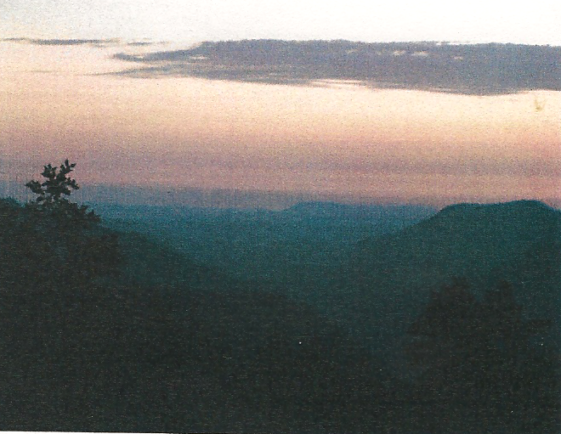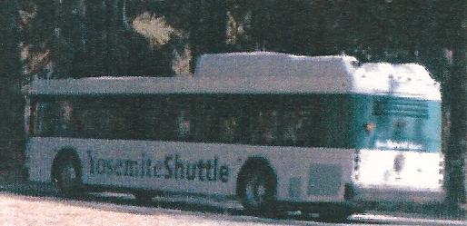

Case Study
Environmental Damage

More developed country

Honeypots

Local scale

Pollution

Page 156 in textbook

Yosemite Factfile

THE YOSEMITE TIMES

Yosemite National Park, California, USA
Volume 1, Issue 1
June 2021

SMOG BLIGHTS YOSEMITE
Thick smog blankets the Yosemite Valley
IS THE HYBRID BUS THE WAY FORWARD?

