Name___________

Geography

Coasts

Revision Guide

2021

Section C: Physical landscapes in the UK
Coasts processes and landforms

1a. The size of a wave is determined by:  - Distance the wind blows over the water (fetch)  - How long the wind blows for (duration)  - How strong the wind blows (intensity) | 1b. Two types of wave:  - Constructive. Gently sloping less frequent waves with a strong swash that deposit sediment to construct beaches.  - Destructive. Steep, high and frequent waves with a strong backwash that reduce the size of beaches. |  |  |  | 2a. Weathering is the breaking down of rock in situ. 3 types:  - Mechanical (physical) weathering such as freeze thaw & salt crystallisation.  - Chemical which changes chemical structure of the rock such as carbonation from acidic rainwater.  - Biological weathering from flora and fauna such as rabbits.
2b. Mass movement is the downward movement of material under gravity. 4 types:  - Rockfall – Landslide – Mudflow -Rotational slip |  |  | 3. Erosion is the shaping and moulding of landforms as a result of the work of running water, sliding ice, breaking waves and wind-borne grit and dust. 5 types of coastal erosion:  - Solution – dissolving of soluble chemical in rocks due to saltwater  - Hydraulic power – explosive force of the wave hitting the cliff and also trapping air into holes and cracks. Explosive force of trapped air in a crack is known as cavitation  - Attrition – Rock fragments in the sea banging together to become smaller and more rounded.  - Corrasion – Rocks being picked up and flung at the cliff face  - Abrasion – sandpapering effect of pebbles grinding on a rocky platform to make it smooth
7. Durlston Head, near Swanage, Dorset - headland.
Swanage Bay, Dorset – Bay.
Durdle Door, Dorset – arch.
Kimmeridge Bay, Dorset – wave-cut platform.
Old Harry Rocks, Dorset – stacks & stumps.
Hurst Castle Spit, Hampshire – spit.
Slapton Sands, Devon - bar
4a. Four types of coastal transportation:  - Solution – dissolved chemicals  - Suspension – Particles carried in the water.  - Saltation – Particles bounced along the seabed.  - Traction – large pebbles rolled along the seabed. |  |  |  | 4b. Longshore drift is moving sediment along the beach in a zig-zag motion due to the prevailing wind hitting the beach at an angle. |  | 4c. Coastal deposition occurs in low energy environments such as bays and near estuaries.
5a. Geology – hard rock such as granite, limestone and chalk are more resistant to erosion and so headlands, cracks, caves, arches, stacks and stumps can form. Soft rock like clays, sands and glacial till are not resistant and so erode rapidly into low lying bays. |  | 5c. Erosion landforms. Form in areas with hard rock.  Headlands & bays. A rocky coastal promontory made of resistant rock: headlands lie between bays of less resistant rock.  Cliff. A steep high rock face formed by weathering & erosion.  Wave cut platform. A rocky, level shelf at or around sea level representing the base of old, retreated cliffs.  In a headland there often caves, arches & stacks.  Cave. A large hole in a cliff.  Arch. A wave eroded passage through a small headland.  Stack. Isolated pillar of rock left when the top of an arch collapsed.  Stump. Small remnant of rock left after a stack collapsed.
5b. Refraction is the bending of a wave so that its energy is concentrated in one place (headlands) and dissipated in another (bays).
6. Depositional landforms. Form in low energy environments.
Beaches are deposits of sand and shingle.
Sandy beaches are mainly found in sheltered bays that are subject to constructive waves as these have a strong swash and weak backwash.
Pebble beaches are found in high energy environments subjected to destructive waves which wash away the finer sand and just leave the larger pebbles. The pebbles come from nearby eroded cliffs.
A berm is a clear ridge of sediment.
Dunes form when sand is deposited after being blown onshore from the beach. Embryo dunes form when sand accumulates around obstacles such as pieces of wood or rock to form dunes. Plants such as marram grass have long roots which binds the sand together to make it more stable.
Spit. A long, narrow finger of sand or shingle jutting out into the sea from the land.
Bar. Where a spit extends out across a bay, trapping a freshwater lake or lagoon behind it.
Offshore bar. Elongate ridges of sand or gravel deposited beyond a shoreline by currents and waves. Known as a submerged bar if below sea level for most of the time or a barrier island/barrier beach if part of it is always above sea level.

Coastal management

1a. Coasts need to be managed to maintain a balance between the forces of nature & the demands of people.
- People working & living on the coast need to be protected from erosion & flooding.
- Projected sea level rise makes the issue of coastal management even more important.
- Planners need to consider costs and benefits when deciding on a coastal management strategy.
1b. There are four different management options for a stretch of coastline:  Hard engineering – using artificial structures such as sea walls to control natural processes.  Soft engineering – less intrusive, more environmentally friendly methods that work with natural processes to protect the coast.  Managed retreat – a controlled retreat of the coastline, often involving allowing the sea floor to flood over low-lying land.  Do nothing approach – no intervention. |  |  | 1c. The most common hard engineering structures are:  Sea wall – concrete barrier against the sea, placed at the foot of cliffs or the top of a beach. Often recurved.  Groynes – Timber or rock structures built out into the sea from the coast; work by trapping sediment moved by longshore drift.  Rock armour – Piles of large boulders dumped at the base of a cliff; work by absorbing wave energy.  Gabions – Wire cages filled with rocks that support cliffs and provide a buffer against the sea.  Nowadays hard engineering options are less popular as they are expensive, can cause knock on effects elsewhere & look unnatural.
3a. Nowadays soft engineering schemes tend to be the preferred option as they are cheaper, work with nature & are more sustainable than hard engineering schemes. However they do require ongoing maintenance.  Soft engineering includes beach nourishment, dune regeneration & dune fencing. |  |  |  | 3b. Beach nourishment (soft engineering) is a broad term for the replacement of lost sediment. A nourished beach means fewer waves reach the back of a beach. As more wave energy is absorbed and dissipated by the beach the rate of erosion is reduced. This is used at Swanage in Dorset.  There are three types of beach nourishment; beach recharge, beach recycling and beach re-profiling.
3d. Sand dunes are effective natural buffers to the sea but are easily damaged.  Dune regeneration – planting marram grass on existing dunes to help stabilise them.  Dune fencing – constructing fences on the seaward side of existing dunes to encourage new dune formation. | 3c. Three types of beach nourishment:  Beach recharge:  Sediment is taken from the bay and pumped onto the beach.  Pevensey (East Sussex) happens every year.  Sandbanks (Poole) every ten years.  Beach recycling:  Bulldozers move sand/sediment from a down-drift area and return it up drift.  Beach re-profiling:  Bulldozers move sediment dragged by backwash towards the water back up the beach. This artificial reshaping uses existing beach material to make the beach a more effective buffer.
4a. Managed retreat is a form of soft engineering as it allows natural processes to take place. Managed retreat is the decision to allow a controlled retreat of the coastline; often allowing flooding to occur over low-lying land.  This often involves managed realignment;  Managed realignment is creating a new engineered position of coastline often further inland. Engineering options include bund lines.  Managed retreat has social, economic and environmental benefits and consequences.  Our example is Medmerry in West Sussex. |  | 4b. Coastal realignment in Medmerry, West Sussex  Why the scheme was needed:  Medmerry is the largest managed coastal realignment scheme in Europe. The Environment Agency considered the region around Medmerry to be at risk from flooding due to climate change. The only coastal protection was provided by a shingle beach. This was re-profiled every year at a cost of £200,000. This was unsustainable. If breached the following structures were in danger:  - 348 properties. - Water treatment plant. - Main road. - Holiday homes and rental cottages  The strategy:  Clay embankment was built around the zone to be flooded; up to 2km inland. This would protect properties and structures from the new intertidal area. The clay embankment was protected by a drainage ditch on the landward side and rock armour on the seaward edge.
4c. Do nothing approach (no intervention).
The do nothing approach has been taken in Happisburgh, Norfolk. The sea defences, revetments and groynes were built in the 1930’s. They have not been repaired as the cost of new defences exceeds the value of the land.
There is no particular environmental or social (cultural) reason to protect this stretch of coastline.
The locals have responded by raising funds to buy rock armour. This has largely been unsuccessful.
4d. Lyme Regis, Dorset is a small coastal town along the Jurassic Coast. This is a World Heritage Site. The town is a popular tourist destination. The town is built on unstable cliffs that are eroding rapidly. A range of management strategies have been used at Lyme Regis, including: Hard engineering – rock armour, stone groyne, drainage & piling in the cliffs, sea wall. Soft engineering – beach nourishment with sand imported from France & also shingle dredged from the English Channel and beach re profiling.

What do I need to revise?

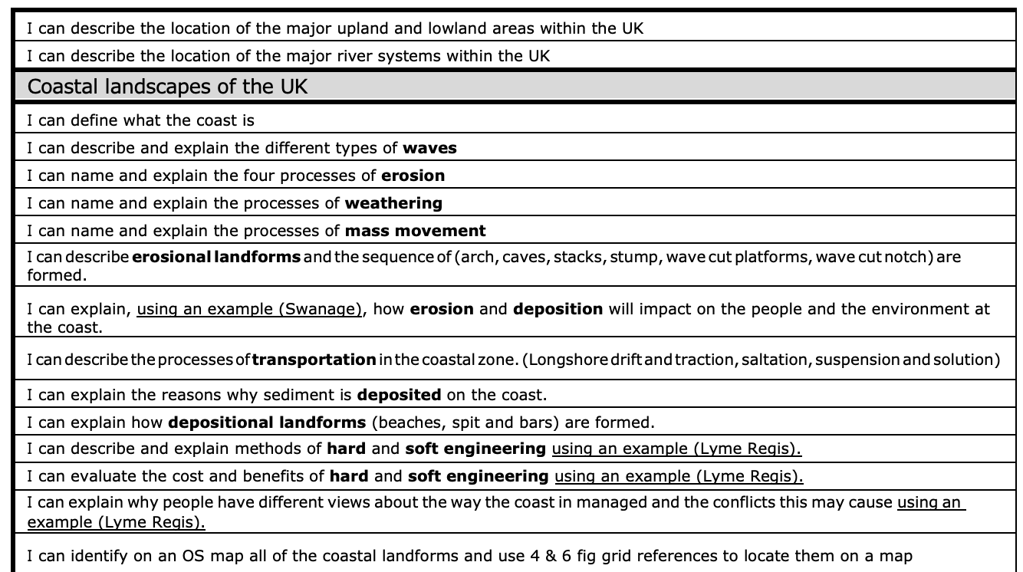

Coasts: Workbook

The UK has a range of diverse landscapes

The map shows a range of upland, lowland and coastal areas in the UK. Study the map. You need to know a range of upland, lowland and coastal areas.
1. Where there are blank boxes, write the mountain range or river names.
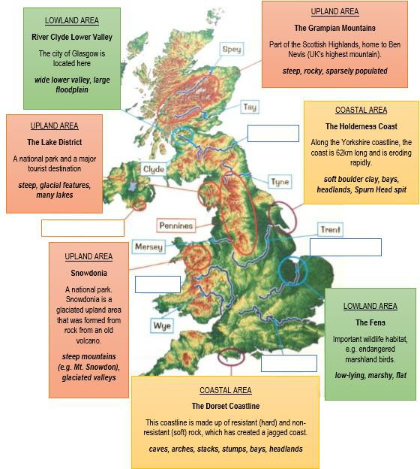
What is the name of the red line and what does it represent?
1. Using the map, complete the following sentences by filling in the gaps or deleting incorrect terms.

a. Steep land tends to be found in upland / lowland areas.
b. Flat land tends to be found in upland / lowland areas.
c. Two lowland areas in the UK are _______________________and ______________________.
d. The River Ouse is found in the lowland area of_________________.
e. The lower valley of the River Clyde is home to the Scottish city of ____________.
f. Two upland areas in the UK are and
.
g. The mountain of Ben Nevis is found in the _______________Mountains in the country of_____________________.
h. The Mount Snowdon is found in ___________________National Park in the country of_______________________.
i. Along the Dorset coastline, it is the alternating bands of ______ and _________ rock that has caused a jagged coastline.
j. The Holderness Coast is __________________very quickly, at around 1m per year and up to 10m in some places.

The coast is shaped by a number of physical processes

Study the diagrams below showing waves types
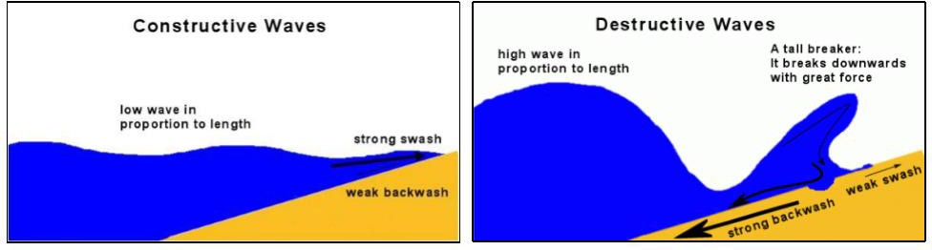

3. Define swash and backwash.
________________________________________________________________________________________________________________________________________________________________________________________________________________________________________________________________

4. Study the photo below of Beachy Head and Seven Sisters near Brighton in England. Based on what you can see in the photo, say which wave type mainly occurs there (constructive or destructive), then offer reasons for your choice.

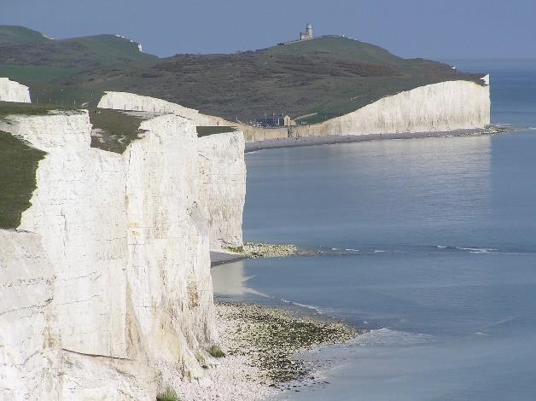

Main wave type___________________________________________________
________________________________________________________________________________________________________________________________________________________________________________________________________________________________________________________________
________________________________________________________________________________________________________________________________
5. Explain how freeze-thaw weathering can cause coastal cliffs to break up.
________________________________________________________________________________________________________________________________________________________________________________________________________________________________________________________________
________________________________________________________________________________________________________________________________

6. The photograph below shows cliffs in North Yorkshire, which suffered mass movement in 1993. Explain what causes mass movement to occur

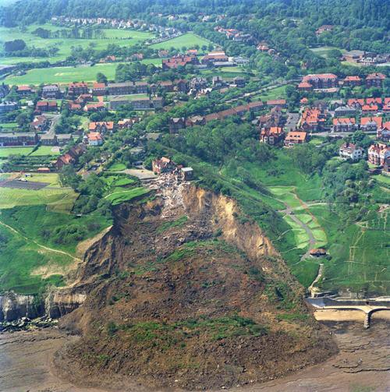

________________________________________________________________________________________________________________________________________________________________________________________________________________________________________________________________
________________________________________________________________________________________________________________________________

7. In the boxes provided, draw labelled diagrams to show how the processes of hydraulic power, abrasion and attrition erode rock.

Hydraulic power | Corrasion | Attrition

8. Label the diagram to show the process of longshore drift and how it affects a coastline. You should include a range of terms such as: swash, backwash, erosion, transportation, deposition.

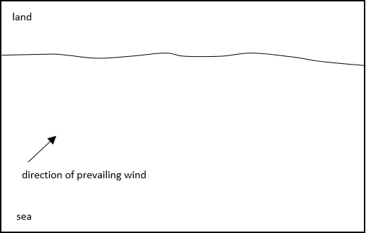

Distinctive coastal landforms are the result of rock type, structure and physical processes.

9. The map below shows the geology of part of the Dorset coastline. On the map, show how the coastline is likely to change in the future. Annotate the changes that you make with brief explanations.

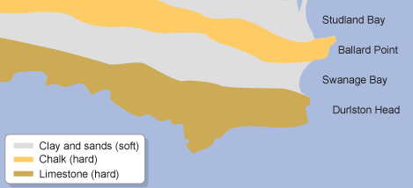

10. Using a diagram, explain the formation of a cave, arch and stack.

11. Explain how a wave-cut platform is formed.
________________________________________________________________________________________________________________________________________________________________________________________________
________________________________________________________________________________________________________________________________________________________________________________________________

12. Which of the following statements are true? Shade two ovals only.

a. Depositional landforms occur where swash is strong.
b. A spit is an erosional landform.
c. A coastal bar forms when longshore drift deposits sediment across the entrance to a bay.
d. A headland is a depositional landform.
e. A wave cut platform is a depositional landform.

13. Next to each image below, name the coastal feature and say whether it is formed by erosion or deposition.

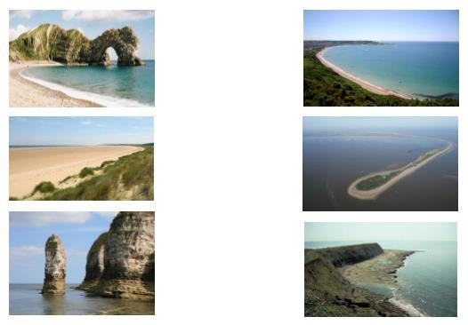

14. Complete the table below to help you revise your named example of a section of UK coastline.

A named example of a section of coastline in the UK

My example: Dorset coast around Swanage (p102-105)

An example of one depositional landform found on this section of coastline. Include a diagram or sketch of the feature and its name if it has one. Stretch: say how the feature is likely to change in the future.
An example of one erosional landform found on this section of coastline. Include a diagram or sketch of the feature and its name if it has one. Stretch: say how the feature is likely to change in the future.

Different management strategies can be used to protect coastlines from the effects of physical processes

15. Define hard engineering.
________________________________________________________________________________________________________________________________________________________________________________________________

16. Using the annual sea wall maintenance cost data provided, identify the mode, median, mean and range.
Year | 2011 | 2012 | 2013 | 2014 | 2015 | 2016 | 2017
Annual costs (thousand £) | 20 | 30 | 18 | 62 | 36 | 20 | 24

Mode_________ Median_________ Mean__________ Range_________

17. Select one of the following hard engineering strategies: sea walls, rock armour, gabions or groynes.
Draw a labelled diagram to show how your chosen strategy protects the coastline.
Chosen strategy:______________________

18. Select one of the following soft engineering strategies: beach nourishment, dune fencing or dune regeneration.
Describe how it protects the coast, and outline one advantage and one disadvantage to the strategy.

Chosen strategy:_______________________
How does it protect the coast?
________________________________________________________________________________________________________________________________________________________________________________________________
Advantage
________________________________________________________________________________________________________________________________
Disadvantage:
________________________________________________________________________________________________________________________________

19. Suggest why managed retreat may be an appropriate response to coastal erosion in some cases.
________________________________________________________________________________________________________________________________________________________________________________________________
________________________________________________________________
20. Complete the table below to help you revise your example of a coastal management scheme in the UK

An example of a coastal management scheme in the UK
Lyne Regis
Identify the location of your chosen coastal management scheme on the map. Be sure to label the place name. | Provide a sketch drawing of your chosen coastal management scheme.
Explain the reasons why management was needed along this stretch of coastline. | Describe the management scheme and explain how it helps to protect the coastline.
Describe the impacts/effects of the management scheme. | Outline the conflicts or problems that have arisen from the scheme. (You might refer to economic or environmental problems, or to disagreements between stakeholders.)

