EDUQAS
FOOD AND NUTRITION
Raising Agents
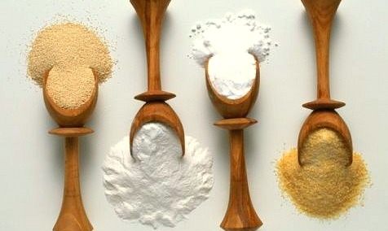
Pupil Name |  | DATE
 |  | Task | Marks available | Marks achieved
Grade Boundaries |  | 1 | 20
9 | 68 plus | 2 | 26
8 | 60 - 67 | 3 | 8
7 | 51 - 59 | 4 | 30
6 | 42 – 50 | Totals | 85
5 | 34 - 41 | GRADE ACHIEVED
4 | 25 - 33

SECTION 1 - Raising Agents

- List foods which need raising agents to produce the correct characteristics of baked products.

Food Products | Identify what sensory properties these baked products will have once cooked.

(16 marks)

- List the 3 common raising agents.

(3 marks)

- What is self raising flour?

(1 mark)

SECTION 2

- Use the words below to complete the statements :

expands | trapped | heat | holes | heated
texture. | moisture | structure | acidity | sponge

The action of |  |  |  |  |  | (or all 3) triggers a reaction with the

with the specific raising agent to produce gas. Gas |  | when

Gas becomes |  | as it bubbles through the mixture.

When heated the bubbles form a firm |  | containing tiny |  | left by the

expanded gas. This gives products like cake a |  | like
(10 marks)

- What are the 6 mechanical methods of introducing air into mixtures?

(6 marks)
- What should a successful baked product with a raising agent be like?

(4 marks)
- What happens to a cake if a raising agent isn’t added?

(3 marks)
- Why is this?

(2 marks)
- What is added in the chemical raising method?

(1 mark)

SECTION 3

- What is Bicarbonate of soda.

(1 mark)
- Why isn’t it used by itself very often?

(2 marks)
- What is baking powder?

(1 mark)

- What effect does cream of tartar have on bicarbonate of soda.

(2 mark)

- Fill in the missing words in the statement below.

Baking powder needs |  | and |  | to create

(3 marks)
SECTION 4

Complete the following.

- Mechanical

Manually |  | air into food products using

The processes of:

(5 marks)
- Chemical

Adding a chemical which causes a chemical reaction producing

In an oven the CO2 gas expands and |  |  |  | the mixture.

Some of the gas escapes but some is |  | in the mixture as it cooks and sets

Examples in food production include:

Bicarbonate of soda is used to make |  | this is a bread which does not use

as the raising agent.

Bicarbonate of soda plus |  | equals baking powder.
(10 marks)

- Biological

A biological raising agent is added which produces |  | gas.

The |  |  |  | is activated during bread production when

 | is combined with |  | in a warm moist condition.

When the |  | yeast is added to the |  | and warm liquid it increases in

 | during the |  | stage. | Example:

(10 marks)

- What are Yeasts?

(1 mark)

- Where are they found?

(2 marks)

- What can become fermented by yeasts and becomes unfit to eat?

(2 marks)

