Year 7 Drama @ Cirencester Kingshill School

Name:______________________________

Form:________ / _____

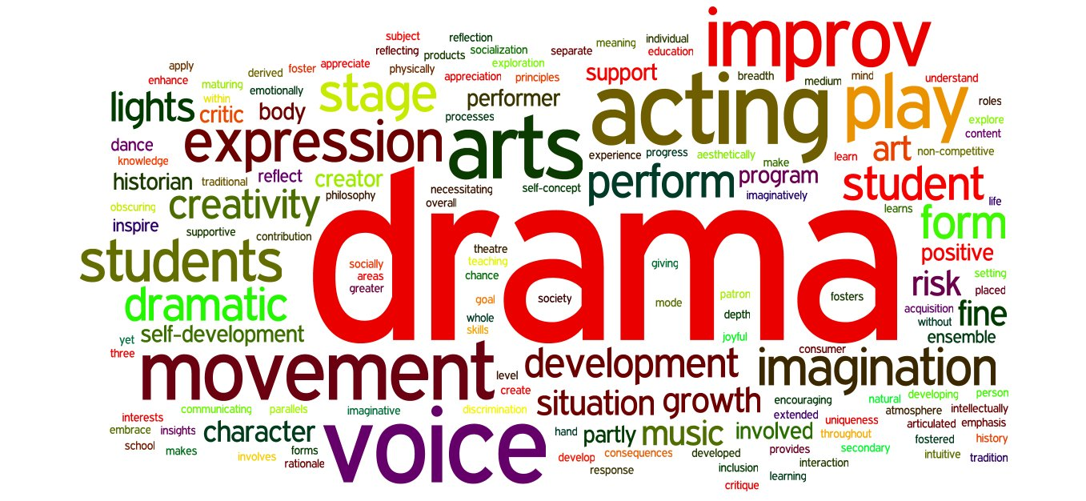

This is a place to record your thoughts, ideas and progress…..
Enjoy! Ms Stones

We will be looking at how the Ancient Greeks explained the beginning of the world and creativity. You will be using your body, voice and space to tell stories and seeing how we use Drama techniques to explore ideas more deeply.

Find out as much as possible about the myth of Prometheus and the fire
- Describe/ draw the 5 still images you used to tell the Ancient Greek Story “In the beginning….” add your narration.

- Describe “The Stealing of the fire”

- Design your God/ Goddesses costume and props. Explain why you have made the choices you have. What do you think about Prometheus stealing the fire?

- Write a diary/ draw a picture explain Prometheus’ punishment.

If/ when you complete this then learn a a monologue from Macbeth
We will be looking at how to use you voice to paint pictures and make text come alive. You will be learning and performing a section from Macbeth

Macbeth Act 1 Scene 7
Macbeth Monologue Act 1 Scene 7
This well known monologue from Macbeth is one of Shakespeare’s finest. It displays his poetic genius in lines like “Shall blow the horrid deed in every eye, that tears shall drown the wind.”, whilst also showing his is uncanny humanity. We see a man struggling with his conscience. Macbeth is dealing with the internal conflict of whether to follow his ambition or to remain loyal.
Hopefully most of us haven’t ever considered murdering our way to the top, but we can recognise this familiar struggle with our ambition. We understand what it is to want something, whilst still feeling like we can’t be dishonourable or disloyal. Finding the universality of this monologue is the best way to approach it.
Step 1: Understanding the Play
We always begin our monologues unpacked by working out the broader story we are trying to tell. Understanding the play is vital to understanding the monologue. You simply have to read the play.

At the start of the play we see Macbeth on the battle field. He has just won an important battle for King Duncan. Macbeth is a Thane and has so far proved a brave and loyal servant to the King. He is told a prophecy by a group of witches that he will one day be King, and encouraged by his wife, he decides to take action. Macbeth murders the King and takes the crown. To maintain his power he must kill many more and is eventually overcome by guilt and fear. He clings onto his faith in the prophecies, but is eventually undone. A classic tale of unmitigated ambition inevitably causing ones downfall.

Step 2: Understanding the Monologue
Now we have a good understanding of the play and the character, let’s get stuck in.
Macbeth is weighing up whether or not to kill King Duncan in this monologue. Should he follow his desire and take the crown? Macbeth is alone at the start of Act 1 Scene 7…

Macbeth Monologue (Full Shakespearean Text)
Macbeth: If it were done, when ’tis done, then ’twere well
It were done quickly: if the assassination
Could trammel up the consequence, and catch
With his surcease success; that but this blow
Might be the be-all and the end-all – here,
But here, upon this bank and shoal of time,
We’d jump the life to come. But in these cases
We still have judgment here; that we but teach
Bloody instructions, which, being taught, return
To plague the inventor: this even-handed justice
Commends the ingredients of our poison’d chalice
To our own lips. He’s here in double trust:
First, as I am his kinsman and his subject,
Strong both against the deed; then, as his host,
Who should against his murderer shut the door,
Not bear the knife myself. Besides, this Duncan
Hath borne his faculties so meek, hath been
So clear in his great office, that his virtues
Will plead like angels, trumpet-tongu’d, against
The deep damnation of his taking-off;
And pity, like a naked new-born babe,
Striding the blast, or heaven’s Cherubins, hors’d
Upon the sightless couriers of the air,
Shall blow the horrid deed in every eye,
That tears shall drown the wind. I have no spur
To prick the sides of my intent, but only
Vaulting ambition, which o’erleaps itself
And falls on the other.

Modern translation
If I am going to do this murder, it would be best that I do it quickly.
If the Murder of the King could be like a fishing net and grab all the possible consequences at once, I would do it. And I would even give up the after life for it.
But for crimes like this there are still punishments in this life.
By committing evil acts we only teach other people to be more evil, and the evil of our students will come back to get us as teachers. Justice, which is always fair and even, forces us to have to drink from the poisoned cup that we serve to others.
The King trusts me in two different ways.
Firstly, I am his loyal subject, so I should try to protect him, because it is my job.
Secondly, he is a guest at my house, so I should be closing the door on his murderers, not trying to murder him myself.
Furthermore, Duncan has been so humble as King, so free of corruption, that his great legacy will speak for him when he dies, as if angels were playing trumpets against the sheer injustice of his murder.
And pity, like a newborn baby, will ride through the wind with winged angels on invisible horses and spread the news of the horrible deed to everyone around the world. This wind of such horrible news, will cause so many tears that a flood of tears will drown the wind as a hard downpour of rain.

I can’t convince myself to take action. The only thing motivating me is pure ambition, which makes people leap into action and into tragedy.

Unfamiliar Words
Spur: Incentive, stimulant.
Trammel: entangle, catch up [as in a fishing net] Faculty: function, power, capability
Clear: pure, spotless, faultless
Office: role, position, place, function
Cherubin: cherub, angel; or: cherubim, angels
Stride: sit astride, straddle
Sightless: invisible, unseen
Overleap: leap too far, overshoot

Step 3: Performing the Monologue
Macbeth. What a fantastic character to play. The first step is letting go of any idea you may have of how to play the character. This is going to be your Macbeth, and it’s going to different to anything that’s come before. So many great actors have taken on this role and each brings their own unique twist, you have to do the same.

Always focus on sense and clarity when performing this monologue. It’s a complex one which has some difficult metaphors that really take time to unpack. Work through it slowly and make sure you understand what you’re saying.

The key to nailing this monologue is the inner conflict. However, you can’t play conflict. I would recommend focusing on what the character has to win and lose. How good it would feel to be King, and how horrible it would be living with the guilt.

In an audition scenario, don’t feel you need to play the “Scottish warrior” and instead focus on living in the imaginary world. Keep it simple.
Film yourself!

