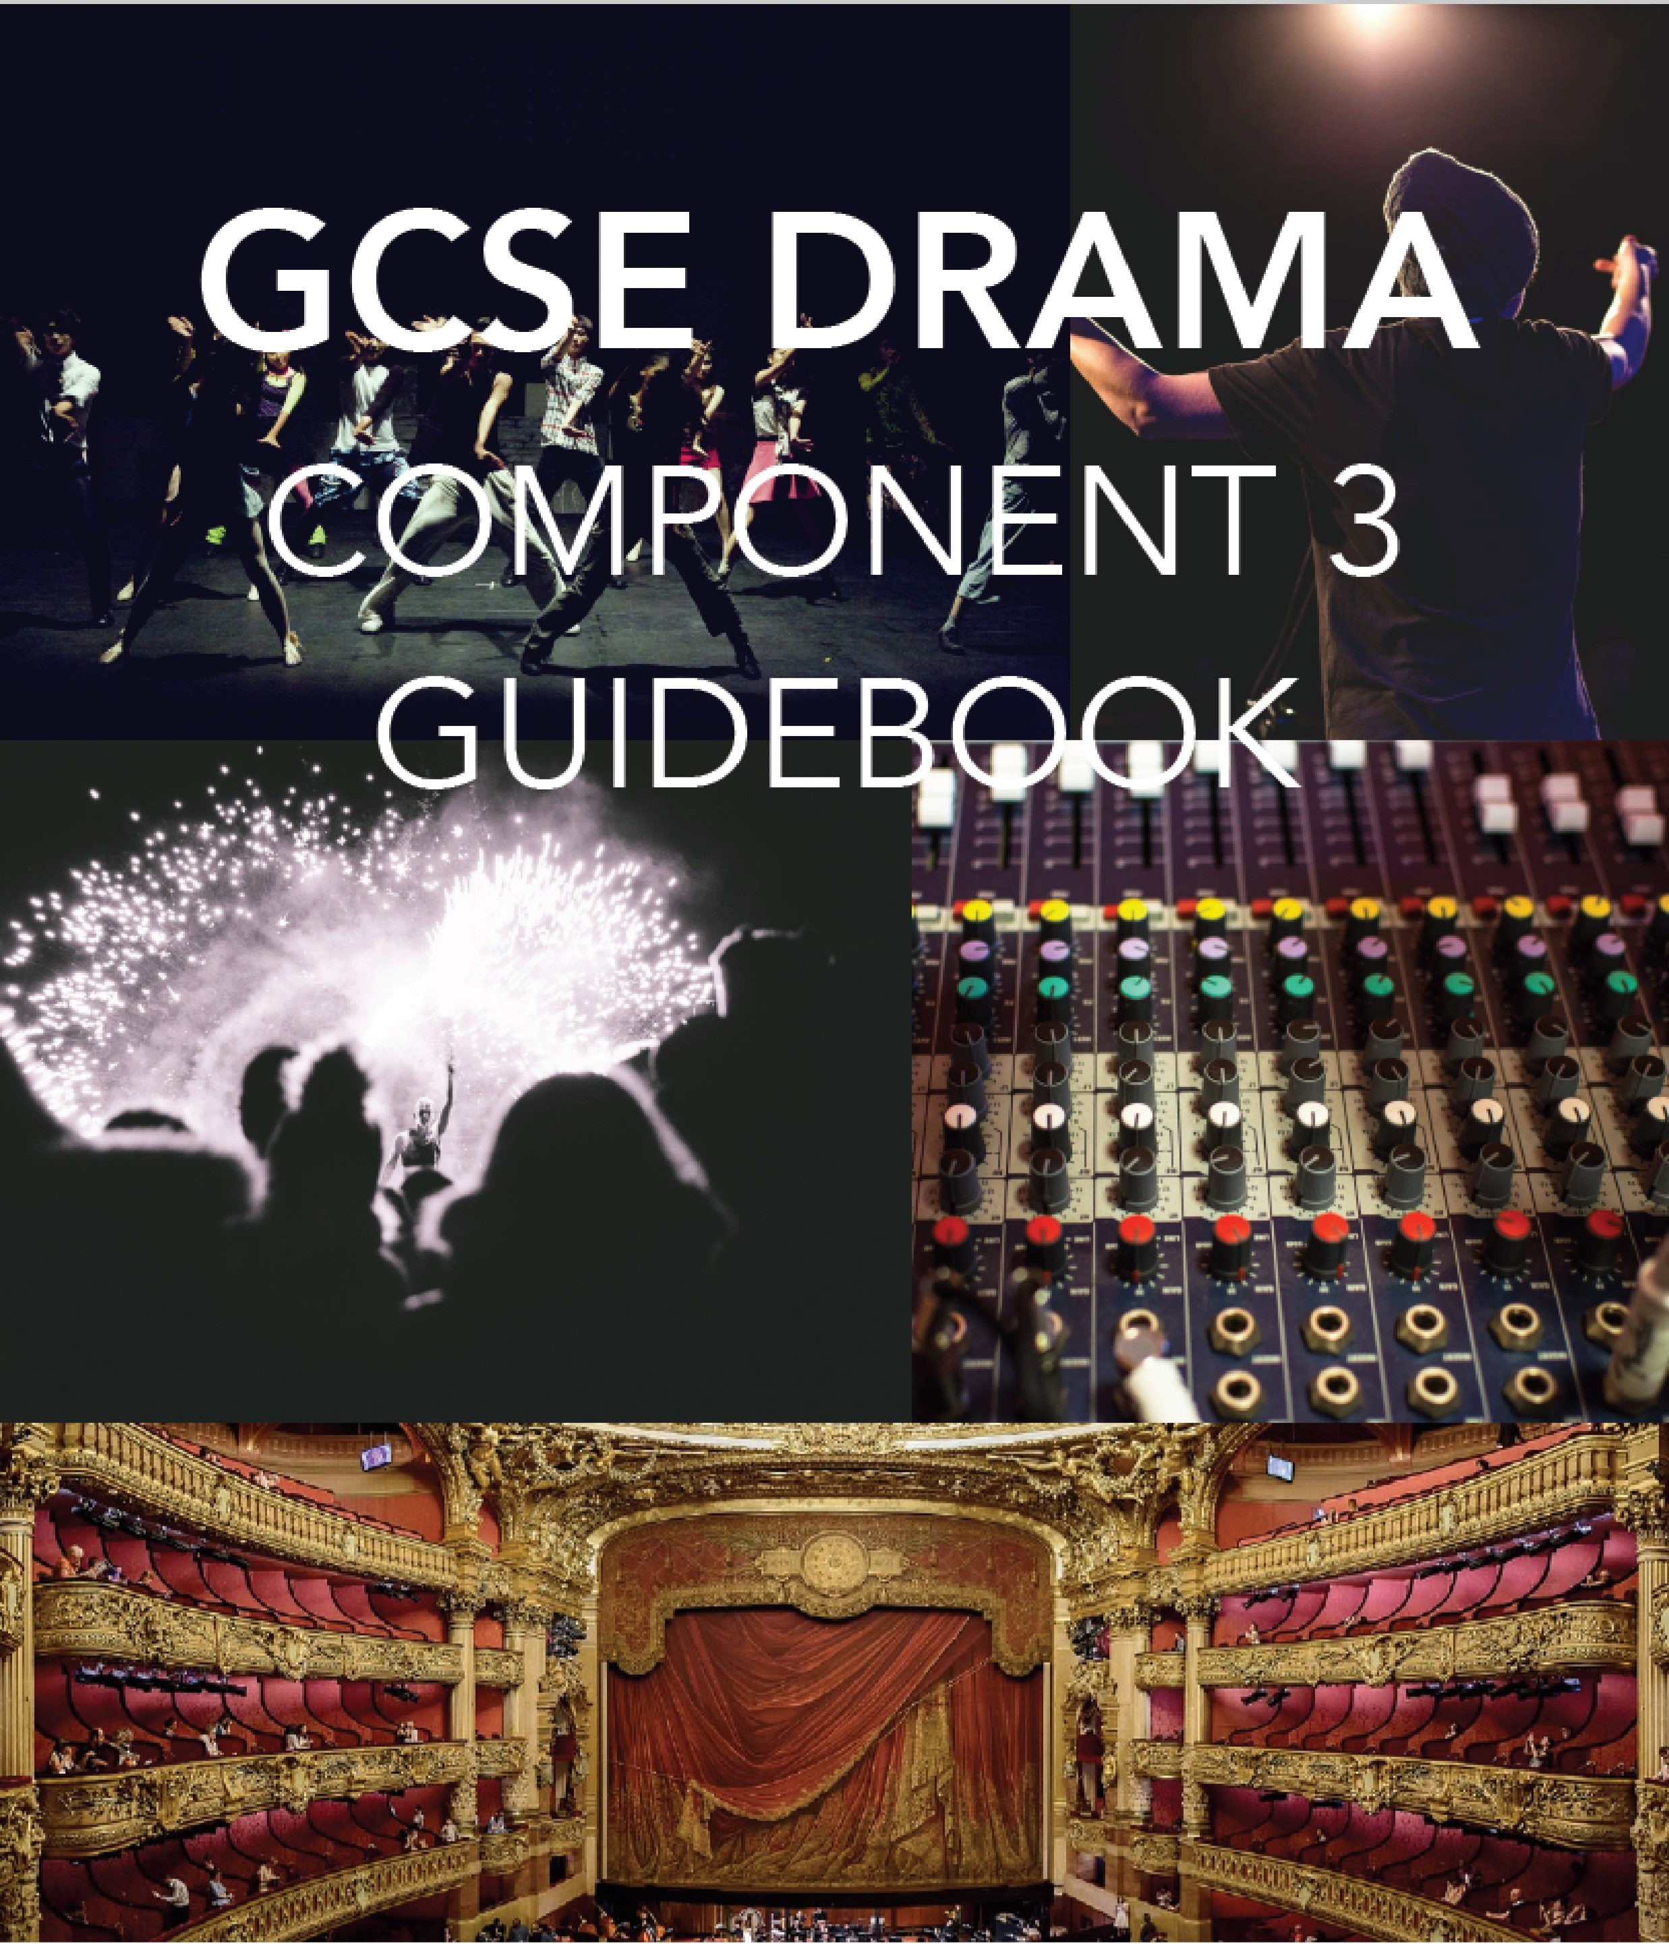
NAME:__________________________________________________
Page
of
1
42

Throughout this guide there are a number of symbols used to help you.

A medal highlights best practice to maximise marks.

A book suggests further reading.

A loudspeaker points out important information which you must

take note of
to avoid losing marks.

Component Overview 3
Section A Introduction 3
The Structure of ‘DNA’ 4
Themes 5
Playwrights Intentions & Genre 6
Historical Context 6
Character Breakdowns 7
Production Concept 15
Original Performance Conditions 23
Rehearsal Techniques 24
Performance Terminology 27
Example Paper 27
Section B Introduction 32
Performance Analysis Checklist 33
Writing a Successful Review 34
Example Questions & Answers 36
Final Tips for Sections A & B 39

Component Overview
The written exam comes in two sections. The first section will test your ideas for and understanding of the set text, the second will test your ability to review a piece of live theatre you have seen.
The exam lasts 1 hour and 30 minutes and is worth 40% of your overall grade.

Section A Introduction
You will study ‘DNA’ by Dennis Kelly across the two years of your GCSE course. You will explore it practically from the perspective of an actor, director and designer.
Your practical exploration of the text will lead to you preparing your own production of the play. You will not present a performance of your concept for the play, you will instead write about your ideas in response to a series questions in the exam. Below are the areas the exam board say you may be tested on in the written paper.
- The characteristics of the performance text, including; o genre o structure o character o form and style o language/dialogue o stage directions
- The social, historical and cultural context including the theatrical conventions of the period in which the performance text was created
- How meaning is interpreted and communicated through performance conventions
- Use of performance space and spatial relationships on stage, including the impact of different stages (proscenium arch, theatre in round, traverse and thrust) on at least one scene
- Relationships between performer and audience
- The design of lighting, sound, set (including props) and costume and make-up - The actor's vocal and physical interpretation of character.
This element is worth 45 of the 60 marks available in this component.
You are allowed to take a copy of ‘DNA’ into the exam but it must be a clean copy with absolutely no annotations or highlighting at all. If your copy is found to have notes or highlighting this will be treated as plagiarising/cheating. Check with your teacher if you can make notes on the copy you are working with in lessons.
DNA premiered in 2008 at the National Theatre before going on a national tour. It follows a group of teenagers, who have accidentally killed one of their classmates. When they realise what they have done, they try to cover up this crime, inadvertently implicating an innocent man in the process. As the play progresses, their situation gets steadily worse and, at each turn where they could come clean they decide to take further dishonest action making their situation even worse. It is an exploration of gang mentality and the themes of bullying, youth violence and power.

The Structure of ‘DNA’
The play has what is called a cyclical narrative. This means that the same structure is repeated in each of the four sections. The structure is as follows-
The section is introduced by Mark and Jan who grab the audience’s attention by discussing the “problem” which will be dealt with in the following scenes of this section.
Then we have a scene between Leah and Phil where, in abstract terms, Leah discusses a theme or the behaviour of the group.
We then move onto a group scene, where we see the group deciding how they will fix “the problem”.
Finally, there is a scene with Leah and Phil again discussing the effect of the group’s suggestion of how to fix their “problem” and again discussing the deeper issues of the play.
This sequence is repeated throughout the play with a new “problem” being dealt with in each section, for example, in Section 1 the problem is that Adam is dead, in Section 2 it is that a real person has been framed for Adam’s murder, in Section 3 it is the Adam has returned and in Section 4 it is that the group cannot deal with their actions.
Section 1- Adam is Dead & The Plan is Hatched
Scenes
1: A Street (p9-10) | 2: A Field (p10-12) | 3: A Wood (p12-26) | 4: A Field (p26-28)
Jan & Mark | Leah & Phil | Lou, John Tate, Danny,  Richard, Cathy, Brian, Mark, Jan, Leah & Phil | Leah & Phil
Section 2- The Postman is Framed
Scenes
1: A Street (p29-30) | 2: A Field (p30-32) | 3: A Wood (p33-41) | 4: A Field (p41-43)
Jan & Mark | Leah & Phil | Phil, Leah, Lou, Danny,  Richard, Cathy, Jan,  Mark & Brian | Leah & Phil
Section 3- The Return of Adam
Scenes
1: A Street (p44-46) | 2: A Field (p46-48) | 3: A Wood (p48-60 | 4: A Field (p61)
Jan & Mark | Leah & Phil | Cathy, Brian, Leah,  Mark, Lou, Jan, Adam &  Phil | Leah & Phil
Section 4- Normal Life Continues?
Scenes
1: A Street (p29-30) |  | 2: A Field (p30-32)
Jan & Mark |  | Richard & Phil

Themes
Bullying- One of the obvious themes is bullying. Most of the characters are bullied throughout the play and it seems that they use bully to assert their dominance over one another. The most horrific example of bullying is the gang’s treatment of Adam. He wants to be part of the gang so desperately that he is willing to suffer the group’s bullying at all costs. Even when we find out he is alive, he still is not spared and is subjected to further jibes and bullying. Eventually, the bullying leads to his real death. Note that some characters bully others more readily and more easily than others. It would be good to map out who the main bullies are and who just goes along with it. Mark and Jan’s description of Adam’s death will help you work this out.
Gangs- The group we follow in ‘DNA’ are a gang. Adam is of course on the fringe of the gang and is desperate to be a fully fledged member, which makes him a target for their bullying (see above.) However, we also see a few other characters who are on the fringe of the gang and want to be accepted. They are willing to sacrifice their morals and do terrible things to be accepted by the others. Analyse the group scenes and see who you think could be described as being on the fringe of the gang.
It is this idea of how dangerous a gang mentality can be that Dennis Kelly says inspired him to write the play. Read the interview with Dennis Kelly later in this section and see if you can find links to this theme in what he says.
Power- There are constant struggles for power within the gang throughout the play. Kelly even suggests that there have been struggles within the gang before the events of the play begins- look at the conversation between John Tate and the others in the first group scene about who’s “side” everyone is on. The role of leader is not fixed and changes as the character’s statues rise and fall. Initially John Tate is the leader – his ability to ban the group from using the word ‘death’ is an example of him attempting to control the escalating hysteria in the group. Richard then appears to be contender for the role of leader but doesn’t manage to successfully challenge John and falls away. Phil’s brooding personality and ease with violence and control certainly qualifies him for the role. Finally, having committed the act of murder, Cathy emerges from the role of follower to become a leader as the others are terrified of her. .
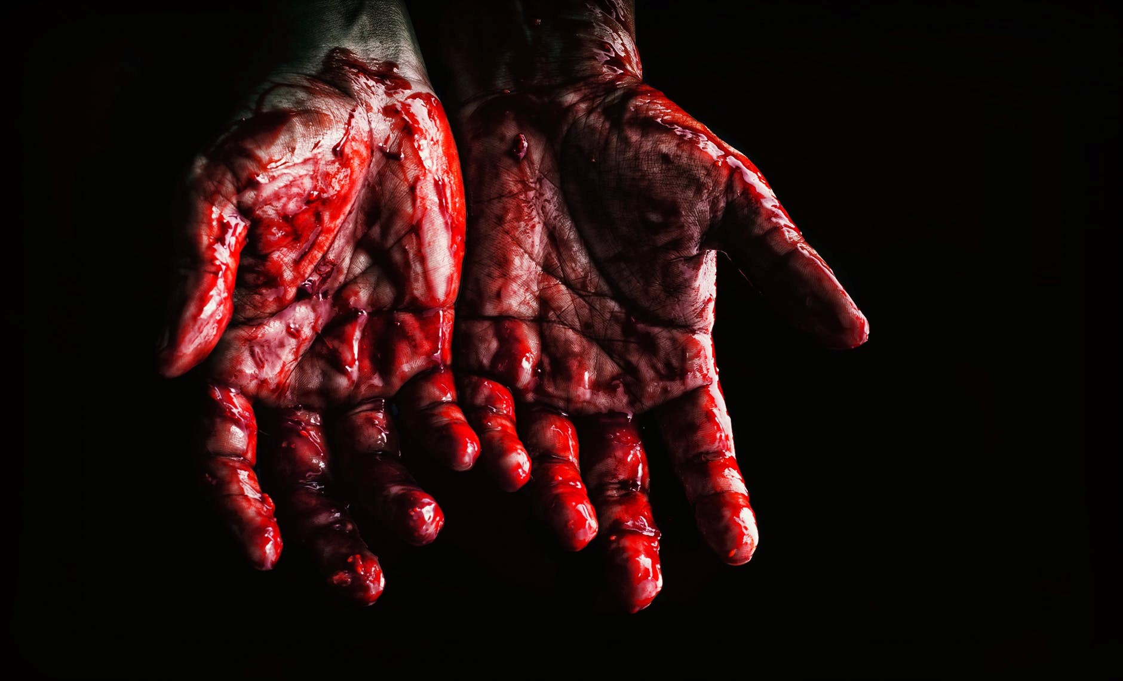
Violence- The gang is ruled by violence. They have committed a violent act which binds them together but they also threaten violence against one another too in order to gain power. Some of the violence is explicit, some of it is implied. Think of the way that Leah speaks to Phil about monkeys versus his quiet brooding dangerous character. Nevertheless, violence is bubbling away underneath each scene whether it is implied, spoken about or carried out.

Playwrights Intentions & Genre
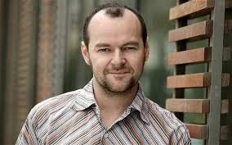
It is important that you understand why Dennis Kelly wrote the play, in other words what his intentions for the play were.
Once you know why he wrote the play, you should then think about how you can incorporate his intentions within your own production.
When asked what inspired him to write DNA, the playwright Dennis Kelly answered:
“Oddly it was to do with western foreign policy. At the time, people were becoming
increasingly scared of terrorism (as they
are now). I felt our fear meant we were in danger (as we are now) of over-reacting and curbing our own liberties and the liberties of others. So I began to ask myself whether it was right to sacrifice the individual for the many – this for me is the central question in the play. What the characters are struggling with in the play itself are questions of how far they should go to protect the group – how many wrong things you can do for a greater purpose.”
(An interesting interview with Kelly can be found here- http://www.telegraph.co.uk/culture/ theatre/theatre-features/9052744/Dennis-Kelly-Rioters-thought-there-were-no-rules-butmy-characters-know-right-from-wrong.html)
In terms of genre, the play has been described in many different ways. One reviewer
Ensure you read the information on Historical Context later in this chapter as it relates directly to Kelly’s point on western foreign policy mentioned here.
described it as a tragi-comedy, meaning it is a play which has moments of comedy and moments of tragedy. Think back to your first read through of the script, it is likely you laughed at some points and gasped at others. These reactions tell you the description used by the reviewer is potentially correct.
But, Kelly said that he didn’t agree with this description. So how does he describe his own play?
“Well I don’t think modern plays tend to fall into such easy categories as they used to. Often plays have humour in them but are tragic at the same time. I think there is humour in DNA but if you call it a comedy that is the element that comes out more in our minds. It takes away from the more tragic elements and makes them feel slightly glib – after all, a child dies and that is not funny. Equally, if you called it a tragedy, the humour would suffer. I think the nice thing about theatre these days is that plays don’t need to be categorised, they can just be..,”
So perhaps rather unhelpfully Kelly refuses to categorise his play, however, as he concedes the play has moments of comedy as well as moments of tragedy it would be fair to describe it as a tragi-comedy for the purposes of this exam.

Historical Context
You must understand what was happening in the world at the time that Kelly wrote the play to fully know what it is about. The most important events which were occurring the world at the time it was written and first performed are highlighted below.

The War on Terror
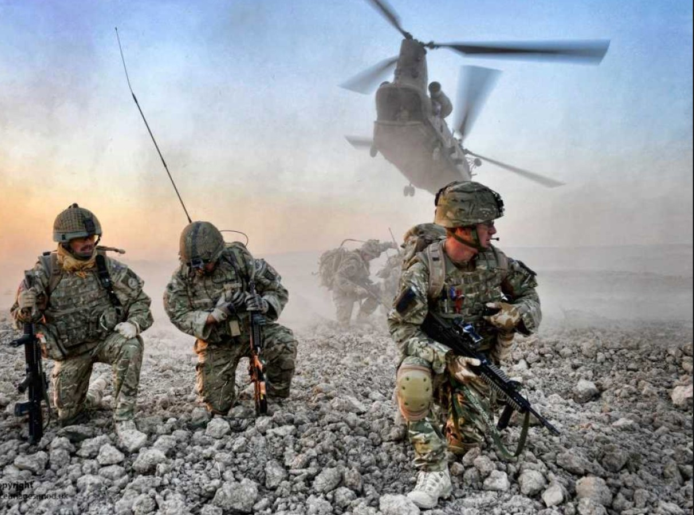
Following the terror attacks of September the 11th
2001, Western foreign policy changed
drastically.
With further terror attacks taking place across North America, Europe and Australia, desperate politicians looked for a common enemy to blame. The finger was pointed squarely at the muslim faith, rather than at the extremists themselves.
With this new enemy serving as a catalyst for action, US President George Bush led a coalition of Western nations, including Britain, into Afghanistan to oust the Taliban government.
We now know that, under the guise of protecting Western citizens from future terror attacks, terrible acts of torture and violence were committed by coalition forces across the region, particularly at Abu-Ghraib detention centre. There are certainly parallels between the “for the greater good” attitude which was adopted by the coalition forces and the attitude of the gang in the play. Whilst President Bush was happy to torture prisoners to get information which could help them win the war, the gang is happy to ruin an innocent man’s life to protect themselves and, ultimately, kill Adam to stop themselves from being discovered.
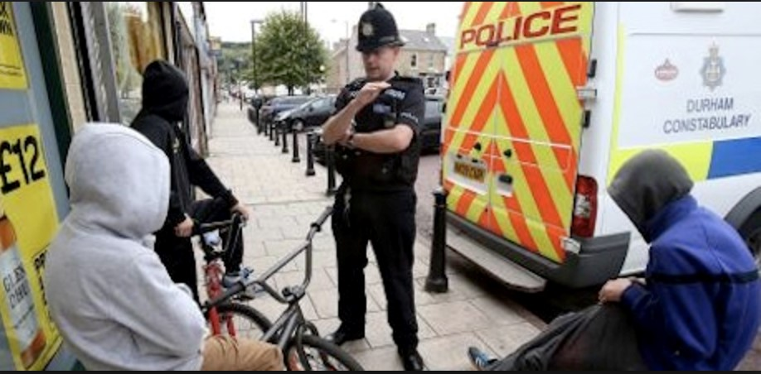
The ASBO Generation
The play utilises the fears of the early 21st century media and population who became obsessed with the idea of lawless or feral children. The media led people to believe that young people were no longer following rules and were descending into anarchy on the streets. We were told that the ‘ASBO generation’ who were ‘plaguing our streets’ needed to be controlled. The
government then introduced a raft of extreme measures such as super high-pitched ‘mosquito’ sirens which only youngsters could hear. The sirens would cause pain inside the heads of youngsters causing them disperse. The demonised figure of the young person in a ‘hoodie’ who resorted to violence and intimidation to get their way played into many of these negative stereotypes. The play reacts to this context of fear not by modelling the behaviour of young people behaving in contrary ways to this stereotype but by satirising such fears through the presentation of these behaviours in such an extreme, and at times blackly comic, way.
Therefore, the play serves to expose those fears for what they are – a media construct.

Character Breakdowns

Mark and Jan
These characters act as our narrators. Each section begins with them throwing the audience directly into the action, introducing the "problem" quickly and dramatically. They also fill in any blanks for us surrounding the group's actions and relationships.
Mark and Jan are responsible for the events surrounding the bullying of Adam that lead to him falling into the grille. On pages 20 – 23 we are see a detailed description of the events leading up to Adam's fall. Interesting, Mark and Jan appear to be trying to justify their actions in this scene:
Mark: "We were having a laugh, weren’t we…" (p20).
They say something along these lies numerous times as if trying to wash their hands of guilt. They also try to convince themselves that Adam is actually enjoyed the whole process.
Mark: "Oh yeah, Adam he was laughing harder than anyone." (p21).
We get the impression that Mark and Jan might also be younger members of the group throughout the play. At the very least, they are certainly less able to assert themselves than the others and rarely demonstrate aggressive behaviour. They often look to Phil for reassurance and take instructions from him.
Jan: "Are we going to be in trouble"
Phil: "If you go now and say nothing to no one about this, you won’t be in trouble." (p57).
Key Questions for Mark & Jan:
•What is their relationship? Friends? Boyfriend and girlfriend? Siblings? How will you make this obvious through their use of space and proxemics?
- Could costume be used to highlight that they are younger/ weaker members of the group?
- They are on stage and do not speak for large sections of the group scenes. What rehearsal techniques could you use to prepare these actors to ensure they remain in character even when not delivering lines?

Leah
Leah's main relationship in the play is with Phil. However, this clearly a one sided relationship and it is difficult to say for sure whether the two are boyfriend and girlfriend or if they are simply friends. She is clearly very concerned about their relationship saying things such as – ‘You need me as much as …’ regularly, revealing her insecurity and desire for some response from Phil.
The scenes between Phil and Leah are virtually monologues delivered by her, There is often no reaction at all from Phil. The fact that he never responds and yet she continues to try to connect with him is yet another piece of evidence to prove that he means a lot to her. She tries a variety of techniques to gain his attention. Often she will put herself down hoping that he will then compliment her (again showing her insecurities) but she often talks about intellectual topics such as bonobos, science, nature. These points often seem unrelated to the events of the play but in actual fact often have a much deeper meaning/reveal something about the group so must not be discarded. When Leah begins to get really frustrated with Phil, she resorts to doing something physical to herself and her pet hamster! She also attempts putting Phil down or repeating his name. However, none of these tactics work.
Another important aspect of her personality is that she is the most moral of the gang. She often tries to reason with many of the characters. She is sensible and able to think for herself and often speaks her mind. However, she still falls under the leadership of Phil as she is not strong enough to alter the opinions and actions of anyone in the group.
We are given little to no background information about the characters by Kelly, however, Leah does reveal that both her and Phil have known Adam a very long time and used to go to his birthday parties. She then pleads with him to help Adam, not harm him.
Leah: "It’s Adam, Phil, Adam! We used to go to his birthday parties, he used to have that cheap ice cream and we used to take the piss, remember?" (p58)

Key Questions for Leah:
- Does she love Phil or are they just friends?
How could this be reflected in their use of space/ interaction/vocal characterisation?
- How could you show that Leah is slightly more moral/follows rules than the rest of the group in her costume/make-up/hair?
- What do each of Leah's monologues really mean and how does Kelly use them to reveal the themes/deeper issues of the play?
Then, how in turn will you use these monologues to reveal this important information to your audience?
- Leah repeats the same words or phrases over and over in her speeches. Which rehearsal techniques could ensure her delivery was varied and kept the audience engaged?

Phil
Although he is probably on stage the most out of all of the characters, he rarely speaks.
In the scenes with Leah he only responds to her when she storms off towards the end of the play. Although, he does not ignore her completely, Kelly details his reactions in the stage directions and if you look closely you will see that he sometimes uses facial expressions and body language in response to what she says. This includes the shocking revelation that she killed her pet with a screwdriver – at which ‘Phil shrugs’! (p32)
Phil clearly considers everyone’s words and actions before he speaks. And when he does finally offer his point of view everyone listens to him. He gives calm and detialed instructions to each member of the group as he assigns roles and tasks for them to complete. He is willing to do anything to protect the group and often appears cold, sinister and twisted as his solutions to each of the problems in each section of the play often include violence, lying or twisting the truth. A key quote that justifies his actions, and to a greater extent the central theme of the play
is:
Phil: "I’m in charge. Everyone is happier. What’s more important; one person or everyone?"
The rest of the group are clearly comforted by Phil and look up to him. He has controlling/ reassuring body language. When addressing Lou on p57, the stage directions state that he, ‘Places a hand on her shoulder, smiles, warm, reassuring’ and he calms the other's fears with reassuring lines such as "Everything is going to be fine"
He does not realise that he needs Leah until she has left him- he calls after he when she walks off. Ironically, this is the first time he shows her any affection or acknowledges her but she now wants nothing more to do with him as she is disgusted by what he has become. The play ends with Phil again on stage with another character, seemingly ignoring what they say. However, the stage directions state, ‘Phil is not eating.’ perhaps to show his depression that Leah is gone?

Key Questions for Phil:
- What does Phil really think of Leah? Why does he continue to allow her to be with him if she annoys him so much?
- How could you show Phil's rise to power as leader of the group? Could his physicality change from Section 1-3?
- How could you use costume, make-up and/or hair to show Phil's impact upon the group? Could the others begin to dress like him to show his influence over them?
- Phil is on stage and does not talk for a long time, what rehearsal techniques could help ensure an actor reacts/remains in character at these moments?

John Tate
John Tate is the first leader of the group. He enforces his rule through the use of fear to control the gang. However, his leadership is weak and others have clearly challenged him in the past. He is visibly shaken and struggling to find a way forward during Act 1 Scene 3. He panics and is therefore unable to truly control those around him or the situation as it spins wildly out of control. His only piece of advice is to try to ban the word, ‘dead,’ as it is clearly causing him to panic more and more every time it is mentioned. Here is a clear example of him using fear to enforce his will as he says he will ‘bite their face. Or something.’ if anyone uses the word again. However, his threat also reveals how little power he actually has- his use of ‘Or something’ shows he is clearly not in control of his thoughts, words or the situation.
He then becomes even more insecure with the challenge to his leadership by Richard. Again, given that the only way he knows how to lead is through fear, he begins threatening Lou, Danny and Richard in order that they will submit. His words are very patronising as he talks down to each character –
John Tate to Danny: "you’re on you’re own side, which is, well, to be honest, very silly and dangerous"
John Tate to Brian: "you crying piece of filth"
Key Questions for John Tate:
•How did he become leader when he clearly struggles to maintain control in Section 1?
•Which rehearsal techniques could you use to explore the power struggle between the group before the play began and why would this be important for the actor playing John Tate in Section 1?
- How could you use proxemics or levels to physically demonstrate the loss of status John Tate experiences in his only scene?
- How could you use vocal characterisation to demonstrate the loss of status John Tate experiences in his only scene?

Cathy
From the second we meet her Cathy has no remorse about the group's actions/Adam's "death". She finds the situation the group are in to be ‘exciting’ and ‘better than ordinary life’ (p16) and her excitement grows even further when she is asked to appear on TV to discuss Adam's disappearance. "They might even give me money for it, do you think I should ask for money?" (p36).
Cathy is incredibly heartless. She takes Phil's instructions regarding getting DNA onto Adam's jumper a step further and finds someone who meets the description of the made up post-man and has him deposit his DNA onto the clothing, knowing full well that the police may track him down and arrest him. She claims she did this to simply "show initiative"- but remember that Cathy ultimately becomes leader of the gang so perhaps this is the beginning of her reaching for the top spot by demonstrating that she is not afraid to take action?
She looks up to and is always supported by the leader- whoever they may be at that moment in the play. For example, John Tate backs her up on p7 "Don’t tell Cathy to shut up". and she is also trusted with important tasks such as getting DNA onto the jumper and killing Adam at the end of the play. Cathy's position within the gang continually rises throughout the play as she becomes closer to/ more relied on by the leader and in turn is more feared by the others.
At the climax of the play, Cathy is Phil's ‘second in command’ as she is given the task of killing Adam.
By the end of the play Cathy is now in charge and appears to have grown even further into an incredibly sadistic character. This is due to Phil leaving the the group after Leah's departure.
Richard tells us how Cathy has been acting as leader:
Richard: "Cathy doesn’t care. She’s too busy running things…She’s insane. She cut off a first year’s finger, that’s what they say anyway."

Key Questions for Cathy:
- How could Cathy's change in status be revealed through the use of levels, proxemics and interaction with others?
•How could her changing levels of status be made clear in each group scene?
- How could Cathy's enjoyment of the group's situation be made clear to the audience in Section 1 to foreshadow her sadistic nature in future sections?
- Could Cathy's costume/hair/make-up reveal her dark personality and nature?

Richard
At first, Richard appears to be a strong character and is set up as someone who could potentially be leader of the group. We hear that Lou is scared of him and he presents a challenge to John Tate’s leadership.
However, even although he stands up to John Tate (‘You shouldn’t threaten me John’ p17), he is eventually put in his place when John Tate turns the entire group against him by telling them to choose sides. (Act 1 Scene 3). He then sinks back down the pecking order to a lowly foot soldier of the leader, doing whatever he is told and blindly looking up to Phil for the rest of the play along with the others. Richard's way of dealing with the situations that arise is to become sarcastic and to put others down.
Act 2 Scene 3:
(p36)
Cathy: "It was great"
Richard: "It was shit"
(p39)
Cathy: "Richard, we showed initiative"
Richard: "That is the most stupid-"
Richard is a very negative character and moans whenever he is asked to do something or given instructions by the leader. Perhaps this is why he does not progress in the social hierarchy and Cathy does- he is disruptive to the gang rather than helping them achieve their aims.
By the end of the play, Richard takes the place of Leah. His speech/ monologue takes the same structure as Leah’s where he appears to talk about something unrelated, tries and fails to get Phil’s attention by walking on his hands.
Key Questions for Richard:
- What happened the last time Richard attempted to stand up to John Tate? How could this be explored in rehearsal and how will it inform the actor's performance in Section 1?
- How could Richard's attempted power grab (and failure!) be illustrated to the audience in his use of space/body language/ levels/proxemics/vocal characterisation?
- What does Richard really think of Phil and Leah? He comes to Phil at the end of the play to beg him to return to the group- for someone who has a clear problem with authority it is interesting that he likes Phil even after he has served as leader.

Brian
Brian is the weakest member of the group. He is chosen as the one the ‘fake man’ ambushes in the woods. The other characters see him as weak and vulnerable and that is why they select him to be the one to go to the police with the story of the flasher. They believe he is the most likely to be a victim so the police will fall for his story.
Brian is frequently bullied by all of the characters. Richard clearly dislikes him. Cathy is physically violent towards him and slaps him when he is upset. Finally, Phil threatens him with the same fate as Adam if he does not follow orders (p40).
Ultimately, Brian cannot deal with his guilt surrounding his part in the gang's behaviour. We hear that he is prescribed medication to help him cope and see how he reverts to a childlike state of ‘play’ by Section 3 as his way of dealing with the events.
Key Questions for Brian:
- How did Brian come to be in the gang and why does he stay?
•Do any of the characters behave supportively towards Brian or are they all horrible towards him?
- How will you show that Brian is terrified of characters like Phil and Cathy in his physical and vocal characterisation?
•What rehearsal techniques could be used to create the two different emotional and physical states we see Brian in before and after he has lost his mind?

Danny
Danny is presented as a sensible character and appears as an opposite to the rest of the characters.
Look at the second group scene in Section 2 where Cathy's actions are revealed to have framed an innocent man. Danny is one of the few who worry for his future "You need three references…" (p36) and also that they are framing a man "We can’t let them think it’s him." (p39). He is also one of the few who are not comfortable with the use of violence as a means of controlling others and is visibly shocked when Phil threatens to throw Brian down the grille "Is he serious?’"(p40).
Key Questions for Danny:
- Why is he a member of the gang when he so clearly holds different deals to the others?
- How could his vocal and physical characterisation reveal that he is unsure about the group's course of action?
•How could you use his costume/hair/make-up reflect that he is sensible and follows rules more than the others?

Lou
Lou is a follower. She does exactly as she is told by whoever the leader is at the time. Her dialogue is very simple and she speaks using simple sentences or short phrases. Phrases such as ‘We’re screwed’ (p34) make her appear young/not assertive. This idea is furthered as she clearly relies on being given instruction and appears to believe the lies the group have created (p35)
Lou:" Because he saw him in the woods"
Leah: "He didn’t"
Lou: "He did he-"
Also note here that she is cut off by Leah making it appear as if her words are not important/ the others care little about her opinion. Lou continues to side with the leader of the group, even when Cathy's reign of terror is in full swing. Richard tells us she is playing a "Dangerous game." and he feels "sorry for her."
Key Questions for Lou:
- Does Lou feel the same about all of the leaders? Does she prefer one more than the other? Why? How could this be demonstrated to the audience?
- If you decide she is younger than the others, how could her vocal and physical characterisation reflect this?
- She is more impressionable than the others and will follow others quickly.
Could her costume/physical appearance reflect this aspect of her personality?

Adam
Adam is the victim of the group's bullying. We learn about him through the words of Jan and Mark on pages 20-23. Adam desperately wants to be part of the group and he will do anything to be accepted: Mark: "…He’ll do anything to be part of the group."
When Adam finally appears in Section 3 we find out he has been living in a hedge. He has suffered a head injury and this is evidently still affecting him as his memory is weak and his speech is confused and staggered. Phil then has Brian and Cathy kill him to cover up what they have done once and for all.

Key Questions for Adam:
- How will you use make-up/costume/hair to show that Adam has been living outside and has a head injury?
- How will the actor utilise vocal and physical characterisation to make clear that he is unsettled and unwell mentally in Section 3?

- Adam's speech is important in revealing to the audience what really happened to him once he fell through the grille. Where will you position him on stage to ensure it has maximum impact? How will different stage designs alter your ideas here?

Production Concept
You must show an understanding of how to design and stage your production of ‘DNA’ for the written exam. In other words, you must have your own production concept.
Before you can even begin thinking about your set design, you must decide upon the style you will be working within.
Naturalism- Attempts to create a very realistic world on stage for the audience. Everything should look exactly as it would in real life with very detailed costumes, props and set. The lighting and sounds should be subtle and build the location. Very good for plays with a hard hitting message where you want the audience to be drawn into the world of the characters so they are shocked by the events and feel changed by the experience of watching the production. Popularised by Stanislavski.
Epic Theatre- Is not concerned with creating realistic world’s on stage and seeks to remind the audience they are watching a play constantly. This is done to avoid them being distracted by the plot entirely and rather have them pay attention to the messages and themes within the text. The audience are reminded they are watching a play with the use of techniques such as placards, multi-rolling, narration, projections, stereotypical characters, over the top characterisation, symbolic or bare sets and allowing the lighting and sound equipment to be visible on stage at all times, as well as other techniques. Developed by Brecht.
Theatre of the Oppressed- The action can be paused by the audience in order that they can offer suggestions to the characters on how to improve their situation. Also involves “pop up” performances where actors will start to perform in a public place, amongst an unsuspecting public, so that they can be ambushed by the play’s messages and themes. Has been described as “graffiti theatre”. The productions are always highly political in nature and target communities who are oppressed in a similar way to characters within the play with the aim of helping them find a way to resolve their situation.
Developed by Boal.
Physical Theatre- Meaning, location and atmosphere is created through abstract movements and dances rather than words alone. Can be good to convey difficult topics or messages to an audiences. Also very good for plays with multiple locations very quickly one after another as the actors can use their bodies and movements to create locations rather than relying on lots of set. Popularised by groups such as Frantic Assembly and DV8.
A theatrical style is the manner in which a storyline or message is conveyed. There are a huge host of theatrical styles. Below are short introductions to the most common opti

There are lots of different theatrical styles. It would impossible to name all of them here- even these explanations are very very basic. Do ensure you consider which style would best suit Kelly’s writing style and discuss your choice with your teacher. You should also read around your chosen style and investigate other productions which have been presented in this style.

Types of Stage
Once you have decided which style you will be working within, you should decide on which stage you will present your production upon.
Each of the different stage configurations listed below will effect your audience and performers very differently. There are positives and negatives to each stage type and you will have to decide upon which one best fits your style and ideas.

Be aware that some stage types are better for certain stage types. Ensure you discuss the correct style for the stage type named in the exam.
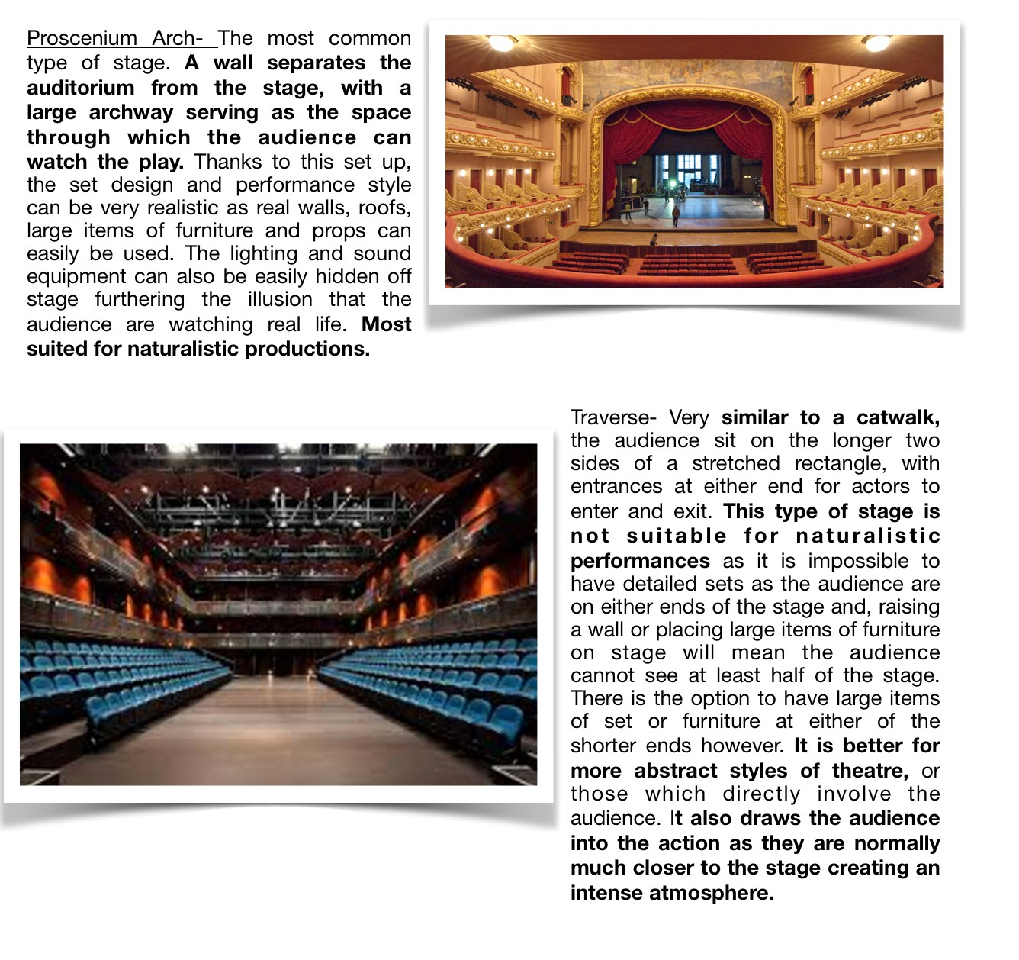

Traverse-

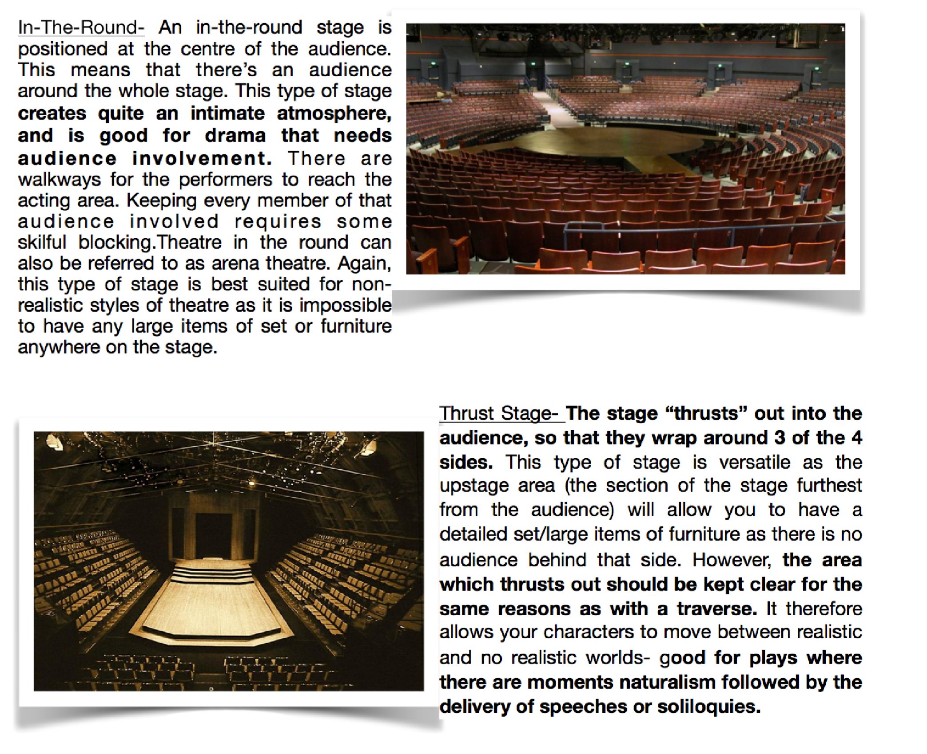
You should also be aware that some stage types are better for other styles than others!
Ensure you use the correct stage type for your style to avoid dropping marks.

.
Now you know what style and type of stage you will be working with, it's time to think about what your production will look like.
Dennis Kelly is very ambiguous about a lot of the play, but one thing he is very particular about are the locations. We move between three- A Forest, A Field and A Street repeatedly and each has a very specific purpose.
One thing which unites each of the locations is that they are outside. Another is that each of them are isolated. The characters are in each of the spaces on their own, discussing and doing terrible things. This helps build the tension.
The fact that each of the locations is nowhere specific (i.e. no specific street, wood or field is named or even alluded to) is a clue to Kelly's intentions for the play. He is warning us that these events could happen anywhere- we are all at risk when we start to follow a "for the greater good" mentality.

Set Design
The fact there are three very different locations which are revisited numerous times will require some thought from you as to how they will be presented on stage.
Will you have three very detailed sets which are carted off and on every single time there is a scene change? Hopefully not as that will become very repetitive and isn't very imaginative.
Below are some questions to consider as you create your set design concept.
Where

Where is your play set? A street/
forest/field in the Middle East will
look very di
ff
erent to how they look in
England.
What atmosphere is
required by each of the
locations?
How will each location change to
show the passage of time? For example,
will the leaves be green in your forest at the
beginning of the play but the trees will be bare at
the end to reflect the cold atmosphere and
represent the death of reason and morality
amongst the group?
What are the themes of the play
which you consider to be important
and how could they be represented
in your set?
What are the most important
aspects of each location which could
be used to hint at each setting? E.g.
could a few tree trunks be brought on to
create the forest? A fence upstage to
create the field? etc.
How will you move between each of the
scenes quickly and e
ff
ectively? Will you have
the stage split into three distinct areas with the area
we are in highlighted by lighting and the other two in
darkness? Or will you have each location fill the
whole space and think of ways to move scenery
o
ff
an on?
Avoid having lots of blackouts between each scene- it ruins any sense of pace and lacks imagination. Instead consider how you could use your set to build and maintain the atmosphere through your transitions between scenes.
Remember that your set design will obviously be impacted very much by the style you have chosen.
Whilst a forest in a naturalistic production should look as realistic as possible, in an Epic Theatre presentation of 'DNA' the forest could be presented more abstractly with simple placards stating "Forest" and "tree" on stage.
Regardless of your chosen style, everything on stage should have a meaning or purpose. These meanings could be, but are not limited to:
- Acting as a symbol for the themes of the play
- Creating an atmosphere
- Reflecting the passage of time
- Setting the location
- Revealing something about the characters or the plot
Below are links to previous productions of 'DNA' and an explanation of how the set was designed/what messages the set was conveying in order to inform your own planning. Each is followed by a commentary explaining the important features and starting points for you.
Example 1- This production chose to enclose the stage in an ominous black void. The stage faded off into nothing, with the floor being painted a grey colour which gradually fades away into black so that it is difficult to see where the stage starts and ends. Similarly, there are no walls or anything to mark the edge of the stage vertically which adds to the unsettling sense of darkness around the location. Darkness is a primal fear for humans- we don't know what is out there watching us. Perhaps the director chose to have the characters surrounded by this darkness to symbolise the fear they each hold of being caught and of one another.
https://i.pinimg.com/564x/7a/b9/97/7ab9974b289e680136b6a9277362f1a7--googleimages.jpg
Example 2- This designer has decided to cover the floor in a mulch/mud mix to create a naturalistic wood environment upon which scenes are played. Perhaps this is an idea to think about if you are aiming to create a truly naturalistic production. Most interestingly, there is also a raised area, with steps leading up to it, in the upstage area. Perhaps this is in place to allow actors to experiment with levels. Given that the play explores status and power regularly throughout the various scenes allowing for levels could be a wise move. https://pbs.twimg.com/media/BtY7q8SIMAAU06z.jpg
Example 3- The director here has mapped out an area for the wood scenes to take place by scattering leaves centre stage. Note that the other areas of the stage are left uncovered to allow the street and field scenes to take place at opposite ends of the stage. This would mean easy transitions between locations with the lighting simply going down on the two areas not in use. There are also four identical screens upstage. Perhaps a comment on the fact the events of the play could take place in multiple locations/ anywhere? http://smartfuse.s3.amazonaws.com/speters.org.uk/uploads/2014/11/
DSC00838-1024x575.jpg
Example 4- This production again makes use of projection, but it is the whole cyclorama (back wall of a stage) which is covered rather than individual screens. This allows the projection of trees to appear oversized and imposing. Perhaps this is to suggest the isolation of the location as well as creating an ominous, eerie atmosphere. Note that the trees here have no leaves- a comment on the lack of life and morality amongst the group perhaps?
http://www.theartsdesk.com/sites/default/files/images/stories/THEATRE/ jasper_rees/_W0D0057.JPG
Example 5- This is perhaps the most simple of all the productions. It is also the original, staging at The Cottesloe in The National Theatre, London. Note that there are no floor covering, no walls, no levels and the set is simply one large screen upstage which changes to create the wood, field and street locations. This has the benefit of allowing quick transitions, but is perhaps too simple to allow you to gain the marks possible in the larger 15 mark questions.
https://itsthetheatregeek.files.wordpress.com/2012/02/dna_196web.jpg
The aspects considered to fall under the bracket of “set” have been highlighted above already, but a checklist of things you could include would help, there is one below:
- Floor coverings (be it painted on, actual material such as bark and grass, loose items such as leaves and branches or a floor cloth)
- Walls
- Furniture
- Large scenic elements (trees, stumps, fences, buildings, higher and lower levels, lampposts etc.)
- Screens for projection
Lighting
Once you know what will be onstage, you should consider how it will be lit.
Lighting is exceptionally powerful and should work with your set to create the location, time and atmosphere as well as highlighting key themes and symbols hidden within
the text.
There are a number of specific types of lantern (the technical term for a device which creates light in a theatre) which you should be aware of in order to gain high marks. They are covered on the next page.
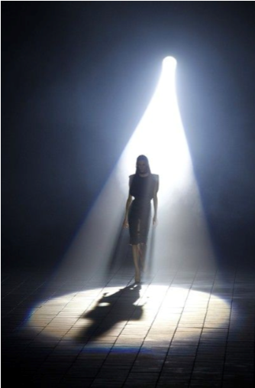
Profile Spotlight- A lantern which creates a hard edged beam of light on the stage. Good for highlighting very specific areas on stage. Notice how the beam has a definite end creating a perfect circle around the actor in the picture to the left, this is what disguises a profile spotlight from a fresnel (see below.) Gels and gobos can be used in profile spotlights (see below.) Only appropriate for lighting small specific areas of the stage.

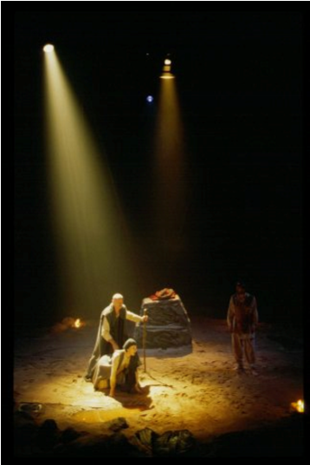
Fresnel Spotlight- This lantern produces a soft edged beam which is good for lighting smaller general areas of the stage. Notice how the edge of the beam fades off gradually into the darkness in the picture to the left. This is what distinguishes this lantern from a profile spotlight. It is more naturalistic. Gels can be used and barn doors (metal flaps) can be clipped onto the front of the lantern to direct the beam towards or away from certain areas
of the stage.

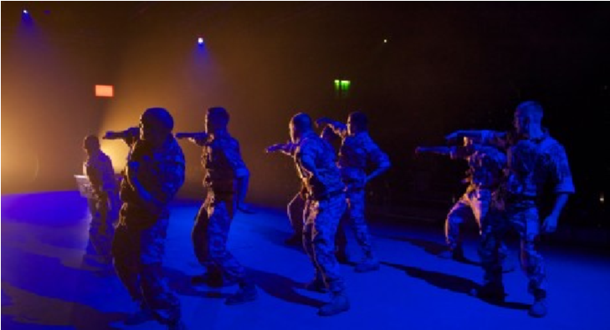
Flood Light- Suitable for lighting large areas of the stage in one intensity and colour, a flood light literally “floods” the stage with light. Good for quickly setting the atmosphere and tone of scenes across the whole the stage. In the example to the left, there is a blue wash across the stage, with 2 fresnel spotlights at the side of the stage to pick up the actors. Gels can be used. Difficult to control so only good for lighting very large areas of the
stage generally.
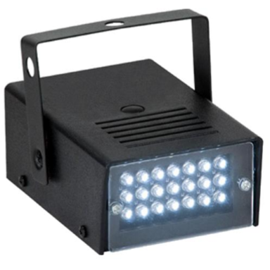
Strobe Light- This special type of lantern flashes a very bright light quickly off and on. This makes the action appear “jumpy”. Very good to highlight drama but should be used sparingly to avoid overwhelming the audience and losing it's impact. Can also be used to create the effect of lightening strikes.
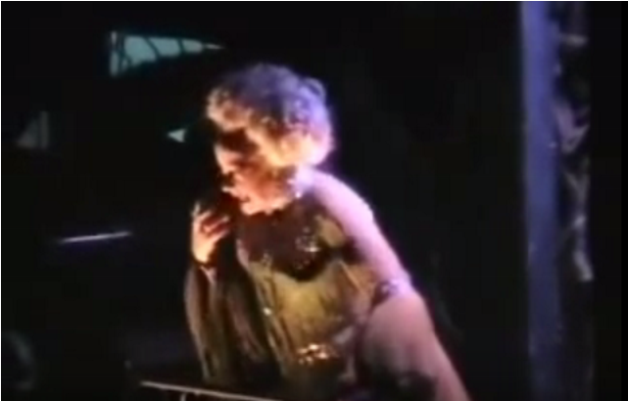
Birdie- A tiny lantern which can be very easily concealed within pieces of scenery. Excellent for the provision of uplighting (when a lantern is located below an actor and shines up onto them from below as in the picture to the left here.) as it is so small and can be hidden anywhere on stage. Uplighting helps to distort facial features of actors and creates an unsettling eerie atmosphere.

Moving Head- This highly versatile type of lantern can be preprogrammed to move so that beams of light sweep across the stage, change colour and project pictures onto the stage as it contains gobos and gels within it (see points on Gobos and Gels below)

Gels are you used to change the colour of the beam. These are coloured plastic filters which are slotted in front of a lantern. They come in a great many colours and shades and must be considered when designing the lighting for a production.
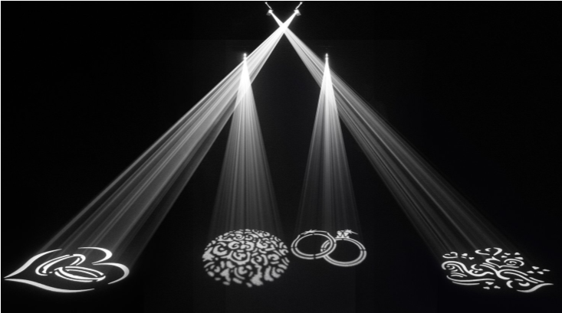
Gobos are metal stencils which are slotted in front of profile spotlights to project an image onto the stage. Examples of 4 different gobos are included in the picture to the left. They can quickly convey locations for the audience, for example, you could use a gobo of light streaming through trees which is projected onto the stage floor when your production moves into the wood to quickly set the location without the need for lots of set.
A lighting checklist...
Each time you make a decision on lighting, ensure each of the following points are considered.
- Lantern- You must consider what are you are lighting in order to know which type of lantern you should use.
- Colour- You should then decide which gel you are going to use, if any, in order to help create the atmosphere/location/time.
- Intensity- How bright or dim a light is will change it’s effect upon the audience and must be considered. In the theatre brightness is called intensity. e.g. scenes taking place in the day will be lit with a “high intensity” wash, whereas scenes taking place in the evening would be lit with a “low intensity”.
- Angle- A light placed on the floor at the front of the stage angled up onto an actor will create a huge imposing shadow behind them. This is called uplighting. The same lantern placed at the side of the stage, shining onto the actor from the wings (side lighting) will make their features appear sunken and gaunt, highlighting their facial expressions. This potentially suitable for very dramatic moments where you want to highlight a character’s reactions to the audience. Finally, placing a lantern above the actor shining down on them from the front (front lighting) is the most naturalistic.

Sound & Music
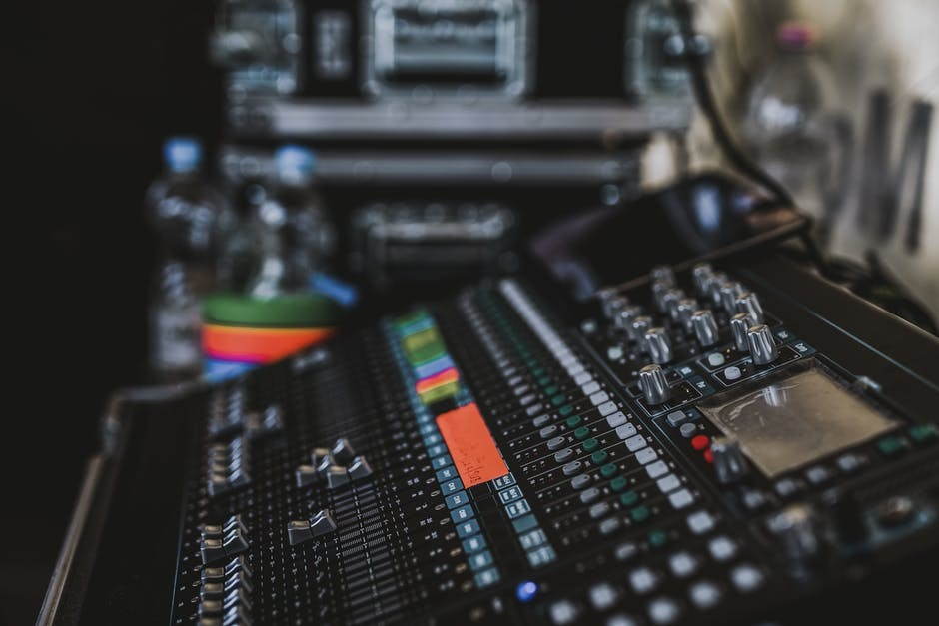
When used correctly, sound and music can add atmosphere, emphasise action happening on stage, help set the scene, indicate a change of time or location or focus attention onto a character.
There are a number of aspects to sound which must be considered when discussing it in the exam.
Live vs Recorded- Do you want the sound to be produced on the stage during the performance (live) or recorded beforehand and played over a speaker system (recorded)?

Diegetic Sound- Sound which is heard by the characters on stage and exists within the world of the play is called diegetic sound. For example, the sound of an alarm clock going off which a character wakes up to and turns off is clearly diegetic as the character reacted to it. The sound of cars passing by played under an outdoor scene would would also be classed as diegetic, even although the characters aren't reacting to it as those sounds exist within the world of the play. How could you use sound to help set your scene's location/time/atmosphere?
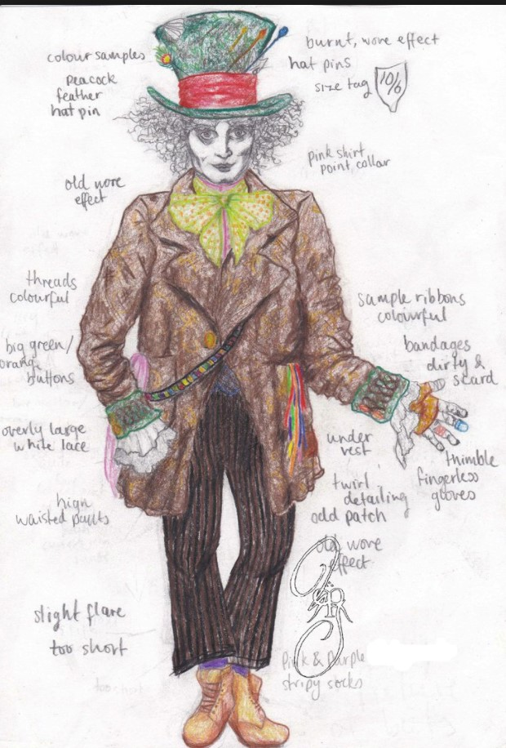
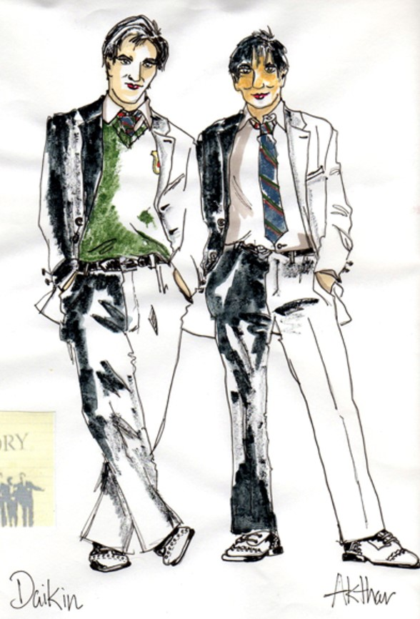
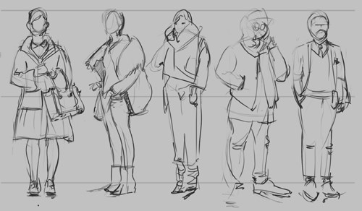
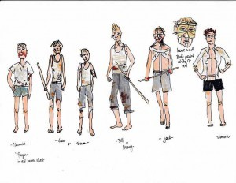
Non-Diegetic Sound- Sound which exists outside the world of the play and has been played on top so that the characters cannot hear it is called non-diegetic sound. For example, if you wanted to have a drone or dramatic music playing underneath a scene where something shocking happens, this would be counted as non-diegetic. Are there any points where you would like to highlight a theme or create an atmosphere through the inclusion of non-diegetic sound?
Do not fall
into the trap of simply having each of the characters in "normal clothes" or
"school uniform". This is much
too general and will get you little to no marks.

Costume
Costume is an excellent tool with which you can use to support the rest of your design concept.
When considering costume, the following points should be given attention.
- Garments- The items of clothing they are wearing
- Material- What are the garments are made of (e.g. a character wearing a silk blouse could suggest they are high status.)
- Condition- A character who was wearing school uniform, with their top button done up, tie done neatly and shirt tucked in would show the audience they are in control and obey rules. A character in a scruffy school uniform with their top button undone and shirt untucked could suggest they are naughty and care little for rules.
- Seasonal- Think about the time of day and year that each scene is set in and ensure that you are dressing the characters appropriately. For example, a scene set outside in winter should have characters wrapped up in coats and jumpers. This will help to create the cold atmosphere.

Original Performance Conditions
You are expected to have an understanding of the original performance conditions of 'DNA'. You should be able to discuss if your own concept is similar to or different from the first performance of the play. You should also be able to justify why your production is similar/ different to the original.
Below are some key facts about the original performance highlighting important points:
- First staged in 2008
- First performed at The Cottesloe Theatre at The National Theatre
- The original stage type was end on, which is similar to proscenium arch in that the audience are all on one side, but there is no arch between the audience and the stage. Rather the front row of chairs stops and the stage instantly begins
- The original actors were the same age as their characters
- Relied heavily on atmospheric lighting and projections to set the scene, rather than having large items of set
- Each character was dressed in a school uniform, with small personalised items to reveal their something about character
To view pictures of the original production click here- http://simondaw.com/portfolio/dna/
Another more recent, and more stylised, production was presented in 2017 by NYT (National Youth Theatre) and again in 2018
- Toured the UK in 2017 and 2018
- Utilised stylised lighting (both stage lighting and handheld torches/lamps/strip lights) to create locations and atmosphere
- Included extra moments not in the script, such as seeing Adam in the grille, to develop upon Kelly's ideas.
- Switched the gender of some characters, John Tate became Jo Tate for example- again making the point that these events could occur anywhere to anyone.
To view production images of the new National Youth Theatre production click here- https:// w w w . f a c e b o o k . c o m / p g / N a t i o n a l Y o u t h T h e a t r e / p h o t o s / ? tab=album&album_id=10154213197253517

Rehearsal Techniques
As well has having ideas for how your performance will look in terms of set, lighting, sound and costume, you must also have ideas for how you would prepare the actors in rehearsal and how they would present their characters during a performance.

Rehearsal
Below is an introduction to some of the most common rehearsal techniques, but there are hundreds of others you may come across.

After the description of each technique is a short note in orange italics, just like this paragraph. This explains how each exercise helps the actor develop their character.

Role on the Wall- An outline of a character is stuck on the wall. The actor then writes everything the character thinks or says about themselves inside the outline. They should also note absolute facts given to them in the script such as their age, their relationships/family, their nationality, their job etc. Outside of the outline they should then write what other characters say or think about them. A very useful way to gather the full picture painted by the playwright to give the actor a detailed blueprint upon which to build their character with a full understanding of their own thoughts about themselves and what others think of them.
Emotional Memory- An actor remembers a point in their life where they have experienced something similar to the character and remembers how they reacted. They then use this memory to colour their own performance. Roots a performance in the real world and therefore makes it more naturalistic.
Hot Seating- An actor sits in front of the cast who ask them questions about their characters relationships, backstory and motivations. The actor responds in character and uses their understanding of the text to improvise answers if required. Allows an actor to develop a greater understanding of their character's motivations and gives them freedom to experiment with their vocal delivery and physicality free of the constraints of the text.
Experimentation with Lighting- Once a scene is set, the performers then run it with one angle/ colour/intensity of lighting used. They could also film themselves doing this if there is no director. The impact of the lighting upon the scene is discussed- did it help to set the location/atmosphere/ tone of the scene or not? This experimentation continues until the correct lighting state is found. Helps to support lighting designers in ensuring their design fits with and supports the work of the actors and vice versa for the actors with the designer's work.
Experimentation with Sound- As above, but a scene is performed with sound effects or music before discussions are held on how effective the effect/music was. As with "lighting" above.
Experimentation with Stage Type- Actors re-stage a scene on a different stage type to see how this effects their own performance and connection with the audience. Discussions are held on which stage type is most appropriate for the style and play. Will allow actors to ensure their acting style matches the stage type and encourages them to experiment with different staging options to ensure they are making the correct choice.
Animal Study- An actor decides on an animal which shares similar characteristics as their character. They observe the animal, noting how it moves and interacts with others. They then use their findings to subtly influence the way in which they move and interact when you are in role. For example, if an actor playing Phil notices he is silent for most of the play, but suddenly jumps to being vicious and violent the could decide his personality is similar to that of a tiger. On observing tigers he would see that they too sit still for large portions of the day, watching others and stalking their prey before attacking. They could decide to adopt the stillness of a tiger contrasted with the sudden sharpness of their movement when they pounce to find a contrast between his movement in the field and wood scenes. Helps an actor decide upon their physicality and how to interact with others. This is particularly useful for when an actor does not have a lot of lines but needs to remain alive.
Ranking Status Levels- Actors perform a scene, getting higher when they feel their character gains status and lower when they feel their character looses status. This should be non-natraulsitic, ignoring any blocking which may have been set. Characters can puff up their posture, climb on a chair or stand on a table to get higher if they wish. They look particularly for the moments where both characters feel their are gaining status as this is where moments of tension and conflict can arise in the performance. Once they have found this understanding of who is high and low status at each moment they return to the scene with it's normal blocking and use their findings to influence their performance. Very good for moments where there is a clear status hierarchy amongst a group, particularly if it is large. Allows the actors space to consider their character's relationships with one another and carry out detailed work on their status in relation to others given that they are not trying to present the scene naturalistically initially.
Actioning- Assigning a verb to each line which an actor can use to influence their vocal and physical delivery. For example, if an actor had the line "Hello, where have you been?" and their action was "to stroke" they would attempt to stroke with their line so perhaps they would smile, soften their facial expressions and use a warm welcoming tone. However, on the same line, if their action was "to push" they could frown with hard facial expressions and make their voice sound like a push with a loud volume and angry tone. Helps to ensure there is variety in the delivery of lines and physical performance. Very useful when an actor has repeated lines or large chunks of text which are in the same vein to ensure each is different.
Levels of Tension (Le Coq's Seven) - Actors abstractly explore moving and sounding out when feeling seven prescribed levels of tension, moving from the lowest (catatonic) up to the highest (tragic). They then consider how each level of tension made them feel and which moments in the play fit each level. They return to their naturalistic performance, knowing which level each moment is for their character, and aim to replicate the feeling of each level of tension in their vocal and physical delivery in a more naturalistic way. Will ensure that an actors vocals and physicality are entirely engaged in each moment and provides variation throughout the play as an actor will constantly move between levels of tension in reaction to the events around them.
Or
Leading body parts/ Character Centres- Actors decide where their character's centre of gravity is placed within their body and experiment with moving around the space leading from that centre. They may find that placing their centre of gravity in their forehead means their head stoops, their shoulders roll forward and they slump into their spine. This perhaps creates a low status character. Maybe then they could experiment with placing their centre of gravity within their chest. This makes their shoulders roll back, their chest puff out and their chin raise. This creates a high status character and affects the speed with which they move around their room and the gait of their steps. Once they decide which centre of gravity is most appropriate for their characters, they return to the scene and utilise their findings in their physical characterisation. Helps an actor create a character's physicality and walk which is entirely different to their own.
Still images- Actors create a frozen image of a moment in the play. Gives actors the space and time to consider how they could use their physicality and the space/levels to communicate with the audience.

Motivation Units & Objectives- An actor splits their script up into chunks (aka units) where the topic of conversation is the same, imagining they are creating "chapters" in the script. These units can be only a few lines or could be a whole page. The actor then decides what their character wants in that unit (aka their objective). They then use this objective to colour their performance in the following rehearsals. Once you hit the end of a unit the actors decide what their objectives are in the next unit and so on until the whole script is split into units and each unit has an objective. Importantly, every character's objective must change whenever a unit changes. Splitting the script up into units is excellent because it makes the actors look objectively at their lines. This ensures there is variation in their performance as each unit has a new objective and therefore requires a new tactic be employed by the actor. This keeps scenes fresh and ensures the delivery and physicality of their performance remains varied.

Off-Text Improvisation- Actors consider moments not included the script which they feel it could be useful to explore. For example, actors could question how Phil and Leah met given that they seem to be such different people. They could then carry out an off-text impro of the first meeting between Phil and Leah, using what they know from the script as a basis upon which they could create their own backstory. They then return to the text with a greater idea of their character's history and back story. Fantastic for developing the relationships between characters. Also gives each actor more depth to their character as it makes it seem as if they exist and have a life beyond the world of the play.
Tug of War / Angels and Devils - Actors deliver pieces of text when they are arguing whilst playing tug of war. As the intensity of their argument increases so too should the intensity of their tugging. They then go back to performing the scene as normal, using their findings to influence their performance. Helps actors to feel a real tension in their physicality and vocal delivery whilst delivering their lines which they then aim to replicate when performing the scene normally without tugging.

Thought Tracking- An actor speaks their character's thoughts out loud before delivering their lines, by improvising what they feel their character may be thinking. Once they know how their character feels and what they are thinking, they then return to performing the scene as normal and use their thoughts internally as the scene progresses. Helps the actor to understand their character's inner workings and motivations. Also ensures they remain alive and appear realistic as, if they are living through their thoughts when performing the scene naturally, their facial expressions and physicality will continue to react to what is going on around them

Rehearsing in Costume- When a character has a particular item of costume which is important to them, it can be useful for the actor to rehearse wearing it quite early on, rather than waiting until the dress or tech rehearsals. This could help them to develop mannerisms and gestures/ adopt a suitable posture influenced by their costume. For example, a character wearing a hoodie all the time may have a slumped posture and, if the hood is up, droop their head to the ground and avoid people's gaze as they feel the hood being up cuts them off from the rest of the world. A character in a gown with a corset would also move in a very different way to how the actor would move in everyday life.
A high achieving candidate will be able to 1. name rehearsal techniques 2. describe what they are 3. discuss the outcome of each technique in terms of it's effect upon an actor's performance in key moments of 'DNA''.

Performance Terminology
As well as showing an understanding of how an actor could prepare for a performance, the paper will expect you to have clear ideas for how an actor could perform a part for an audience.
This means you must have a bank of drama terminology under your belt with which to describe your ideas.
Below is a glossary of important key terms which you must use in answers about the performance of an extract of the play.
Physical Terminology
Body Language- The use of an actor's body to communicate how their character feels. Can be described as "open/closed body language" or in terms of an emotion such as "confident body language". You should always explain how the body language is created too e.g. "Anxious body language with folded arms".
Facial Expressions- The use of an actor's face to reveal how their character feels. Described in terms of emotions such as "an angry facial expression". You should always explain how the actor creates the desired expression e.g. "An angry facial expression with gritted teeth."
Gait- The manner in which an actor walks. Can be described as an "open gait" for large strides or "closed gait" for small steps.
Gestures- The use of an actor's hands and/or arms to show how they are feeling. Normally described in terms of an emotion and followed up with an example such as
"Anxious gestures like wringing his hands."
Posture- The shape in which an actor holds their body to reveal their character's feelings. E.g. "Confident posture with shoulders back and head raised high."
Proxemics- How close/distant an actor stands to/from another character to reveal their relationship.
Use of Space- How an actor moves through the space. Could be described as "confident and directly" or "slowly and indirectly." Also used to describe where the actor places themselves on the stage to reveal their feelings. e.g. confident use of space could be standing in the centre of a room whilst a nervous character may choose to press their
back against the upstage wall.
Vocal Terminology
Accent- Changing the pronunciation of words to make a character's heritage, nationality or social class obvious to an audience.
Articulation- Ensuring lines are delivered clearly so that an audience understands them. Particularly important at moments of low volume or high pace.
Pace- The speed at which an actor delivers a line. Can be described as either a "fast pace" "slow pace" or "moderate pace".
Pitch- How high or low an actor delivers a line. Can be described as either a "high pitch" "low pitch" or "moderate pitch".
Projection- Ensuring a line is delivered in such a way that it fills the performance space and is heard by the audience.
Rhythm- The beat with which an actor delivers a line. Can be described as either a "smooth/confident rhythm" or "a broken/ stuttered rhythm".
Tone- The emotional colour an actor adds to a line. Can be described in terms of an emotion i.e. a "happy tone" or an "aggressive tone." Not to be confused with pitch.
Volume- How loudly an actor delivers a line to reveal their characters feelings. Can be described as a "high volume", "low volume" or "moderate/comfortable volume".
Remember to always use the WHAT, WHERE, WHY structure in Section A, with the WHAT being one of the key terms from this page to maximise your marks.

Example Paper
It has been made deliberately difficult to predict what structure the exam will come in so there are very few hard and fast rules. However, there are some key facts you should know. Below is an example 'DNA' paper for your reference.

DNA Dennis Kelly
Questions (a) to (c) are based on the following extract.
Read from: page 9 "One" to: page 11 "Pause. She sits."
(a)
- Name two rehearsal techniques that a director could use to prepare an actor for the role of Mark in this extract. [2]
- Explain how these two techniques help to prepare the actor for this role in performance. [4]
(b)
- Briefly describe Leah’s peer group. [2]
- Explain how any one line in the extract illustrates her peer group [3]
- Suggest a suitable costume for Leah and explain how it could be used to show her peer group. [4]
(c) Explain how an actor playing the role of Leah in this extract, could communicate her character to the audience. [15]
In your answer refer to:
- character motivation
- voice
- movement
- interaction
(d) Explain how at least one key scene can be designed for a thrust stage. [15]
In your answer refer to:
- structure and style
- set
- mood and atmosphere
- how the play as a whole was originally staged
Note that you are Note that you are given an extract given an extract at here. In the paper the top of the page. you will always have In the paper you will a series of questions always have a series on a stated extract of questions on a and one the wider s t a t e d e x t r a c t text. Ensure you read (which you must all of the information s t i c k t o w h e n carefully to avoid answering these writing about the questions.) You will wrong part of the also always have at
play. least one question on the play as a w h o l e . I n t h i s example that is
question (d)
As you can see, the questions worth the full 15 marks have bullet points to guide you. Ensure you use them as an essay plan and tick them off as you go to avoid missing out crucial information from your response.
The numbers in t h e s q u a r e brackets after each question d e n o t e h o w many marks it is out of.
In this example, In this example, t h e q u e s t i o n s the questions r a n g e f r o m 2 r a n g e f r o m 2 markers to 15 markers to 15 markers. Whilst we ^{markers. Whilst} cannot say that ^{we cannot say} they will always be ^{that they will} broken down this always be broken way, we do know ^{down this way,} that the most a what we do know question could be ^{is that the most} awarded is 15 marks a question marks. will be awarded is 15.

Example Answers
Below are example answers, some are top band, some are middle and some are bottom. After each answer you will find commentary explaining why each answer was placed in each band to help you understand what is expected of you.
Question A
TOP BAND
- The two rehearsal techniques I would use for this scene are hot seating and uniting.
- I would use hot seating so he understands his motivation and relationship with Leah. This is important as Kelly gives little background so the actor must create one. For example, after hot seating, he may find that his motivation is "To make Leah understand." This could influence his interaction as he could grab her on "Not living dead, yes" to emphasise his point. Uniting would force the actor to vary his delivery which is important as they repeat "Dead?/"Yes!" a lot and the actors should deliver each line differently so it is not monotone or boring. Breaking the scene up into units with a different motivations would help.
MIDDLE BAND
- The two rehearsal techniques I would use for this scene are hot seating and uniting.
- I think that hot-seating would be good to get him to know his character which is quite frantic. He is a child who is panicking so I would also get the actor to split his script up into units to make sure that he was clear about what he wanted at each moment rather than just being generally panicky.
BOTTOM BAND
- Hot seating. Uniting.
- I think hot seating would be good to get him to know his character and uniting would be good to split the script up.
As you can see, the top band answer is clear in what each exercise is and what it would do to the actor's performance. It also uses quotes to mention specific moments where it would be helpful in performance. The middle band does begin to explain what each technique is and why it would be helpful, but there are no specific references to the scene and it lacks clarity and development. The bottom band answer is much too short and does not show an understanding of what each technique is or why it was being used. There is no understanding of the character or extract demonstrated either.
Question B TOP BAND
- Leah is part of a strange gang. They treat one another horribly, yet they also rely on one another entirely. Leah, is particularly reliant on her boyfriend Phil.
- Leah is very different to her peers, particularly Phil. The line "Are you thinking about me?" shows that she relies on him for validation. Their scenes are almost all her monologues and the fact she continues to ask such questions showing how emotional she is compared to her peers.
- She would wear the same contemporary school uniform (white cotton shirt, grey polyester skirt and red and black striped tie) as the rest of her peers showing they are from the same school. Similarities with her peers are highlighted by her having her tie short. Her differences to the others would be highlighted by tucking her shirt in and having her shoes be highly polished as she is the most moral of the gang. In contrast to Leah, characters who care little for rules, such as Phil and Cathy, would be untucked and wearing dirty trainers.
MIDDLE BAND
- Leah is in a gang of friends who are all the same age and are quite nasty to one another. She might be in a relationship with Phil.
- "Are you thinking about me?" Shows that Leah is very reliant on her boyfriend, Phil as she cares a lot about what he thinks of her, especially as she asks this question a lot in different ways.
- I would put her Leah in a school uniform to show that she is young and the same age as the other members of the gang. They would all be dressed the same with a white shirt, red and black striped tie, grey trousers or skirt and school shoes.
BOTTOM BAND
- Leah is in a gang of friends.
- "Are you thinking about me?" Shows that Leah cares what Phil thinks.
- School uniform because they are all at school and young.
The top band answers each make detailed points and justify them. Notice how they also use the wording of the question to help shape them. The middle band makes good points, but does not reference the question as clearly and does not always justify. The bottom band answers are much too short and have no justification.
Question C
Leah cares about what other people think of her, particularly Phil. Therefore, her initial motivation is to make Phil open up. To show this, she should start standing upstage, watching him as he eats centre stage, never breaking eye contact revealing intense feelings towards him. She would walk slowly towards him, stopping when she had a close proximity to him on "What are you thinking?" Then when she receives "no answer" she would crouch down beside him, trying very hard to hold eye contact showing that she wants him to open up.
On the line "You can tell me, you know." Leah would drop her volume and use a soft caring tone. This would show that she is a very caring individual, which foreshadows her issue with Phil's solution for Adam's return. When that doesn't work, her pitch should increase, as should her pace to create a desperate tone building as she delivers "I wont, I wont..." to show she is panicked by his continued silence.
Later, her motivation changes to making Phil feel sorry for her. On "What, like I talk too much?" to show this she would get up and walk away from Phil quickly downstage left, keeping her back to him. Her posture would be stooped with her shoulders rolled forward and her gait would be quick and wide. This would all show that she is upset, however her facial expressions would give away her true feelings- she would slowly peer out from behind her hands which are covering her face to glance towards Phil to see if he is looking her way with wide eyes and a slight smile. However, when she notices that Phil is still continuing to eat and ignore her she would frown, with her posture suddenly returning to upright. This shows the manipulative side to Leah- she is putting on a performance to get her way.
In the final section, Kelly uses very long sentences punctuated by lots of commas. This makes it clear Leah is worked up as she is speaking quickly. This means her motivation has changed to trying to make Phil scared of her. She would use violent gestures as she says "I talk too much, what a crime, what a sin..." such as slamming her fist against her chest. She would also pull her hair. Her facial expressions would be wild with gnashing teeth and her lines would be delivered in a high volume with an exceptionally fast pace.
This would be a very good top band answer.
Each of the bullet points are covered in great detail, quotes and drama terminology are used regularly and the WHAT, WHERE, WHY structure helps to give the answer focus.
Do try to select 3 key moments to discuss in the longer 15 mark questions, unless the paper specifically tells you to focus on a different amount of key moments. This will ensure you give yourself enough to say to get the full 15 marks.
Question D
'DNA' takes place in three different locations. The writing style is very naturalistic, with everyday dialogue. However, as this production is staged upon a thrust it is impossible to create a naturalistic environment given the position of the audience on three sides, therefore elements of my production will be symbolic. This is similar to the original production which took place in The Cottesloe Theatre at The National Theatre, London in 2008. Although this was a proscenium arch stage, it too featured very little set and relied more on symbolic elements.
The first key scene I would stage would be Section 1's Street scene. As Mark and Jan's sections act like portions of "narration" where they set the scene for the upcoming section, having their scenes on the thrust will mean they are close to the audience when they are communicating important information. I would have a street lamp in the downstage left of the thrust against which Mark can be slumped as he says “Not living, dead, yes.” to Jan who stands centre stage in the glow of the street lamp. This simple item helps to set the scene without blocking the sight-lines of the audience on the stage left side of the thrust. The glow will be created with three fresnel spotlights which will be angled down from the roof, near the actual street lamp itself in order to give the impression the light is coming from it. The fresnels will have orange gels to create a streetlight glow. The mood in this extract is tense so there will also be the sound of a gentle storm played, at a low volume, from speakers around the audience drawing them into the action. This compliments the thrusts design given that the audience will be so close to the action.
The second key scene I would stage is the field scene in Section 2. A truck would move forward from upstage stopping centre of the thrust. The use of a truck will mean we can move quickly between the scenes to ensure the levels of tension created in the previous scenes are not lost. On the truck would be a wooden fence and grassy turf to set the location. I have chosen to avoid having the field scenes further down the thrust as they are all static with Leah and Phil sat down most of the time. Having this occur further down would mean that the actors would have their backs to a lot of the audience which would not allow them to connect with these important moments. I would have a gentle breeze sound effect under the scene to highlight the isolation of the location and symbolise Leah's isolation from Phil. As the atmosphere in this extract is exceptionally stressful, profile spotlights in the wings will be at a high intensity shining on Leah’s face to highlight her stressed facial expressions by making her features appear sunken as she says “You don't do you. Oh my god, you don't”.
Section 3's Wood scene, from page 49-60 is particularly important given that it is the climax of the plot when Adam returns. My wood scenes would be located on the upstage section of the stage. Similar to the original production, I would have a large screen upstage against the cyclorama which would have a wood scene projected upon it. However, my projections would be abstract, using Cy Twombly’s Quattro Stagioni series of paintings as inspiration. As each of Twombly’s paintings depict a wood in the four seasons I would use each chronologically as we move through to the Winter painting in this extract. This is to symbolise the passing of time as well as the fact that the morals of the group are entirely dead and warped in this extract. The paintings are also ominous and appear violent with splashes of red and black, almost like blood, symbolic of the group’s actions creating a brutal and unsettling atmosphere. There would be a gently building rumble sound effect under this scene which would rise to a climax on Phil’s line “Please, Phil!” in order to help build the required terrifying atmosphere.
This answer would be a top band response. It uses quotes even although this is a technical question and it uses refined drama terminology such as profile spotlights, trucks, side lighting and gels. The description of the projection is clever as it moves beyond being a simple “wood projection” into a more abstract idea which is far more exciting and links with the themes of the play. Note that points on the original production are woven into the answer rather than simply being chucked into the introduction- this is very good practice. Finally, the structure of having a paragraph for each key moment is very wise and should be replicated if you are asked to discuss different key moments.

Section B Introduction
The final section of the paper will ask you to review a piece of live theatre you have seen.
Below is what you are expected to demonstrate an understanding of in your answers: You will be presented with a choice of two questions. You only need to answer one so you can pick whichever you think you will be better at.
For an acting question-  - interpretation of character o character interaction  - vocal skills o movement skills  For a design question-  - creation of mood and atmosphere o use of performance space  - lighting o sound o set and props o costume and make-up | For a director question-  - interpretation and style o performance conventions o spatial relationships on stage o relationship between performer and audience  For all questions-  - Analysis and evaluation of what makes theatre successful o Personal reaction to key moments o Audience reaction to key moments o Specific reference to key moments (quotes) o Drama terminology used regularly
This element is worth 15 of the 60 marks available in this component.
You will be presented with a choice of two questions. You only need to answer one, so ensure you pick the one you feel you will be able to answer most confidently.

Performance Analysis Checklist
Below are the areas you should pay attention to when analysing a piece of live or streamed theatre. Keeping this by you as you take notes will ensure your work is focused on the correct areas.

Acting
Vocal performance
Physical performance
Interaction Style

Sound
Volume of effects
Recorded sound vs. live
Editing of recorded effects (echos, speeding up or slowing down of pace)
Location of speakers and effect upon audience
Atmosphere created
Style

Costume
Garments worn
Colour of garments
Fabric used to create garments
Patterns on garments
Accessories
Hair and or wigs
Make-up worn
Period created
Location created
Time of day/year Style
Condition of garments e.g. tucked in and neat vs. untucked and disheveled, clean vs. scruffy etc.

Set
Colour palette used
Furniture and props on stage
Wall coverings (paint, wallpaper, projection, material)
Floor coverings (floor cloth, paint, natural materials such as leaves, grass etc.)
Size of set pieces (are some items oversized or shrunk to make a point to the audience?) Location of set pieces on stage (are items close to or far from the audience? Why?)
Location created
Period/time located
Atmosphere created
Time of day/year
Style

Lighting Colour
Intensity
Highlighting of specific areas with lighting
Angles used and effect upon actors/creation of shadows
Specials (strobes, spotlights, projection)
Atmosphere created
Time of day/season/atmosphere created
Location created
Style

Writing a Successful Review
Firstly, you should ensure you discuss a play which you enjoyed.
Being positive about a performance in this exam is far better than being negative as it will give you more to discuss in a refined manner. You may also sound pompous stating that you feel a production was “rubbish” or “boring” given that it has been created by professional theatremakers who have been creating pieces for far longer than you may have been alive!! It is fine to give examples of aspects of the performance which you feel were not successful (as long as you back this up with a justification on why you felt this way.) But you should avoid being overly critical and writing a whole production off as “terrible” or “naff” etc.
You must remember that, at the heart of it, you are expected to analyse and evaluate at every possible moment.
Analysis is working out what something means, describing a moment or aspect of the production and digging underneath it to work out what the actor/designer was trying to tell the audience.
Evaluation is deciding how and why an aspect of the production was successful or unsuccessful. In other words, this is giving your opinion on what you felt was good and not so good about the performance. This will involve giving examples to back up your opinion.
To ensure you analyse and evaluate whilst referring to specific moments in the production you should aim to use the WHAT, WHERE, WHY structure when making a point.

WHAT aspect of the production you are discussing.
This can be an actor’s vocal or physical performance
^{This is the analysis} or an element of the design (costume, set, lighting or sound) depending on the question. Use drama terms.
WHERE this aspect of the production occurred in the performance. Use quotes to help if possible.
This is the evaluation WHY you felt this aspect of the production was successful or unsuccessful.
Read some professional reviews of productions you are thinking of discussing in the exam. Look out for how they use descriptive and analytical language and how they weave the What, Where, Why structure together in different orders. You don't have to and should not always follow the What, Where, Why pattern in this order. You could do Why, Where, What or Where, Why, What. It does not matter as long as all of the
information is covered. Examples of how to mix up the order are included on the next page. Below are examples covering acting, lighting, sound and set. They all use the What, Where, Why structure successfully, but not necessarily in that order. The drama terminology is highlighted in bold to make it easier to spot. The what is dark orange, the where is light orange and the why is yellow.
Acting Example:

Adrian Lester’s use of gestures also helped to create his character, he was clenching his fists and running his hands through his hair when he delivered the line “One more, one more. Be thus when thou art dead and I will kill thee and love thee after.” This really gripped me as I could see how conflicted Lester’s Othello was in this moment- he was furious but still in love with her. The audience audibly gasped at this moment showing how impactful this was…
Lighting Example:
Jon Clark’s use of uplighting here was key. Birdie lanterns were placed along the downstage edge of the stage and were angled up to hit Lester’s face as he delivered the line “One more, one more. Be thus when thou art dead and I will kill thee and love thee after.” I found that the lighting hitting Lester’s face from below made his features appear distorted and eerie. In my opinion, the huge shadow which was thrown onto the back wall was successful in creating a creepy atmosphere as it made Othello appear enormous and powerful and nothing could stop him…
Sound Example
When Othello delivered the line “One more, one more. Be thus when thou art dead and I will kill thee and love thee after.” The pre-recorded sound effect of a deep rumbling drone was played at a low volume from speakers hidden around the auditorium. I feel his was very successful in creating a tense atmosphere and it drew me into the action fantastically as I felt like the sound was coming from all around me…
Set Example
It was important that the audience believe in the world of the play at this moment so that we sympathise with the characters and the set helped to create a naturalistic world which successfully led me to me suspending my disbelief. In the bedroom scene when Othello comes to murder Desdemona a box set was used upon the proscenium arch stage to help to create a fourth wall. The bed was centre stage on a raised platform, pulling the audience’s eyes towards it…

Example Questions & Answers
Analyse and evaluate the use of vocal characterisation in two key scenes to communicate meaning to the audience. [15 marks]
At the start of your answer, you should state the name of the production, the company and the venue.
In your answer refer to:
- the style of the production
- how vocal skills are used to create character and communicate meaning
- your response to the performance as an audience member. [15 Marks]
I saw a production of ‘The Revlon Girl’ by Neil Docking in the Pontardawe Arts Centre. I went with my drama group on October 10th. The play is based on the disaster in Aberfan and was written to commemorate the 50 years anniversary of the tragedy. I really enjoyed this performance because it was both very funny but also extremely sad as it showed the ways in which the tragedy had affected the mothers of the town. The production was naturalistic and all of the characters were realistic and we could identify with their sadness.
In the play we see four different types of mothers and also The Revlon Girl. Each of the actresses used movement in different ways to show their characters and this was really effective. Sian was the character who had organised the meeting with The Revlon Girl; she was a lively and enthusiastic character who established herself as the leader form the opening scene. She moved around the stage with energy and with purpose – she was trying to get everything ready for the meeting. She moved swiftly as she carried chairs from off-stage and set them up ready for the session. She barely stood still and looked almost nervous as she tidied her hair and wrung her hands as she explained the purpose of the evening to The Revlon Girl. In the opening scene she also fussed over everyone as they arrived, taking coats and using her gestures to encourage the others to sit and enjoy. Marylyn entered the stage in a totally different way. She was shy and her gait was small with rounded shoulders. She barely moved at all and her hands stayed close to her body at all times showing her nervousness and lack of confidence. Her eyes darted from one character to the other as she looked for encouragement to stay. Rona was the complete opposite, she was a very angry character and she showed this in the way that she used the stage. She was far angrier in her moves. She sat down with a thud and wouldn’t take her coat off to show that she really did not want to be in the meeting. She used a really aggressive look on her face and scowled at Sian as she tried to make The Revlon Girl feel welcome. In the opening scene The Revlon Girl’s movement was quite still. She did not move much just focussed her attention on her make-up. She had her back to the women and she looked as if she was frightened to look the in the eye. I think this was because she didn’t know what to say and that she was a bit embarrassed.
The second key moment in the play where movement was important was when Sian did her monologue about why she was really sad. This was an important part of the play because we learned about why she had really asked The Revlon Girl to come to the village. In this scene it was really good because all of the other characters were really still and they focused on Sian. This helped us as the audience to concentrate on her as well. Sian was in the middle of the stage and she said her monologue direct to the audience. This was good as I felt that she was talking to me. Her facial expressions were excellent as she tried to stop herself from crying but also showed that the chance to wear make-up could be her chance to get her husband to love her once again. The actress playing Sian also held her shoulders tight to show that she was stressed because she wasn’t beautiful she moved towards The Revlon Girl’s make up table and picked up a lipstick really gently and looked at it with a hopeful expression on her face. I liked the way which Sian changed from using really energetic and enthusiastic movements at the beginning to how still and sad her movements were in her monologue scene. I found this scene very moving and I could feel that the audience really felt sorry for her.
Analyse and evaluate how costume and make-up with two key characters communicate meaning to the audience.
At the start of your answer, you should state the name of the production, the company and the venue.
In your answer refer to
- The style of the production
- How costume and make-up are used to create character and communicate meaning
- Your response to the performance as an audience member
In December my Drama class went to see a production of 'An Inspector Calls' at the Theatre Royal. The production was originally designed and directed by Stephen Daldry. He changed it from the original naturalistic style to an expressionistic one. The two characters I’m going to discuss are Mrs Birling and Sheila Birling.
The character of Mrs Birling is very pompous, superior and wealthy. Unlike the character of Sheila she remains unaffected by the inspector. Mrs Birling’s character and status was immediately established at the beginning. She wore a red velvet dress, both the fabric and colour gave the impression of her status and also the period of the play 1912. She also wore a very expensive jewellery this was important as it helped to highlight one of the key themes of poverty vs wealth. The character wore thick make-up and this contributed to the idea of the character wearing a mask and hiding from the truth. Her hair was piled on top of her head which made her seem very tall and enhanced the idea of her having a high status.
When she was in the tiny house sitting down the costume made her look very grand but when she walked down the staircase onto the cobble street. The long dress and high heels made her movement seem very awkward and off-balance. I liked that idea because it gave the impression that when she left her comfy surroundings she felt out of place and uneasy.
Mrs Birling’s costume didn’t change throughout but there was one small significant change. When she is arguing with the inspector over her role in Eva Smith’s death she took her white gloves off. I think this was symbolic of a fighter taking part in a fight to the death.
Sheila Birling’s costume was in direct contrast. As it’s her engagement party she was also dressed very formally. Her dress was of a softer, looser material and was white. I think this was used to symbolise that she was a softer character because she is prepared to listen to the inspector and change. Her make-up and hair were also more natural, I think the director wanted to make her more natural than Mrs Birling because she is young she hasn’t yet been corrupted by wealth. I really liked the way her costume was used throughout the production. As the play progressed her costume became more tattered and torn, she removes her shoes until she is standing in her petticoat. I think this was symbolic of her allowing the inspector to strip away the layers of lies and get to the naked truth. At this point Edna the maid bought a coat and put it over her shoulders which expressed the idea of her accepting help from all classes of people. I thought the costumes were important in helping the audience the style and themes of the play and also showed the contrast and status of the characters.

Final Tips for Sections A & B
- Ensure your production concept can be adapted for all 4 of the main stage types- proscenium, traverse, thrust or in-the-round as the questions could ask you about either of them.
- Remember that Dennis Kelly is a playwright not an author and ‘DNA’ is a play not a book.
- Once you have used a theatre maker or actor’s full name once you then simply use their surname. For example, once you have introduced Dennis Kelly as the playwright, you should simply call him “Kelly.” The same goes for theatre makers you choose to discuss in Section B such as actors, directors or designers.
- Ensure quotes from plays are contained within speech marks “like this”.
- Ensure play titles are contained within inverted commas and capitalised correctly e.g. ‘War Horse’
- Read the questions through in full before you answer any of them. Look out for which questions are asking you about a specific extract of the play and which are allowing you to discuss the rest of it.
- Use any bullet points you are given under the questions as essay plays to help you prepare your answer before you begin.
- Remember to take your clean copy of ‘DNA’ with you into the exam.
- Pay attention to the suggested timings on the front of the exam paper for Sections A and B to avoid running out of time.
Good luck!

Page 42 of 42

