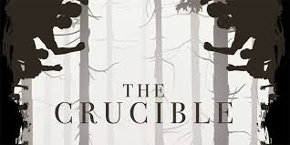**The Crucible Home Learning**

**Copy and paste the link below into your web browser for a copy of the text.**

[**https://archive.org/stream/TheCrucibleFullText/The+Crucible+full+text_djvu.txt**](https://archive.org/stream/TheCrucibleFullText/The+Crucible+full+text_djvu.txt)

1. **Context**

Use ‘Accompanying Resource 1 – Salem Witch Trials’ to complete some research about the context of the play.

1. **Characters**

Use ‘Accompanying Resource 2 – Character List’ to make notes on each of the characters you have come across so far (or all, if you’ve read the whole text.) This could be personality, treatment of others, how they are treated, your opinion of that character. There is a help sheet with some ideas already listed to help you if you need it.

1. **Act by Act Questions**

Use ‘Accompanying Resource 3 – Act by Act Questions’ to answer the questions for the acts you have read (or all if you’ve completed the text)

1. **Extension Challenge**

There are some more challenging questions on the attachment ‘Accompanying Resource 4’ which you can have a go at answering!

1. **End of Play Task**

Create a new front and back cover for the play, thinking of key images and symbols, appropriate fonts, a ‘slogan’ and a blurb

1. **Watching ‘The Crucible’**

Log into ClickView by following the link on Moodle and using your usual log in details. Type in ‘The Crucible’ and watch the film version of the play.