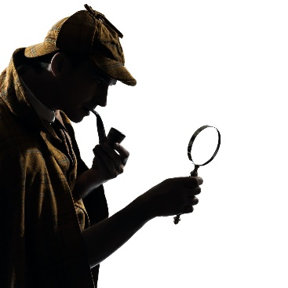
Crime and Society
Home Learning Tasks

- Starting task: Context (complete at start, or at any time during the unit if you haven’t done something similar already)
Create a fact-file or poster with lots of information about what life was like in the Victorian times, including some facts about the creation of detectives and rise in the use of forensic Science.

- ‘The Adventures of the Speckled Band’ (complete if you are missing the lessons in which the class are studying this story)
This is one of the stories we are using in class, you can find a copy of the text in ‘Accompanying Resources 1 – The Speckled Band’ and then there is a task book to complete. This will take several ‘lessons’ to go through.

- Other Stories (complete if you don’t want to interfere with the story being studied in class)
Copy and paste the link below into your web browser, this will take you to a website with all the Sherlock Holmes short stories on. We study ‘The Adventure of the Speckled Band’ and ‘The Adventure of the Dancing Men’ in class, so choose from the many other options and read a selection of short stories. Once you have read a story complete the table underneath the link.
https://www.arthur-conan-doyle.com/index.php/The_62_Sherlock_Holmes_stories_written_by_Arthur_Conan_Doyle

Title: | Brief Summary: | What was the suspect like? | What clues were given? | Did you guess?

- Watching Sherlock Holmes (complete if you don’t want to interfere with the stories being studied in class. Complete once you’ve read a story or if you’re struggling to read one)
There are plenty of versions of Sherlock Holmes stories to watch, follow the link for ClickView on the Moodle homepage and use your usual school log in details to sign in. Type ‘Sherlock Holmes’ into the search bar. Try to watch a Victorian era version, and not the modern Benedict Cumberbatch one! There is also a documentary on the inspiration behind Sherlock Holmes for you to watch.

