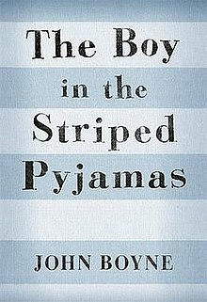
The Boy in the Striped Pyjamas:
Home Learning Tasks

- Background knowledge:
Copy and paste the link below into your web browser and read the information about the holocaust, watch the video and take the test
https://www.bbc.co.uk/bitesize/guides/zkfk7ty/revision/1

- Corrie ten Boom task:
Corrie ten Boom has become a famous figure because of her action during this time. Create a fact file or poster with information about her and what she did
Who else has become famous for helping Jewish people during this time? Find out some information about some more and make brief bullet point notes on them

- Anne Frank task:
Go to ‘Accompanying Resource - Anne Frank’s diary and complete task on sheet

- The text:
Copy and paste the link below into your web browser. This will take you to a YouTube page with video audio books for each chapter of the book.
https://www.youtube.com/watch?v=kdjvCcq-4gg&list=PLtrH7SVGoX0lBbygWT1LphmlkG82H98ie
Listen (you can read instead, or read along, if you have a copy of the text)

- End of book tasks:
- Imagine John Boyne is coming into school to discuss the book. Write a list of questions you have after finishing the story which you would like to ask him
- Create a new front and back cover for the book. This will include images which you think symbolise what happens, a slogan for the story and a blurb to go on the back cover. You could type ‘‘The Boy in the Striped Pyjamas’ book cover’ into Google for inspiration
- Write a book review, aiming for 200 words expressing how you felt about the book
- Follow the link to ClickView on Moodle, use your usual school details to log in and watch the film version.

