Language Paper 2 Revision

Useful websites:
- BBC Bitesize
- Mr Bruff on YouTube
- GCSE Pod videos

- Fill in the attached table with information about what each question is asking you to do
- Have a go at the attached practice paper once you have gone through the useful websites and completed task 1. The mark scheme is also attached to help you understand what you need to do.

General Tasks:
- Read nonfiction!!! Autobiographies, biographies, magazines, historical books…
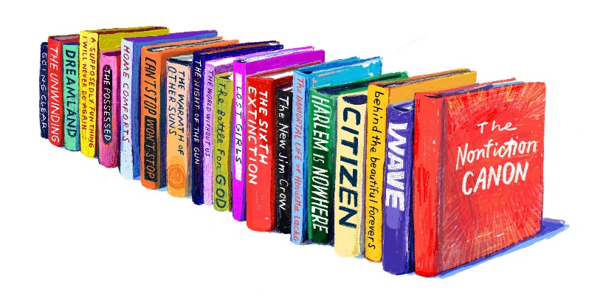
- Build awareness and empathy by keeping up to date with news from around the world

