Scratch
Scratch allows you to write programmes. Programmes are lists of instructions that control what the computer does. In Scratch you are programming sprites. Sprites are cartoon characters that can be controlled.
Sprites can be made larger or smaller by using these buttons
The co-ordinates of the active sprite are shown here
This area allows you to rename a sprite and control its direction
These buttons allow the stage to go full screen
These buttons Start and Stop the programme
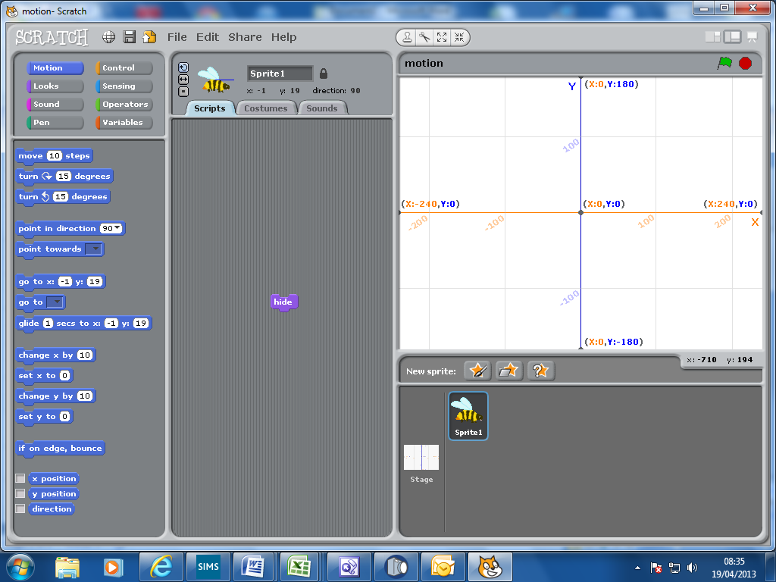
The co-ordinates of your mouse pointer are shown here
This area is called the stage. It currently has a graph paper background.
The stage is also programmable if you select it
This area shows you the sprites you are using. The sprite you are programming is highlighted
This is the area where you build your programmes.
Drag instructions you want from the current tool box.
Drag instructions you DON’T want back into the current tool box.

New sprites can be found or created here
This is your current tool box (Motion), filled with instructions
These are the different categories of tool boxes

