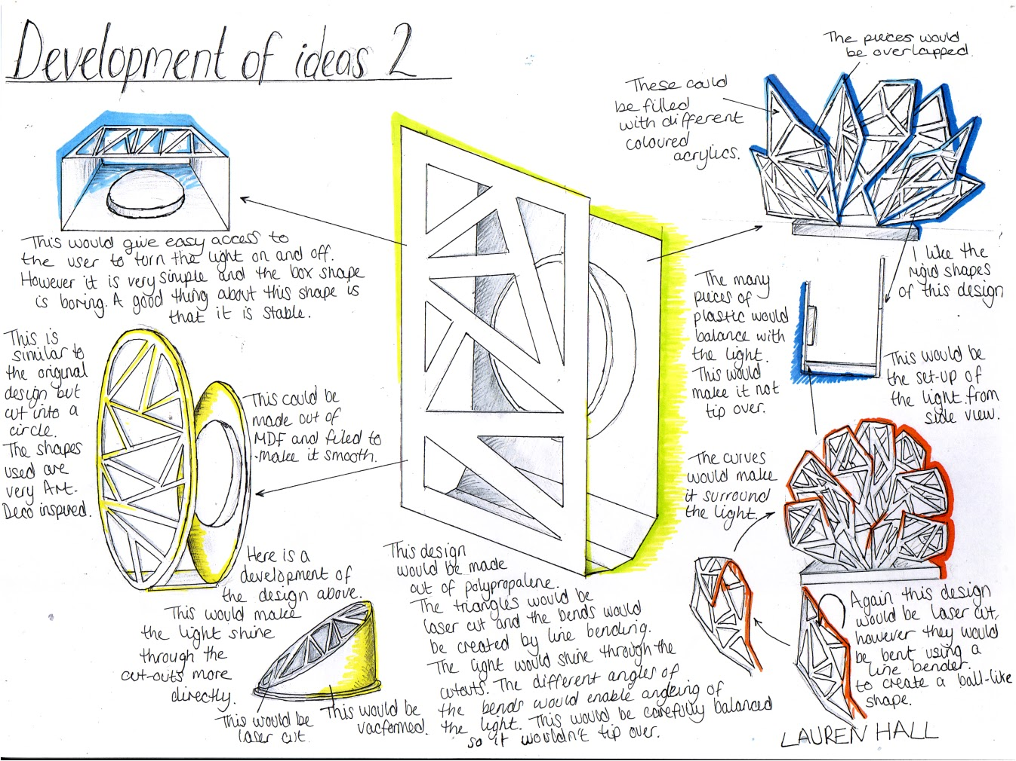

This is a good example of design development. Presentation is excellent as the original idea is drawn in the centre of the page and a range of alternatives are offered around the original idea. The student has used arrows to link thoughts to the central idea. All alternatives to the original idea are explained in detail and the quality of drawing is consistent across the page. All the alternatives to the original idea are relatively simple but they achieve the objective of development of an idea. The student has made reference to materials, shape, ease of use, colour and making techniques.

Development of ideas example